Press release  September 2020 |  | Further information about publication:  Schüco International KG  Ulrike Krüger  Karolinenstr. 1–15  33609 Bielefeld, Germany  Tel.: +49 (0)521 783-803  Fax: +49 (0)521 783-950803  E-mail: PR@schueco.com  www.schueco.de/presse  www.schueco.com/press

Opening unit with narrow face width:

Schüco AWS 75 PD.SI window system

Bielefeld. The Schüco AWS 75 PD.SI (Aluminium Window System, 75 mm basic depth, Panorama Design, Super Insulation) is an opening unit which combines minimal internal and external face widths with excellent thermal insulation.

The Schüco AWS 75 PD.SI can be designed as a standard punched opening, a ribbon window or an insert unit in the Schüco FWS 35 PD mullion/transom construction and is therefore suitable for all applications in commercial buildings and luxury homes.

The Schüco AWS 75 PD.SI window system has minimal internal and external face widths. It is based on system features which are perfectly tailored to one another: a flush-fitted appearance of the inner vent profiles and minimised gasket sight lines, as well as harmonised face widths in fixed lights and opening units for a uniform look. Concealed drainage and a clean language of design thanks to narrow profile radii complete the Panorama Design window system. Added to this is a handle connection without rosettes for a specially developed handle that can also be locked. The window construction offers burglar resistance up to class RC 2.

A perfectly coordinated architectural solution is offered, for example, by integrating the new, high insulation opening unit into the Schüco FWS 35 mullion/transom design (35 mm face width) and combining it with the narrow, opaque Schüco AWS 75 PD VV.SI ventilation vent. The system properties and the design of both units are perfectly tailored to one another, forming a coherent façade appearance.

New landmark for Gersthofen
One of the first buildings to feature the new Schüco AWS 75 PD.SI Panorama Design windows is the new company headquarters of the Roschmann Group (www.roschmann.group). The twelve-storey glass tower on the A8 motorway in Gersthofen can be seen for miles around. From the inside, its transparent twin-wall façade offers impressive panoramic views of Augsburg and the Alps. To avoid interrupting these exceptional views as much as possible, the Roschmann group opted to install an opening unit with minimised internal and external face widths in the all-glass construction without mullions. Carolin Roschmann explains, "The Panorama Design window from Schüco was the perfect choice thanks to its numerous benefits, and in particular energy efficiency." The outer frame was modified by Roschmann so that it "floats" in the surrounding insulating glass. The window vents in the transparent façade therefore stand out with their attractive, slimline face widths and highlight the modern, contemporary architecture of the tower. The new landmark in Gersthofen was designed by Wunderle + Partner Architekten in close collaboration with the façade fabricator.

Schüco AWS 75 PD.SI – benefits for fabricators
There are numerous benefits for fabricators, including maximum use of identical parts within the system and as part of the Schüco AWS modular system, as well as the economical Schüco SimplySmart fabrication process thanks to the extensive portfolio of tools and machinery to support the bonding process. The glass is bonded easily, efficiently and reliably with adhesive tape; there are no waiting times and standard insulating glass is used. Fabrication is extremely efficient thanks to the integration of functions, such as the corner piece with combined drainage. The use of stainless steel corner glass carriers is an important technological element which enables high glass loads to be incorporated with minimal face widths.
Schüco – System solutions for windows, doors and façades
Based in Bielefeld, the Schüco Group develops and sells system solutions for windows, doors and façades. With 5650 employees worldwide, the company strives to be the industry leader in terms of technology and service today and in the future. In addition to innovative products for residential and commercial buildings, the building envelope specialist offers consultation and digital solutions for all phases of a building project – from the initial idea through to design, fabrication and installation. 12,000 fabricators, developers, architects and investors around the world work together with Schüco. The company is active in more than 80 countries and achieved a turnover of 1.750 billion euros in 2019. For more information, visit www.schueco.com

High-resolution pictures are available to download in the Schüco Newsroom at www.schueco.com/press

Picture credits: Schüco International KG
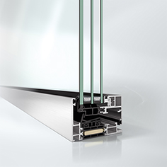
Schüco AWS 75 PD.SI window

Picture credits: Schüco International KG
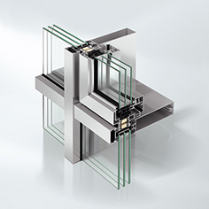
Schüco AWS 75 PD.SI window integrated in the Schüco FWS 35 PD façade.

Picture credits: Schüco International KG
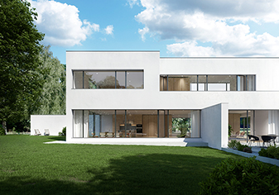
Schüco AWS 75 PD.SI window in a luxury home.

Picture credits: Schüco International KG
Photographer: Daniel Vieser, www.dv-architekturfotografie.de
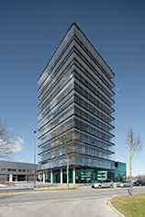
One of the first buildings with the new Schüco AWS 75 PD.SI Panorama Design windows is the new company headquarters of the Roschmann Group.

Picture credits: Schüco International KG
Photographer: Daniel Vieser, www.dv-architekturfotografie.de
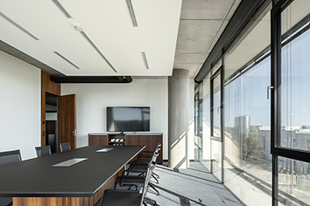
The Schüco AWS 75 PD.SI outer frame was modified by Roschmann so that it "floats" in the surrounding insulating glass.

