Press release  July 2020 |  | Further information about publication:  Schüco International KG  Ulrike Krüger  Karolinenstr. 1–15  33609 Bielefeld, Germany  Tel.: +49 (0)521 783-803  Fax: +49 (0)521 783-950803  E-mail: PR@schueco.com  www.schueco.de/presse  www.schueco.com/press

A fire protection system for maximum flexibility in operation

Schüco FireStop ADS 90 FR 90

Bielefeld. With Schüco FireStop ADS 90 FR 90, a further aluminium fire protection system with 90 minutes of fire resistance and a basic depth of 90 mm is being added to the Schüco FireStop platform. Thanks to the open rebate profile geometry, the fire and smoke protection systems of the Schüco FireStop platform set new standards in installation and flexibility. This is because changes in use or additional adjustments can be implemented without great effort. The simplified system structure also enables efficient and time-saving fabrication.

Schüco FireStop ADS 90 FR 90 combines efficiency, functionality and design in a single system. The key feature of the Schüco FireStop platform is the open rebate profile geometry, through which adjustments can be made quickly and flexibly to suit changing requirements, all while the building is still in use. The profiles, accessories and fittings of the 90 minute fire protection system are largely identical to those of Schüco FireStop ADS 90 FR 30. The highest fire resistance class of 90 minutes is achieved by using accessories such as fire boards and glazing clips. A fire-resistant insulating mat that has been inserted into the outer and leaf frames allows the fire door to be further enhanced. Adjustments such as automating the door or changing from single to multi-point locking can also be implemented quickly and flexibly thanks to the profile geometry. Concealed fittings offer additional design freedom and a uniform look throughout the building, and are now available for the first time for fire doors with 90 minutes of fire resistance as well as for enhanced system sizes. For example, the fire protection system allows clear opening dimensions of up to 1400 x 2700 mm for single-leaf doors and max. 2822 x 2700 mm for double-leaf doors to be constructed.

Simple fabrication and installation
The open rebate profile geometry permits the efficient fabrication and installation of concealed fittings. The fittings can be installed efficiently without additional machining work and almost without the use of any tools. Furthermore, corner joints can now be screw-fixed or crimped in addition to the proven technique of nailing. This reduces the total weight of the Schüco ADS 90 FR 90 fire door compared to the old Schüco FireStop T90 system by up to 20 percent.

For more information, visit schueco.com/firestop.

Schüco – System solutions for windows, doors and façades
Based in Bielefeld, the Schüco Group develops and sells system solutions for windows, doors and façades. With 5650 employees worldwide, the company strives to be the industry leader in terms of technology and service today and in the future. In addition to innovative products for residential and commercial buildings, the building envelope specialist offers consultation and digital solutions for all phases of a building project – from the initial idea through to design, fabrication and installation. 12,000 fabricators, developers, architects and investors around the world work together with Schüco. The company is active in more than 80 countries and achieved a turnover of 1.750 billion euros in 2019. For more information, visit www.schueco.com

High-resolution pictures are available to download in the Schüco Newsroom at www.schueco.com/press.

Picture credits: Schüco International KG
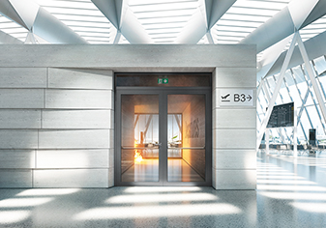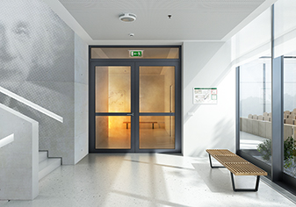
Schüco FireStop ADS 90 FR 90 combines design, efficiency and flexibility in a single fire protection system with 90 minutes of fire resistance.

Picture credits: Schüco International KG
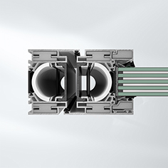
Thanks to accessories such as fire boards and glazing clips, the Schüco FireStop ADS 90 FR 90 fire door achieves the highest fire resistance class of 90 minutes.

Picture credits: Schüco International KG
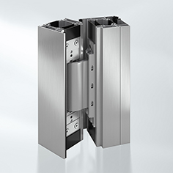
Schüco FireStop ADS 90 FR 90 is the first fire door with 90 minutes of fire resistance to integrate concealed fittings for a uniform look throughout the building.

