Press release  June 2020 |  | Further information about publication:  Schüco International KG  Ulrike Krüger  Karolinenstr. 1–15  33609 Bielefeld, Germany  Tel.: +49 (0)521 783-803  E-mail: PR@schueco.com  www.schueco.de/presse  www.schueco.com/press
New BMW showroom, Esch-sur-Alzette/Luxembourg:
A space to showcase!

The new BMW Muzzolini garage at the crossroads of a busy main road and the edge of the Um Monkeler industrial area is an eye-catching newbuild that serenely meets the strict corporate identity requirements set by BMW for its official distributors. Just a few materials – glass, steel, white walls – have been used to create a sleek building which makes a clear, unmistakeable statement in this urban mixed-use zone with its continuous façade measuring up to seven and a half metres high made from high-strength VISS 60 profiles from Schüco Jansen Steel Systems.

The Muzzolini garage has been an official BMW distributor since 1977 and now has a new showroom in the Um Monkeler industrial area of Esche-sur-Alzette. Architect Louis Weisgerber deliberately avoided closed façade areas when designing the building. It is possible to see inside the showroom when driving past from every street. This is where cars of the BMW brand, sport model M and electric model BMWi are presented across an area of 4500 m². There is also a separate space for "premium selection" used vehicles, workshops, warehouses and offices. The building covers around 9000 m² overall and everything has been designed to meet the latest international standards of the BMW brand.

"The client wanted a virtually column-free showroom, which is why we initially worked with an engineering company to develop the concrete skeleton of the building shell," explains Weisgerber. "This resulted in a modular design for the glass façade." The façade modules measure 2.5 x 3.0 metres as standard, while in the two-storey foyer the façade extends to an impressive height of 7.5 metres – which is particularly remarkable as the enormous glass panes are held in place by comparatively narrow continuous single-piece mullions. The architect deliberately chose the high-strength VISS 60 profile system from Schüco Jansen Steel Systems. "While we were searching for an elegant solution, the metal fabricator pointed us in the direction of this profile. We were immediately won over by the enormous glass loads it can bear with surprisingly narrow face widths."

The high-strength VISS 60 profiles made it possible for the façade to also have an extremely reduced load-bearing structure, much like the building shell. As steel has a very high modulus of elasticity, the profile cross sections can have narrower dimensions. This not only saves a huge amount of material, it also means that more light is let into the building. In order to protect against overheating, triple glazing was fitted with sun shading glass in places. External sun shading in the form of louvre blades and blinds was naturally out of the question as it would have concealed the view of the showroom. The only practical solution was "structural" sun shading. This is provided by the metal constructions which project out by up to 1.5 metres, simultaneously giving the façade the "tension" required by the BMW corporate image. The highlight is that the load of the horizontal sun shading is borne directly by the façade profiles. For this, steel flat brackets, on which the tubular construction clad with sheet metal rests, were welded to the horizontal transoms.

The newbuild not only complies with the BMW corporate identity requirements with a coherent overall concept, it is also exemplary in terms of energy efficiency as it has been classified with Class C energy efficiency standard (in accordance with the Grand Ducal Regulation on the energy performance of commercial buildings). In addition to the projecting sun shading construction, which provides natural shading, the building is also easily cooled during the summer by means of the underfloor heating. In these periods, cool water runs through the pipes instead of heating. This energy-saving concept proved invaluable in the first summer after the showroom opened. "Despite the high temperatures outside, which were continuously over 30 °C for several days, it remained a comparatively comfortable 24 °C indoors," Weisgerber says, describing the simple yet highly efficient solution.

For more information, visit:
Schüco Jansen Steel Systems
Karolinenstr. 1 –15
33609 Bielefeld, Germany
Tel.: +49 (0)521 783-0
Fax: +49 (0)521 783-95 92 52
E-mail: info@schueco.com
www.schueco.com

Project details

Client: BMW Muzzolini showroom, Esch-sur-Alzette/Luxembourg
Architect: Louis Weisgerber, Esch-sur-Alzette/Luxembourg
Metal/window fabricator: BCM Bohlen Constructions Metallique S.a.r.l.,
Echternach/Luxembourg
Steel profile systems:
Façade: VISS 60 steel profiles with high structural properties
Interior walls and windows: VISS
System supplier: Schüco Jansen Steel Systems

Further information about publication:
BAUtext Mediendienst München
Anne-Marie Ring
Wilhelm-Dieß-Weg 13
81927 Munich, Germany
Tel.: +49 (0)89 21 11 12 06
E-mail: a.ring@bautext.de

Schüco – System solutions for windows, doors and façades
Based in Bielefeld, the Schüco Group develops and sells system solutions for windows, doors and façades. With 5650 employees worldwide, the company strives to be the industry leader in terms of technology and service today and in the future. In addition to innovative products for residential and commercial buildings, the building envelope specialist offers consultation and digital solutions for all phases of a building project – from the initial idea through to design, fabrication and installation. 12,000 fabricators, developers, architects and investors around the world work together with Schüco. The company is active in more than 80 countries and achieved a turnover of 1.750 billion euros in 2019. For more information, visit www.schueco.com

Schüco sells steel systems from the Swiss company Jansen AG exclusively in Germany, Denmark, Sweden, Norway, Finland, Iceland, Luxembourg, the UK, Russia and the Baltic States under the name Schüco Jansen steel systems. In return, Jansen AG sells Schüco products in Switzerland.

High-resolution pictures are available to download in the Schüco Newsroom at www.schueco.com/press.

Image credits: Muzzolini garage/Benoit Deprez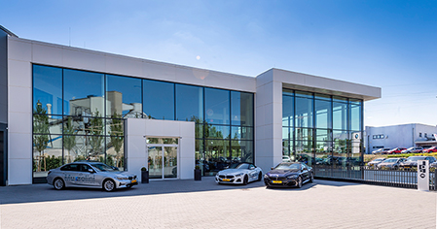
The Muzzolini garage newbuild presents cars of the BMW brand, sport model M and electric model BMWi across a space of 4500 m². Architect Louis Weisgerber deliberately avoided closed façade areas when designing the ambitious commercial building. The façade construction, made from high-strength VISS 60 steel profiles from Schüco Jansen Steel Systems and measuring up to seven and a half metres high, allows views into the showroom from all sides.

Image credits: Muzzolini garage/Benoit Deprez
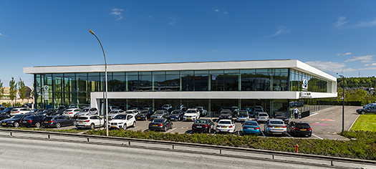
The façade modules were developed from the concrete skeleton of the building shell and measure 2.5 x 3.0 m as standard.

Image credits: Muzzolini garage/Benoit Deprez
However, in the two-storey foyer, the façade stretches to an impressive height of 7.5 m, with the steel mullions continuing as one piece.

Image credits: Muzzolini garage/Benoit Deprez
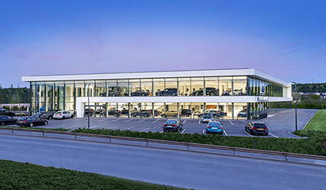
The highlight is that the load of the horizontal sun shading is borne directly by the façade profiles. For this, steel flats, on which the tubular profile load-bearing structure rest, were welded to the transoms.

Image credits: Muzzolini garage/Benoit Deprez
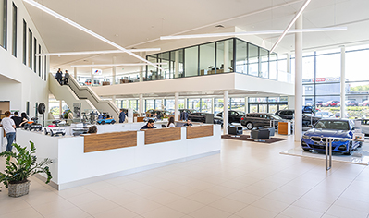
The offices are located in a cube on the top floor, which is fitted with safety barrier glazing made from VISS profiles from Schüco Jansen Steel Systems.

Image credits: Muzzolini garage/Benoit Deprez
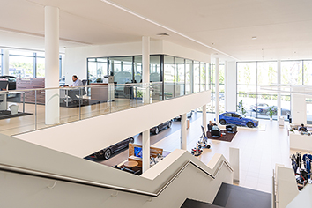
A wide staircase connects the ground floor to the upper floor; with a meeting area in front of the offices.

Image credits: Muzzolini garage/Benoit Deprez
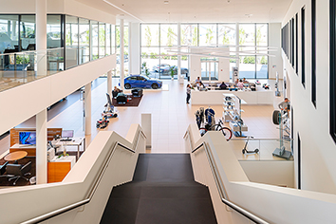
Employees can always see the showroom from their desks too thanks to the interior windows made from the VISS steel profile system.

