Press release  September 2026 |  | Further information about publication:  Schüco International KG  Ute Minartz  Karolinenstr. 1 - 15  33609 Bielefeld  Tel.: +49(0)5217831174  E-mail: PR@schueco.com  www.schueco.com/press  www.schueco.com/press

Elisabeth Selbert district, Mülheim a. d. Ruhr

The island lives

Bielefeld. The new residential district on Elisabeth-Selbert-Straße in Mülheim a. d. Ruhr demonstrates how a housing development can combine affordability with high construction quality and aesthetic appeal. Windows and doors from Schüco play an important role in this award-winning project.

The pressure to cut costs in residential construction is high. Specifiers and architects are facing the challenge of developing urban environments where people enjoy spending time and that foster a vibrant sense of community despite ever tighter budgets. The team from Druschke NxT Architektur shows how this can work successfully with a new district in Mülheim an der Ruhr for the municipal housing authority SWB.

The site is surrounded by Elisabeth-Selbert-Straße, which gives it a unique island-like character. Three of the original six existing buildings were demolished and replaced with six new structures that integrate harmoniously into the topography. Together with the three buildings that were retained, they define a new, green neighbourhood centre with areas for play, relaxation and physical activity.

Subsidized housing and energy supply for the neighborhood
The new buildings house a total of 72 apartments. 39 are publicly funded, with 12 of these in the so-called second funding stream for social housing. This model falls somewhere between traditional social housing (first funding stream) and the private housing market. With affordable rent, it is aimed at middle-income families and is part of the district’s targeted social mixing initiative.

Constructed to the KfW Efficiency House 55 standard, the two to four-bedroom apartments all have a balcony or terrace.
38 geothermal probes supply the apartments with energy, with district heating covering peak load periods, photovoltaic systems generate electricity. Oliver Thiele, Project Manager at Druschke NxT and responsible for the Elisabeth Selbert Quarter, describes the approach: “Our aim was to create high-quality living spaces, both socially and architecturally – open, suitable for all generations and pleasant to live in. That’s how we envisage the architecture of the future.”

Schüco system expertise for windows and doors
The Schüco LivIng 82 AS PVC-U window system contributes to the building envelope’s energy-efficiency concept. It has a frame depth of 82 mm and, in the version used, achieves a U_{f} value of approximately
1,0 W/m²K. Integrated roller shutters provide both screening and sun shading. For summer thermal insulation, the windows are fitted with sun shading glass depending on the orientation of the façade. On the outside, the PVC-U profiles have “AnTeak” woodgrain foils, while the insides are white.

The wood effect of the PVC-U windows perfectly matches the RAL “pearl beige” shade of the aluminium entrance doors from the Schüco ADS 75 SI system. The thermally broken door system combines a U_{D} value of 1.2 W/m²K, pioneering functionality and a high degree of creative freedom.

Oliva GmbH from Marl fabricated around 500 windows and doors for the six barrier-free apartment blocks. The elegant, predominantly floor-to-ceiling units provide users with a high level of comfort. The low maintenance requirements can have an impact on operating costs and thus help to maintain the value of the properties.

Successful transformation
The transformation of the site on Elisabeth-Selbert-Straße demonstrates how an unattractive district can become a vibrant, green urban space. Architect Oliver Thiele comments: “We have created a broad variety of housing for a varied mix of tenants. This brings the island to life and accommodates a diverse range of lifestyles.”

The project has been awarded the 2026 Big See Architecture Award and nominated for the Deutscher Bauherrenpreis 2026 (German Builder-Owner Award).

Project details

Project: Elisabeth Selbert district
Location: Elisabeth-Selbert-Straße, 45473 Mülheim an der Ruhr
Client: SWB-Service- Wohnungsvermietungs- und baugesellschaft mbH, Mülheim an der Ruhr
Architecture: Druschke NxT Architektur GmbH, BDA, Duisburg
Open space planning Förder Landschaftsarchitekten GmbH, Essen
Contracting company: Oliva GmbH Fenster und Türen, Marl
Awards: Big See Architecture Award 2026, nominated for the Deutscher Bauherrenpreis 2026
Completion date: 2024

Key data

Residential units: 72 apartments with between 2 and 4 bedrooms in 6 blocks
Gross floor area: 13,040 m²
Gross volume: 40,710 m²
Living space: 5965 m²
Energy generation: 38 thermal probes, connection to district heating for peak load periods
Overall energy consumption: 31 kWh/m²a
Primary energy requirement: 20 kWh/m²a

Schüco systems used

PVC-U windows: Schüco LivIng 82 AS, AnTeak woodgrain outside; white inside, U_{f} = 1.0 W/(m²K)
Aluminium entrance doors: Schüco ADS 75.SI, flush-fitted, RAL 1035 pearl beige, U_{D} = 1.2 W/(m²K)

Schüco – System solutions for windows, doors and façades
Based in Bielefeld, the Schüco Group develops and sells system solutions made of aluminium, steel and PVC-U for the building envelope. The product portfolio includes window, door, façade, ventilation, security and sun shading systems, as well as intelligent networked solutions for residential and commercial projects. Schüco also provides consultancy and digital solutions for all phases of a building project – from the initial idea through to design, fabrication and installation, as well as after sales with maintenance and servicing. Fabrication machinery and customer-oriented service complement the product portfolio. Founded in 1951, Schüco is now active in more than 90 countries and achieved a turnover of 2.06 billion euros in 2025 with 6750 employees.
www.schueco.com

High-resolution pictures are available to download in the Schüco Newsroom at www.schueco.com/press.

Photographer: TR-Architekturfotografie and Ralph Richter
Usage rights: Schüco International KG
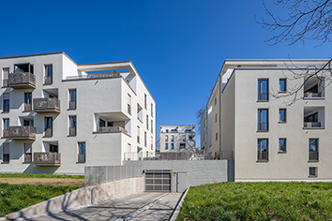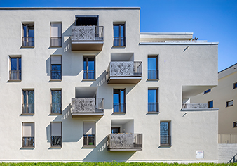
Affordable living with aesthetic appeal: the Elisabeth Selbert district in Mülheim an der Ruhr.

Photographer: Ralph Richter
Usage rights: Schüco International KG
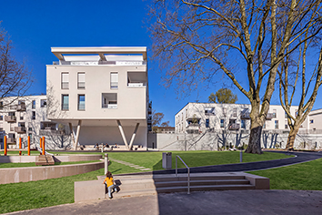
72 new apartments were built in the new developments.

Photographer: Ralph Richter
Usage rights: Schüco International KG
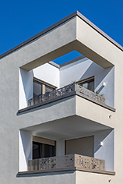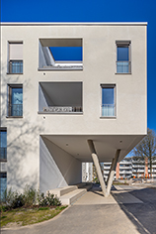
The two-to-four-bedroom apartments each have either a balcony or terrace.

Photographer: TR-Architekturfotografie
Usage rights: Schüco International KG
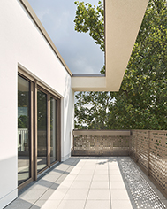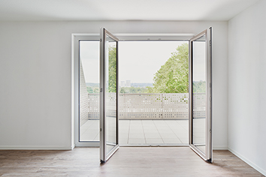
PVC-U LivIng 82 AS window system from Schüco.

Photographer: Ralph Richter
Usage rights: Schüco International KG
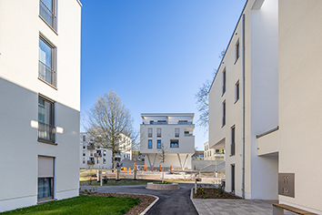
In total, around 500 windows and doors from Schüco were installed in the six barrier-free apartment blocks.

Picture credits: Förder Landschaftsarchitekten GmbH
Usage rights: Schüco International KG
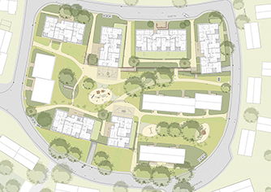
Site map of the Elisabeth Selbert district, Mülheim an der Ruhr.

Picture credits: Druschke NxT Architektur GmbH, BDA, Duisburg
Usage rights: Schüco International KG

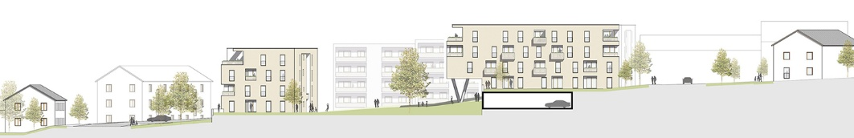
View of the Elisabeth Selbert district, Mülheim an der Ruhr.

