Press release  July 2026 |  | Further information about publication:  Schüco International KG  Ute Minartz  Karolinenstr. 1 – 15  33609 Bielefeld, Germany  Tel.: +49 (0)521 783-6307  E-mail: PR@schueco.com  www.schueco.de/presse  www.schueco.com/press

Lamb Street Building, London

Striking steel construction for commercial and catering trades

Bielefeld. A red oxide steel frame lends the Lamb Street Building its unmistakable appearance. In order to highlight this distinctive industrial character, the thermal building envelope was moved behind the steel construction. Both the aluminium system Schüco FWS 50⁺ SG and the VISS SG steel façade system from JANSEN were used to construct the curtain walling with fire compartmentation.

In London's Spitalfields, a commercial and open space project known as Bishops Square Retail was implemented in line with the master plan by Foster + Partners. The aim is to upgrade and breathe new life into the area around Lamb Street, Market Street and Bishops Square Gardens. The latest phase of the project features a 70 metre-long and 15 metre-wide structure in Lamb Street. With its red oxide steel frame, the Lamb Street Building is reminiscent of the industrial buildings and warehouses that once characterised London's East End. The ground floor houses ten retail and catering outlets. They are designed to enable flexible use of the building throughout its entire useful life. A larger retail unit on the first floor is accessible via a building-height foyer at the western gable end.

Continuous structural glazing façade
It was the architects' express wish to showcase the distinctly industrial character of the striking steel beam structure with visible fixings and a red oxide steel surface finish as an undisturbed, eye-catching landmark. To allow the unique primary construction to take centre stage, the thermal building envelope (a continuous structural glazing façade) was constructed behind it. Both an aluminium and a steel façade system were used for this. The storey-height shop fronts on the ground floor and the retail unit on the upper floor were fabricated using the Schüco FWS 50⁺ SG (Structural Glazing) aluminium system. Entrance doors from the Schüco AD UP 75 aluminium system with concealed hinges and door-height pull bars were integrated into the system, achieving a security level of RC 2. For the building-height atrium at the western gable end, however, the architects opted for the JANSEN VISS SG (Structural Glazing) steel system. “The two systems are virtually identical in terms of look and performance, but the VISS SG steel system can span double the height,” the architects explain. “Given the similarity of the two systems, the combination of aluminium and steel façades offered the optimum solution in terms of cost-effectiveness.”

Combined expertise for successful design
The details of the curtain walling from the JANSEN VISS SG steel profile system, including the glazing clips, were developed by project partners VolkerFitzpatrick, Nuëcø Facade & Glazing Solutions, Foster + Partners and Bond Bryan in close collaboration with one another. The main aim was to ensure that the red oxide steel frame remained the primary design feature, while also fulfilling functional requirements in terms of watertightness, wind loads and air permeability, as well as preventing thermal bridging.

Project-specific mullions and glazing clips
Installing the up to 800 kg curtain walling units behind the primary steel construction posed a significant challenge. At the top and bottom end, the JANSEN VISS SG curtain wall is fixed to the primary construction by means of project-specific, custom-made glazing clips. It is unsupported laterally, so that it can sway with the building. Two steel mullions and a U-shaped profile have been joined together in such a way that they appear unsupported in one length, and are then cloaked to appear seamless. The glass-to-glass corner joints proved to be particularly challenging. For this, the standard VISS SG profile was modified to allow it to be installed at a 45-degree offset, to maintain the glass edge support on both sides. The mullion, which has been reduced as much as possible in terms of form, provides an optimum view to the outside. For its outstanding design and architectural achievement, the Lamb Street Building received a Commendation in the 2024 Structural Steel Design Awards.

Project details
Architects:
Foster + Partners, London/UK (RIBA 1 – 3; design planning)
Bond Bryan Architects Ltd., Sheffield/UK (RIBA 4 – 7; implementation planning and project monitoring)
Façade fabricator: Nuëcø Facade & Glazing Solutions, London
Products
JANSEN VISS SG Structural Glazing steel façade system
Schüco FWS 50⁺ SG Structural Glazing aluminium façade
Schüco AD UP 75 door system
Completion date: 2023

Schüco – System solutions for windows, doors and façades
Based in Bielefeld, the Schüco Group develops and sells system solutions for the building envelope made from aluminium, steel and PVC-U. The product range includes window, door, façade, ventilation, security and sun shading systems as well as smart and networked solutions for residential and commercial projects. Schüco also offers consultation and digital solutions for all phases of a building project – from the initial idea, design, fabrication and installation all the way through to the after-sales service including maintenance and servicing. Fabrication machinery and excellent customer service complement the product range. Founded in 1951, Schüco is now active in more than 90 countries and achieved a turnover of 2.06 billion euros in 2025 with 6750 employees. www.schueco.com

High resolution images are available to download in the Schüco Newsroom at www.schueco.de/presse.

Photographer: Bond Bryan Architects Ltd., Sheffield/UK
Usage rights: Schüco International KG
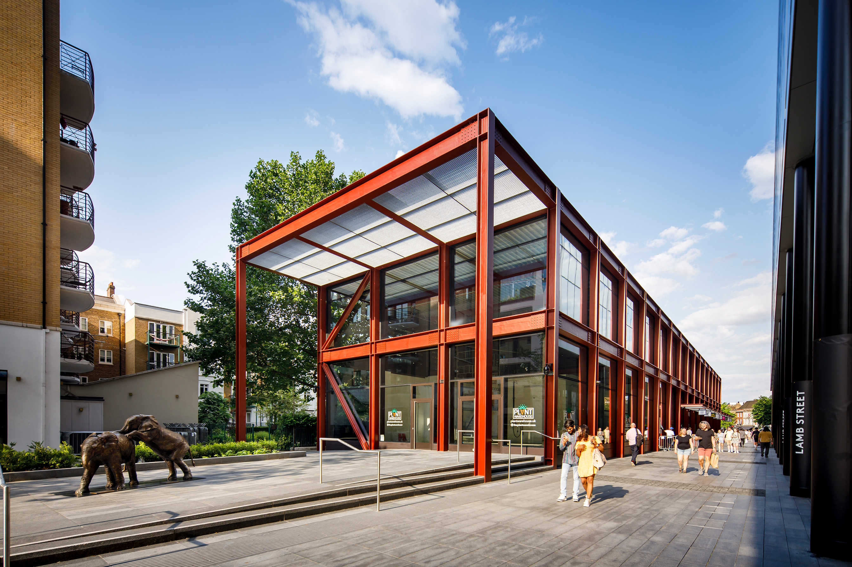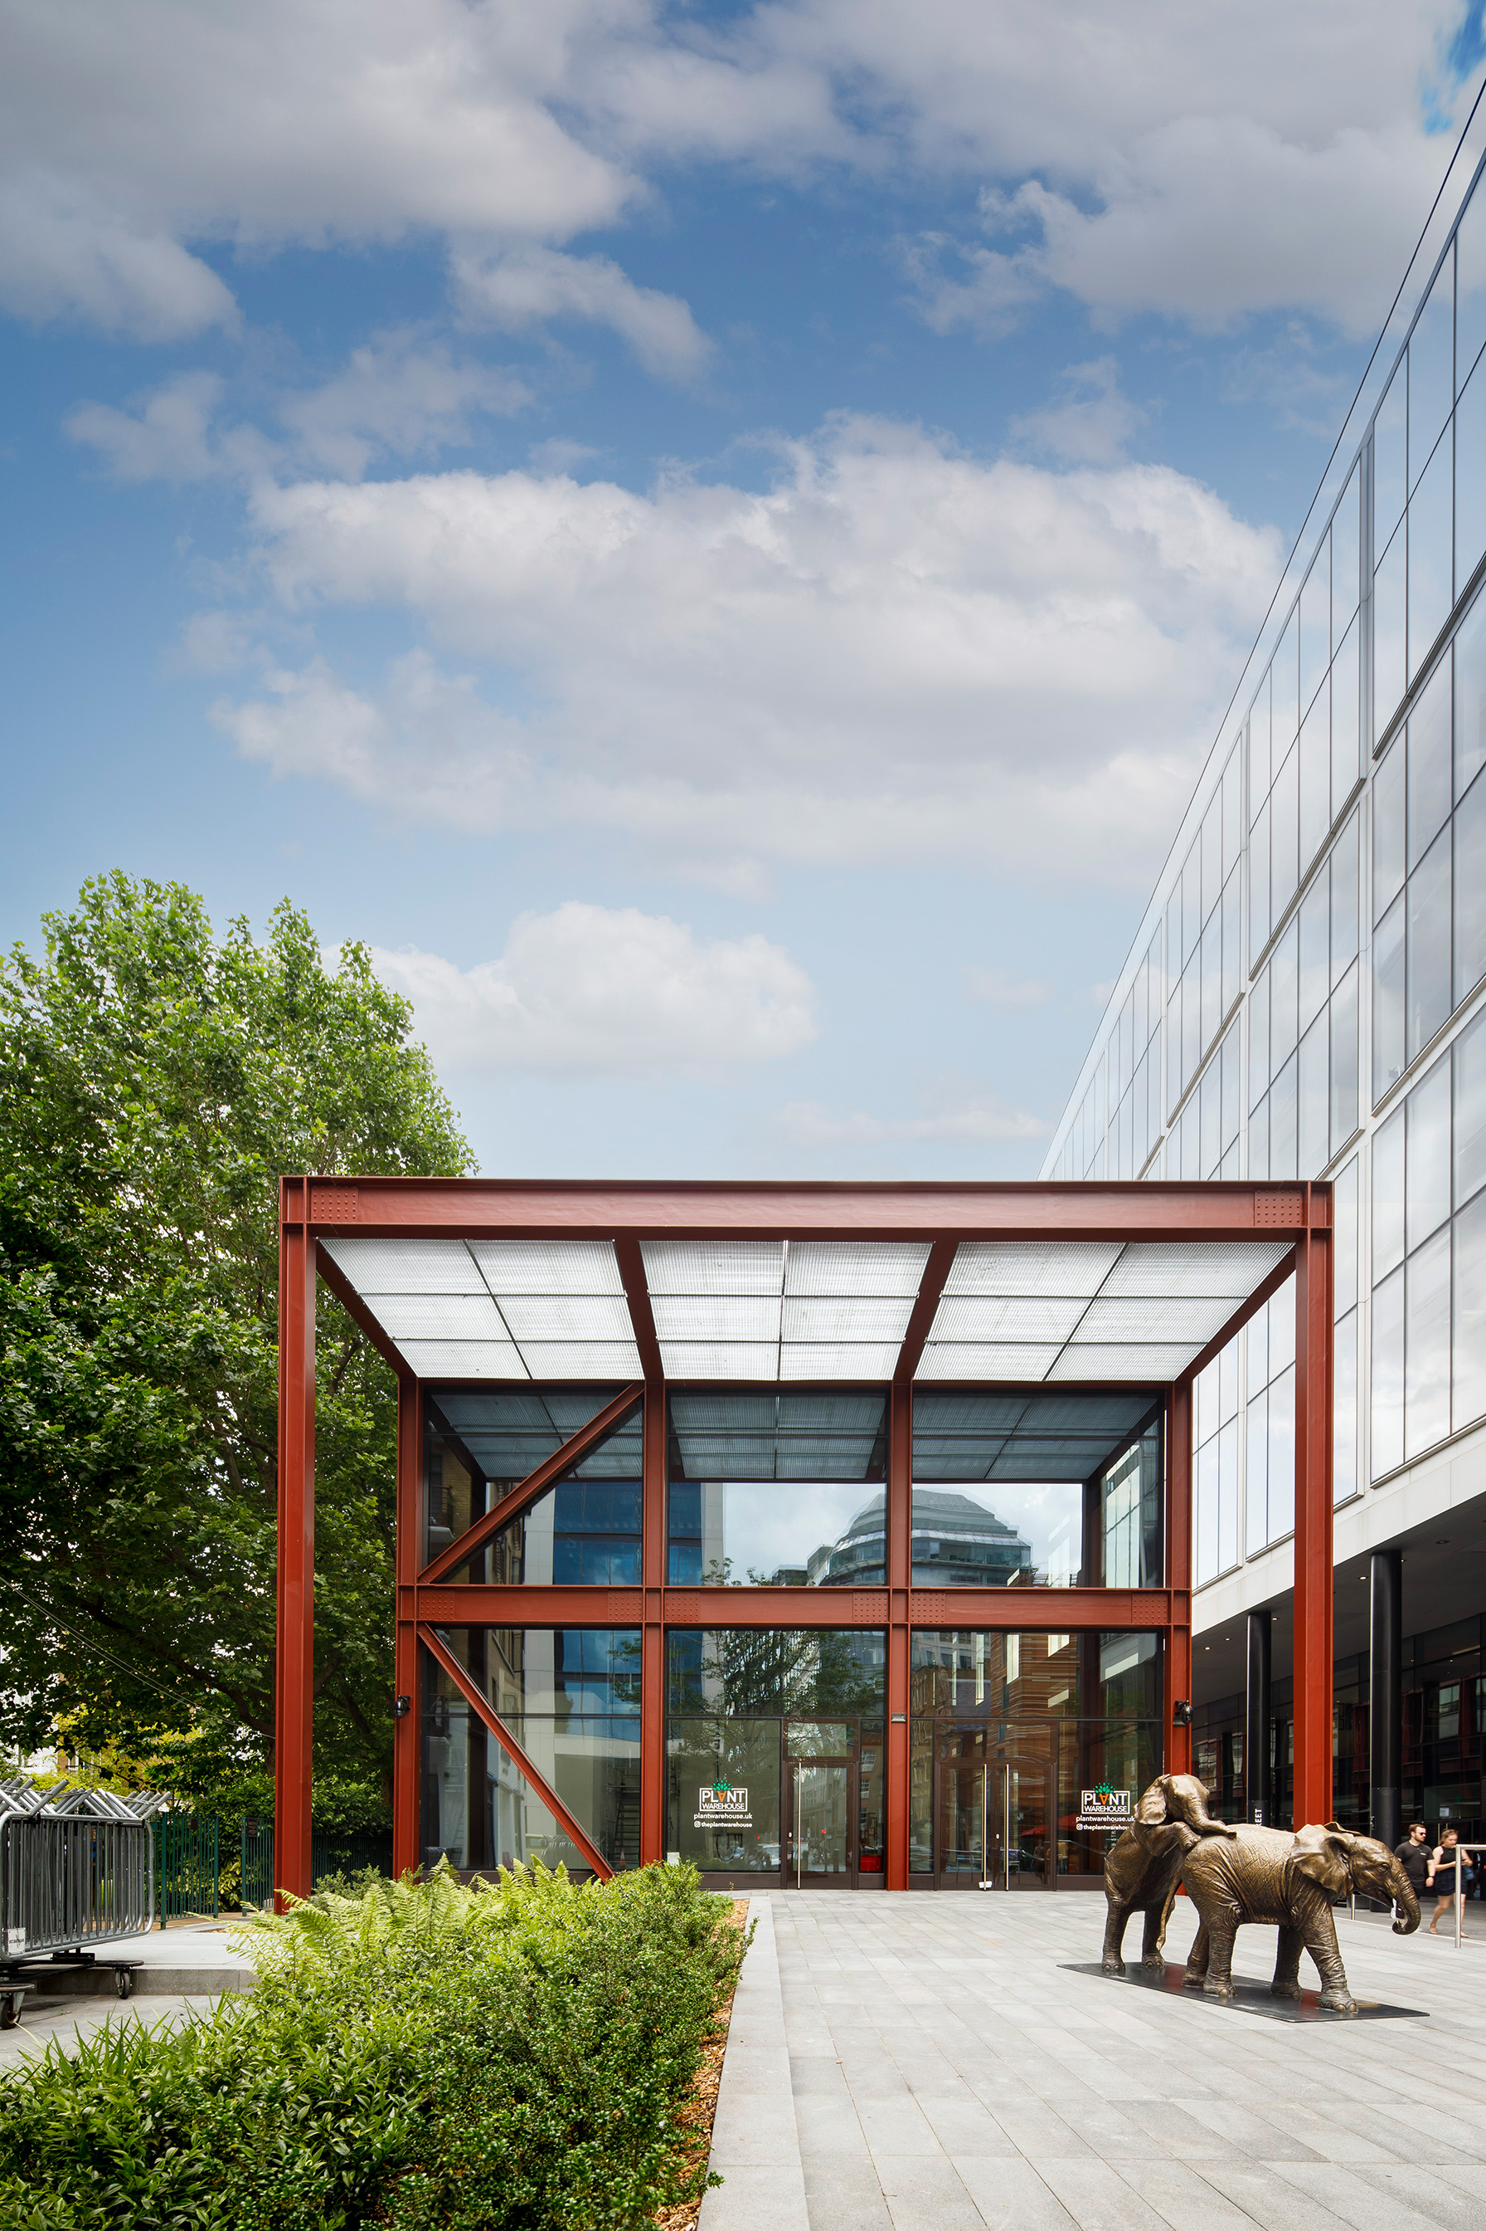
On the ground floor, the Lamb Street Building houses small retail and catering outlets. A larger retail unit on the first floor is accessible via a building-height foyer.

Photographer: Bond Bryan Architects Ltd., Sheffield/UK
Usage rights: Schüco International KG
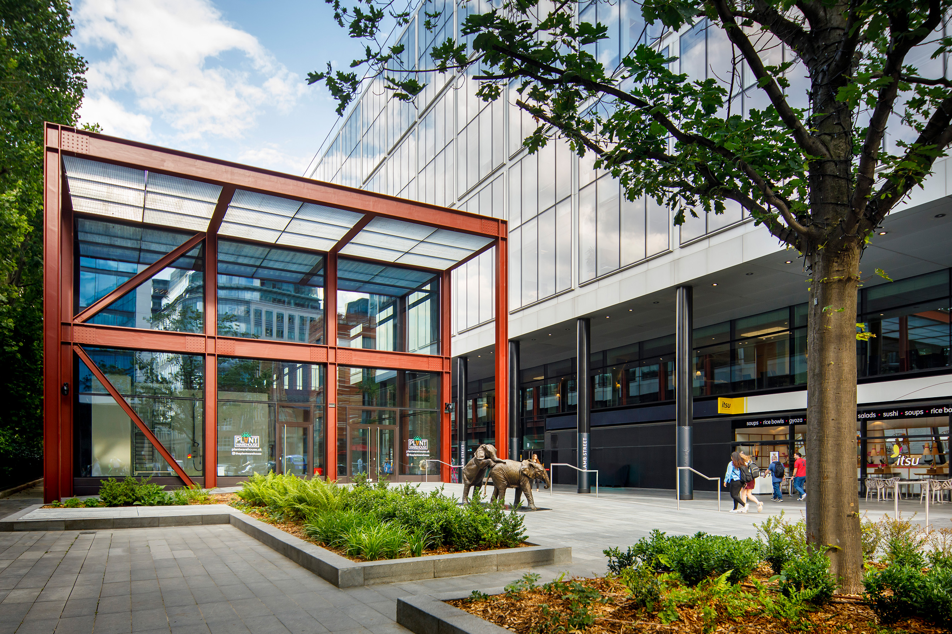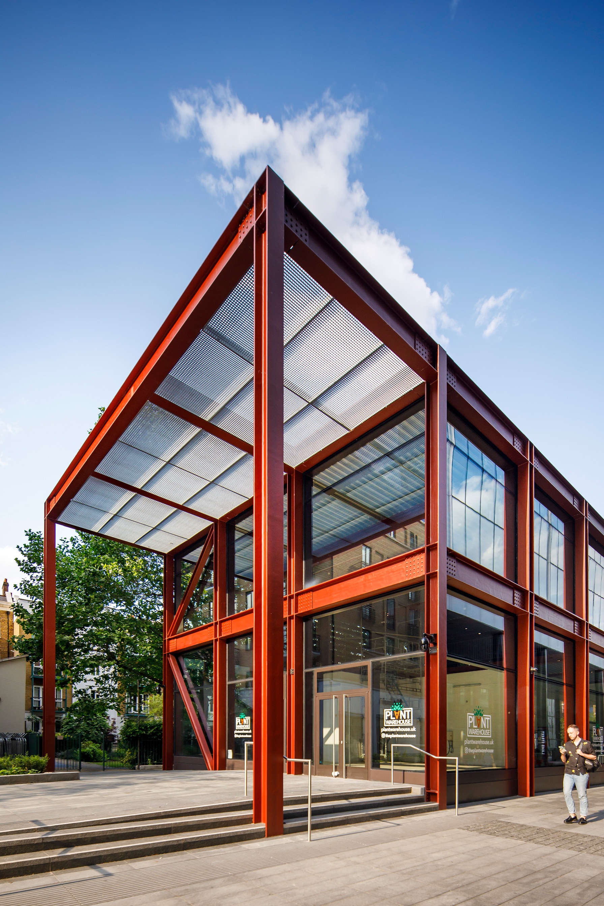
While the façades of the storey-height shop fronts on the ground floor and the retail unit on the upper floor were made using an aluminium system, the architects opted for the JANSEN VISS SG steel system for the building-height façade of the foyer.

