Press release  July 2026 |  | Further information about publication:  Schüco International KG  Sandra Greiser  Karolinenstr. 1–15  33609 Bielefeld  Tel.: +49 521 7831174  E-mail: PR@schueco.com  www.schueco.com/press  www.schueco.com/press

2025 annual report

Value-enhancing, tailored renovation solutions throughout the entire building life cycle

Bielefeld. In 2025, the Schüco Group launched a comprehensive initiative in the field of adaptive reuse. Under the name “Schüco Value Up”, the company presented value-enhancing solutions to support the building envelope throughout its entire life cycle. This represents another milestone in the holistic strategy of Schüco, with the company receiving the German Sustainability Award in the Construction Industry category for its commitment to climate neutrality and resource conservation in the building sector. From a financial perspective, the international company was able to close 2025 with a total turnover of €2.06 billion despite the construction crisis in its home market of Germany.

For the Schüco Group, 2025 was another year marked by global conflict and economic uncertainty, but also one shaped by its own strategic direction. Industry trends clearly show that the construction sector is undergoing a period of radical change. The economic situation remained tense in many markets – rising material costs, delivery bottlenecks, skilled worker shortages, high interest rates and unstable political conditions continued to dampen willingness to invest in the construction sector.

Adaptive reuse as a key driver of growth
The sustainable transformation of the existing building stock is both one of the greatest challenges for the construction industry and one of its most important growth areas. In 2025, Schüco responded to this trend by systematically expanding its service portfolio. With “Schüco Value Up”, the company presented a comprehensive service offering for value retention and the transformation of existing buildings – right across the entire life cycle of the building. In particular, the portfolio includes minimally invasive renovation solutions, consultancy services for property owners and investors, digital processes and tools, service and maintenance offerings, and solutions for demolition and recycling. Schüco is therefore increasingly becoming a comprehensive provider for the planning, construction, operation, modernisation, demolition and recycling phases of building envelopes.

In addition to this, the company is working internationally to expand the availability of low-carbon materials, both to continually optimise its own carbon footprint and to support achieving the climate goals of the construction industry in Germany and the EU. Sustainability requirements and the demand for recycled materials are increasing steadily in other international markets such as Asia, too.

“The future of construction is circular, digital and, above all, focused on managing the existing building stock – and that is precisely what we are working on. Our challenge is to think about building envelopes holistically and to optimise them throughout their entire life cycle – both ecologically and economically.” Andreas Engelhardt, Managing Partner of Schüco International KG

Stability in the construction crisis through internationalisation

Turnover of the Schüco Group
Thanks to its strategic focus on the entire building life cycle, as well as the diversification and internationalisation of the Schüco Group, the company managed to achieve revenue growth in 2025, despite challenging conditions in the construction industry, particularly in Germany. The consolidated revenue was €2.06 billion (previous year: €2.05 billion). This represents an increase of 0.7 percent compared to the previous year. When adjusted for currency fluctuations, the increase in turnover compared to the previous year was 2.3 percent.

In Germany, the turnover of €728 million in 2025 represents another slight drop of approx. 2.8 percent compared to the previous year. The international markets were able to make up for this with a turnover of €1.3 billion, ensuring a positive result for the entire Group. In Europe, turnover increased slightly by 0.7 percent to €965 million, with the other international subsidiaries rising by 8.8 percent to €371 million. It is evident that the proportion of the overall Schüco Group turnover accounted for by the European and other international Schüco subsidiaries is gradually increasing and that the Group is well-positioned and resilient, even in times of crisis in its home construction market of Germany. (Proportion of turnover: Germany 35%, International 65%).

It was possible to offset the effects of a stagnating German economy, the construction crisis and modest growth in the European countries over the last three years by international growth in 2025.

Currently, the Schüco Group is represented in over 90 countries across the globe with its system portfolio. The future development of the company requires an increased focus on international markets. In practice, this means targeted investments to strengthen the core business in Europe, the development of new business based on related areas of expertise, and the continual expansion and further development of existing structures.

2025 turnover by business division
Globally, the Metal Business division achieved a slight increase in turnover of approx. 2 percent to €1.68 billion compared to the previous year. Of this, Germany accounted for €594 million, the other European countries for €720 million, and the international markets outside Europe made up the remaining €369 million.

Turnover in the Polymer Business division increased by approx. 4.5 percent to €327 million. Of this, approx. €99 million was from the German market, where the Polymer Business was able to post revenue growth of approx. 2.6 percent. This was supported by a recovery in the area of newbuilds and the renovation of private residential projects.

With an annual turnover of €33 million, the Service Business division saw a slight drop in revenue. Newly established in 2022, this business division was not able to fully meet the high expectations due to the fact that its organisation and capacity were still being developed. Expansion of this key business area, above all in the fields of renovation, maintenance and servicing, will continue to be vigorously pursued.

Investments and shareholdings in 2025
The economic equity of the Schüco family-owned company remains at a high level and continues to display a balanced capital structure. At €41.2 million, the investments of the Schüco Group almost matched the previous year’s value. One key investment project was the expansion of production capacity at the Sälzer site in Marburg. This subsidiary fabricates façade units in Germany for international projects with high-security requirements. The investment has created additional capacity to service the demand resulting from significantly heightened security needs. In 2025, Schüco also invested in two new international showrooms – one in Paris, France, and the other in Riyadh, Saudi Arabia.

In January 2025, the company acquired the remaining shares in Alufit International Private Ltd., in Bangalore, India. Alufit is one of the largest aluminium façade fabricators in India. The company designs, fabricates and installs complex building envelopes. As a now fully consolidated Indian façade fabrication subsidiary of the Schüco Group, Alufit takes on the implementation of large aluminium and glass façade projects in the Indian market.

In June 2025, Schüco acquired a shareholding in Asset Transformation GmbH, based in Großbeeren, Germany. Asset Transformation supports property owners and investors in further developing existing buildings in a sustainable, economical and future-proof way. The focus is on the holistic planning, management and implementation of renovations and transformation projects for building envelopes, taking into account life cycle, energy and value-added aspects. With this commitment, Schüco is strengthening its portfolio with regard to the analysis of existing buildings.

Employees in 2025
The Schüco Group employed an average of 6750 employees in 2025, distributed as follows: in Germany, the company employed approx. 3800 employees, with the remaining 2950 members of staff employed outside Germany.
Slightly over 2000 employees were based at the company headquarters in Bielefeld. In Weißenfels, which is the second-largest site and home to the Polymer Business headquarters and production facilities, approx. 935 members of staff were employed.
In 2025, the number of apprentices in Germany across all of the sites totalled 206.

Sustainability in the Schüco Group
Since 2017, Schüco has regularly created and published a sustainability report, which provides transparent information about the strategic sustainability work of the company. Since 2024, the information in the report has also been made available in full on the website. The 2025 report was created in line with the criteria of the European Sustainability Reporting Standards and is available at www.schueco.de/nachhaltigkeit.

The Schüco Group is pursuing the aim of further developing its business model in line with the principles of the circular economy. The themes of the circular economy, decarbonisation and resource conservation are central and integral components of the business model. In line with the 2025 sustainability strategy, Schüco is focusing its sustainability work primarily on four strategic pillars – climate protection and adaptation, environmental protection and resource conservation, nature conservation, and social and corporate responsibility.

Closing the material cycles in the construction industry is an essential component when it comes to reducing carbon emissions in the building sector and thereby achieving climate targets. For system solutions made from aluminium and PVC-U, Schüco has introduced low-carbon material grades and firmly established them on the market. In addition, by offering to take back products, Schüco is enabling materials to be fed back into the material cycle at the end of their useful life. The company now has over 95 Cradle to Cradle certified aluminium systems in its portfolio and thereby contributes towards establishing a circular economy in the construction industry.

In order to increase recycling quotas for the company’s own materials, Schüco is concentrating on increasing collection quotas and closing recycling loops. Schüco entered into the field of high-quality recycling of waste windows made from PVC-U as a co-founder of the joint venture RE:CORE in Germany in 2022. With the foundation of RE:CORE Metals GmbH in December 2024 and the first pilot projects, the business area of collection and recycling has been gradually expanded to other construction materials. Efforts to collect waste materials from window production and the dismantling of old façade units from existing buildings were successfully intensified in 2025 across all material categories. This made it possible to steadily increase the volume of materials processed.

In 2025, the long-term commitment of Schüco to driving forwards the issues of decarbonisation, the circular economy and resource conservation in the construction industry was honoured with the German Sustainability Award in the Construction Industry category. As an independent body, the expert judging panel of this renowned award underscores the company’s pioneering role. The criteria for the awards can be found at www.nachhaltigkeitspreis.de.

Innovations
Digitalisation continued to be an important component of the corporate strategy in 2025. Schüco further developed its digital planning, consultancy and service offering in order to increase efficiency throughout the entire building life cycle and to support customers with the planning, modernisation and operation of building envelopes. As part of this, it is the strategic aim of the company to digitally map the majority of the construction processes in order to support collaboration between all those involved in a reliable and transparent way. By scanning a QR code attached to every installed unit, its digital twin can be accessed so that all of the information can also be called up during the usage phase. This makes maintenance and servicing of the installed building components considerably easier for all involved. At the end of the life cycle, information about the materials contained in the units enables sorting by type and efficient return to the corresponding material cycle.
In this connection, the Vision of the AW Circular (Aluminium Window), published by Schüco in 2025, shows what the future of construction could look like under the concept of the circular economy. AW Circular aims to reduce emissions, waste and the use of resources throughout the entire life cycle of an aluminium window and, at the same time, help to close resource cycles. By consistently applying the principles of circular design, AW Circular offers a wide range of circular design options to optimise material health and reduce the carbon footprint, resulting in an extended service life, easy maintenance and repair, reconditioning and retrofitting, the reuse of individual components, and high-quality recycling.

In 2025, the test phase of the FACID NOX textile façade was carried out at the Cologne public high school as a pilot project together with the City of Cologne and the Stiftung “Lebendige Stadt” (Living City Foundation). The research project is investigating the potential nitrogen-binding and air purification effects of this façade solution. During industrial processes, CO₂ and other substances are released into the atmosphere. Nitrogen compounds are a contributing factor to the pollution of outdoor air – when oil, gas, coal, wood and rubbish are burned, nitrogen oxides are released and contribute to particulate matter in the air. This is considered to be one of the main causes of air pollution, especially in cities. In this pilot project, digital measurement technology was used throughout the year to measure the air quality in front of and behind the membrane, in order to document the air-purifying filtration performance. The renowned Jülich Research Centre has been commissioned to evaluate the results. The project and the communication of the results will be concluded in mid-2026.

Schüco as main sponsor of DSC Arminia Bielefeld
The regional roots of the family company Schüco at the headquarters in Bielefeld, East-Westphalia, are evident in the long-term partnership with the football club DSC Arminia Bielefeld.
In 2025, the sporting success of DSC Arminia Bielefeld captured the attention of the whole of Germany. The third division side made it all the way to the German Cup final and got promoted to the second division of the Bundesliga, turning the season into a true summer fairytale for the club and the Bielefeld fans. Schüco has supported the Bielefeld club for over 50 years as a sponsor and for 20 years it has given its name to the SchücoArena, the stadium in Bielefeld. To celebrate the success of Arminia Bielefeld in 2025, Schüco launched a special marketing campaign as a gift to the club, the players and the fans. For the cup final, the Hermann Monument, a landmark in the Teutoburg Forest, was dressed in a giant Arminia Bielefeld shirt. Visible for miles around as a “place of pilgrimage” for fans, this act was broadcast not just locally, but throughout Germany and even internationally in the media and on social media channels.

Outlook for 2026
2026 is a special year for Schüco. 18 January 1951 is the birthday of Schüco, meaning the company is celebrating its 75th anniversary this year. Founder Heinz Schürmann began the company’s history in East-Westphalia’s Porta Westfalica as a 6-man outfit for shop windows, awnings and rolling grilles made from aluminium. Today, the Schüco Group has 6750 employees and is represented in over 90 countries across the globe with its portfolio. The milestones in the company’s history can be found on the website:
www.schueco.com/de/unternehmen/ueber-schueco/historie

2026 is being defined by developments in the field of artificial intelligence. Schüco has been consistently investing in digitalisation for years and in AI-supported solutions since 2025, in order to make planning, fabrication and operating processes more efficient. Digital developments are helping customers to increase their productivity and are strengthening the company’s competitive advantage in an increasingly challenging market place. A specific example of greater speed, better quality and greater customer satisfaction is that Schüco is using artificial intelligence to convert complex customer enquiries into efficient digital service workflows. Decades of product and user experience, as well as expertise in technical solutions, are available across the board and provide customers with a suitable solution or the right contact person as quickly as possible and in an automated way.

The first months of 2026 have demonstrated once again the consequences of climate change with a range of extreme weather events, above all the very early heatwaves in Europe and Germany, as well as frequent heavy rainfall with devastating local repercussions. In this context, the building envelope plays a key role, alongside the resilient (re)design of cities. Flood resistance, cooling, ventilation and external sun shading must also be implemented at the building level – and therefore via the façade. For newbuild projects, these factors – just like thermal insulation and energy efficiency – must be consistently incorporated into planning right from the start. In the urban built environment, the existing building stock must be converted and adapted accordingly. With its existing portfolio, Schüco already offers comprehensive solutions for different international requirements with regard to extreme weather events, but the further development of climate-resilient building envelopes remains one of the most important future focus areas for Schüco.

In the first half of 2026, Schüco has continued to operate in a challenging market environment. Although the German and European construction industries are showing early signs of stabilisation and slight recovery, geopolitical tensions surrounding the Strait of Hormuz have put a strain on the energy and commodities markets. This has resulted in increasing material and transport costs. As a consequence, price pressure throughout the entire value chain has increased, making price adjustments necessary in many areas. Under these conditions, prospects for increased investment in the property sector have once again been dampened in many markets.

Schüco – System solutions for windows, doors and façades
Based in Bielefeld, the Schüco Group develops and sells system solutions made of aluminium, steel and PVC-U for the building envelope. The product portfolio includes window, door, façade, ventilation, security and sun shading systems, as well as intelligent networked solutions for residential and commercial projects. Schüco also provides consultancy and digital solutions for all phases of a building project – from the initial idea through to design, fabrication and installation, as well as after sales with maintenance and servicing. Fabrication machinery and customer-oriented service complement the product portfolio. Founded in 1951, Schüco is now active in more than 90 countries and achieved a turnover of 2.06 billion euros in 2025 with 6750 employees.
www.schueco.com

High-resolution pictures are available to download in the Schüco Newsroom at www.schueco.de/presse.

Photographer: Stefan Brückner
Usage rights: Schüco International KG
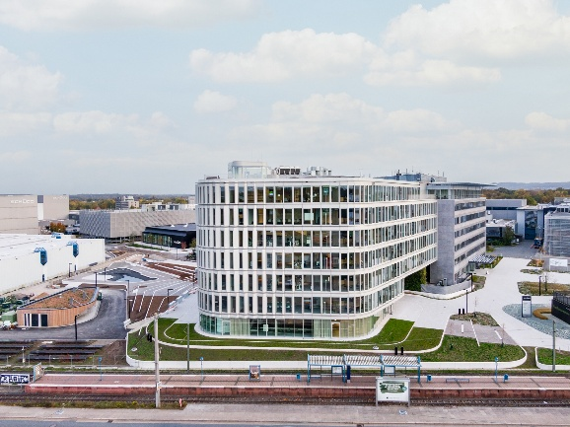
In 2025, Schüco achieved a turnover of €2.06 billion with 6750 employees.

Photographer: Frank Peterschröder
Usage rights: Schüco International KG
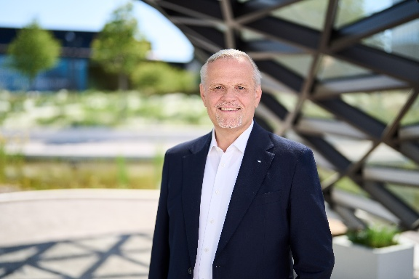
Andreas Engelhardt, Managing Partner of Schüco International KG.

Picture Credits: Schüco International KG
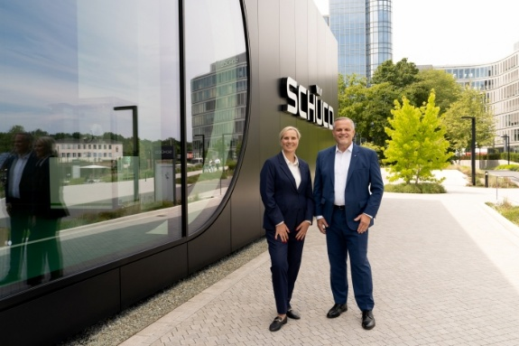

Sandra Greiser, Company Spokesperson and Andreas Engelhardt, Managing Partner of Schüco International KG.

