Press release  July 2026 |  | Further information about publication:  Schüco International KG  Sandra Greiser  Karolinenstr. 1 - 15  33609 Bielefeld, Germany  Tel.: +49 (0)521 783-1174  E-mail: PR@schueco.com  www.schueco.com/press  www.schueco.com/press

Symbolic Key Handover at the Schüco Campus in Bielefeld
Schüco expands fleet with its first fully electric trucks

Bielefeld. Schüco continues to invest in the future of its logistics operations: With the official handover of three fully electric Mercedes-Benz eActros 600 trucks, the company has reached an important milestone on its path toward a sustainable transportation strategy. The vehicles were officially handed over by BERESA during a symbolic key handover ceremony at the Schüco Campus in Bielefeld on July 2, 2026.

The new electric trucks complement Schüco’s fleet of 56 vehicles and will in future be used for regional transport, factory logistics and scheduled long-distance journeys. With a range of up to 500 kilometres per charge, they are already well suited to numerous day-to-day logistics requirements.

Contributing to climate targets and economic efficiency
The electrification of the fleet is a key component of Schüco’s sustainability strategy. Each of the new vehicles can save around 60 tonnes of CO₂ annually. In addition to reducing emissions, the company is also pursuing economic objectives: lower energy and maintenance costs, as well as long-term protection against rising CO₂ prices.

The switch to alternative drive systems is a key component in achieving our climate targets,” said Stefanie Hirschmann, COO of the Metal Division at Schüco International KG. “At the same time, we are strengthening our competitiveness, as sustainable logistics is becoming an increasingly important criterion for customers and business partners.

Environmentally friendly supply chains are gaining particular importance in international markets such as Scandinavia and the Netherlands.

Gradual expansion of the electric fleet
Schüco plans to gradually increase the proportion of electric commercial vehicles over the coming years. This depends, amongst other things, on positive practical experience and the expansion of the charging infrastructure. At its Bielefeld site, the company is currently installing a charging station specifically designed for electric trucks, which is expected to become operational in October. In addition, external charging points will be utilized.

Charging times vary – depending on the charging power – between approximately one and eight hours. Whenever possible, the vehicles will be charged using electricity generated from renewable energy sources, including through an existing agreement with Stadtwerke Bielefeld.

New challenges – and opportunities – for drivers
The introduction of electric trucks is also transforming the role of professional drivers. In addition to their traditional responsibilities, drivers receive training in charging procedures, range management, and energy-efficient driving techniques. At the same time, the new technology offers advantages in day-to-day operations, including quieter driving conditions and modern vehicle systems.

Schüco is also using this transition as an opportunity to further enhance the attractiveness of the profession and attract new skilled workers. In addition to its male drivers, the team already includes three female drivers. The company is also investing in the training and development of future talent in this field.

“The transformation of logistics is not only about technology, but above all about the people behind it,” said Kai Schürmann, Head of Metal Construction Logistics at Schüco. “We want to provide our drivers with modern, future-proof workplaces while inspiring new talent to pursue this important profession.”
Practical experience shapes the transition
When introducing electric trucks, Schüco is deliberately relying on practical experience. Insights gained through collaboration with logistics partners, as well as early experiences from other companies, have been incorporated into the decision-making process.

Current challenges include, in particular, charging planning, range management and the availability of external charging infrastructure. Longer delivery times for charging equipment also posed a problem in the run-up to the launch.

Sustainable logistics as part of the overall strategy
By integrating electric trucks, Schüco is underlining its commitment to consistently advancing sustainability across all areas of the business – from product development to delivery. At the same time, the company is continuously working to optimise transport routes and is also exploring complementary propulsion technologies such as hydrogen for specific applications.

The addition of these vehicles therefore marks not only a technological advancement, but also an important step towards a more sustainable and future-proof logistics operation at Schüco.

Schüco – System solutions for windows, doors and façades
Based in Bielefeld, the Schüco Group develops and sells system solutions made of aluminium, steel and PVC-U for the building envelope. The product portfolio includes window, door, façade, ventilation, security and sun shading systems, as well as intelligent networked solutions for residential and commercial projects. Schüco also provides consultancy and digital solutions for all phases of a building project – from the initial idea through to design, fabrication and installation, as well as after sales with maintenance and servicing. Fabrication machinery and customer-oriented service complement the product portfolio. As one of the leading companies in the construction industry, Schüco is committed to being a pioneer for comprehensive sustainability and to making an active contribution to climate neutrality and the circular economy within the construction sector through its products and services. Founded in 1951, Schüco is now active in more than 80 countries and achieved a turnover of 2.05 billion euros in 2024 with 6850 employees. For more information, visit www.schueco.com

High-resolution pictures are available to download in the Schüco Newsroom at www.schueco.de/presse.

Picture credits: Schüco International KG

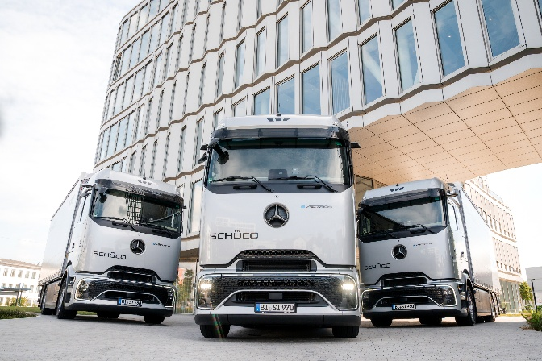
With the official handover of three fully electric Mercedes-Benz eActros 600 trucks, the company has reached an important milestone on its path toward a sustainable transportation strategy.

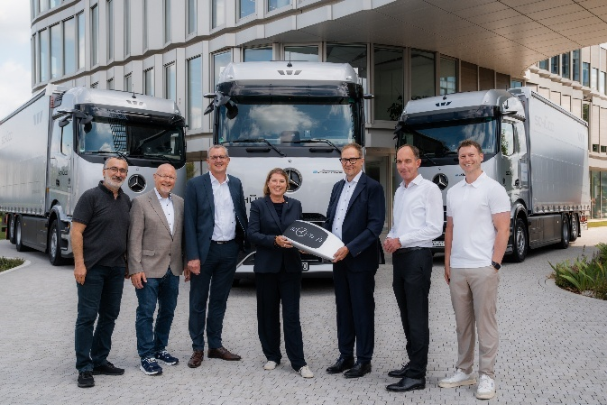

Symbolic Key Handover at the Schüco Campus in Bielefeld

From left to right: Ismail Ertürk, Head of Transport Logistics, Schüco International KG; Peter Janz, BERESA; Jörg Heidemann, BERESA; Stefanie Hirschmann, COO Metal Division, Schüco International KG; Norbert Bökamp, BERESA; Kai Schürmann, Head of Logistics Metal Division, Schüco International KG; David Luka Bartels, Fleet Coordinator, Schüco International KG

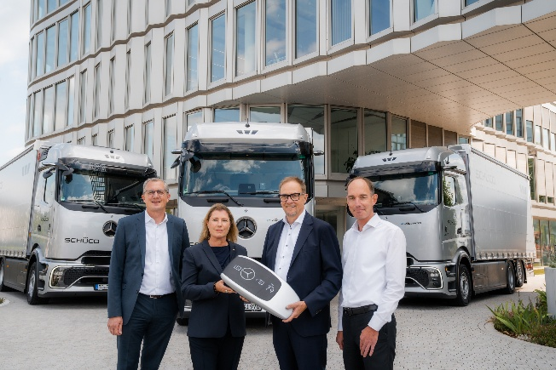

Symbolic Key Handover at the Schüco Campus in Bielefeld

From left to right: Jörg Heidemann, BERESA; Stefanie Hirschmann, COO Metal Division, Schüco International KG; Norbert Bökamp, BERESA; Kai Schürmann, Head of Logistics Metal Division, Schüco International KG

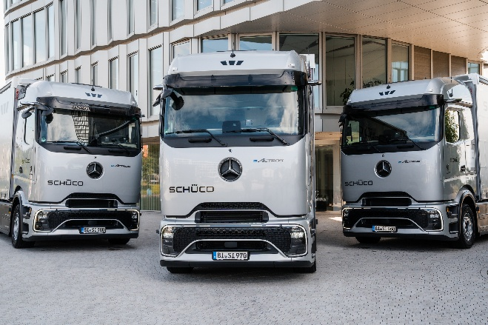
With the official handover of three fully electric Mercedes-Benz eActros 600 trucks, the company has reached an important milestone on its path toward a sustainable transportation strategy.

