Press release  June 2026 |  | Further information about publication:  Schüco International KG  Ute Minartz  Karolinenstr. 1 - 15  33609 Bielefeld, Germany  Tel.: +49 (0)521 783-6307  E-mail: PR@schueco.com  www.schueco.com/press  www.schueco.com/press

Forward-mounted – rear-ventilated – energy-generating:

Schüco AF VC ventilated façade

Bielefeld. When it comes to the decarbonisation of buildings, forward-mounted and rear-ventilated façades offer clear advantages – and not just because of their functional separation. The Schüco AF VC (Aluminium Façade Ventilated Construction) façade construction also enables the integration of Schüco BIPV (building-integrated photovoltaics) to generate your own energy and as a visual statement of energy efficiency and sustainable architecture. Furthermore, this C2C-certified façade system is well suited to both newbuilds and renovation projects.

Schüco AF VC is based on a mullion-transom substructure, which functions as a load-bearing frame and attaches the façade units securely to the building via brackets. This substructure consists of vertical mullions and horizontal transoms that are joined together by means of connectors. A range of different materials, colours and surface finishes allows virtually every requirement to be fulfilled, enabling not only protection against weathering to be provided but also aesthetic and functional aims to be achieved with a single system. In this context, it is particularly important to mention the integration of Schüco BIPV modules as a design feature, as they offer the significant added benefit of generating your own energy directly within the façade. This helps to reduce the operating costs and CO₂ emissions of a building for the long term. Another benefit for all those involved in the project is that both constructions come from a single source and are precisely tailored to one another.

Four design options
Based on a single substructure system, the Schüco AF VC forward-mounted, rear-ventilated façade solution is available in the “concealed fixing”, “point fixing”, “full-frame fixing” and “two-sided fixing” design options. Schüco BIPV modules can be used with all four versions.

The “concealed fixing” option provides a high level of design freedom and can be used to create particularly elegant and uniform surfaces. The “point fixing” version is particularly well-suited to façades aiming to create a sleek, open appearance through individual, visible fixing points. The “full-frame fixing” design option is perfect for façades intended to stand out with a clean, geometric structure and a modern, uniform appearance. And the “two-sided fixing” version is ideal for the spandrel area below ribbon windows.

A wide variety of possible combinations
The Schüco AF VC ventilated façade system, which can be adapted to meet a range of different usage and design requirements, integrates seamlessly – both visually and technically – with Schüco non-ventilated façades, ribbon windows, windows or the Schüco Perfect modular all-in-one solution. Schüco Perfect consists of a window unit and a façade-mounted Perfect module, for which various add-ons (sun shading, flyscreen, safety barrier, window sills) can be selected.

Some useful information: When used as part of a building renovation, the Schüco AF VC façade construction constitutes an individual measure that is eligible for subsidies – for example, for material or labour costs. The system also features low fabrication and installation work coupled with the extensive use of identical parts and minimal use of materials for the load-bearing structure.

More detailed technical information about the façade system is available for design and architectural practices as well as specialist metal fabrication companies at www.schueco.de/af-vc.

Schüco – System solutions for windows, doors and façades
Based in Bielefeld, the Schüco Group develops and sells system solutions made of aluminium, steel and PVC-U for the building envelope. The product portfolio includes window, door, façade, ventilation, security and sun shading systems, as well as intelligent networked solutions for residential and commercial projects. Schüco also provides consultancy and digital solutions for all phases of a building project – from the initial idea through to design, fabrication and installation, as well as after sales with maintenance and servicing. Fabrication machinery and customer-oriented service complement the product portfolio. As one of the leading companies in the construction industry, Schüco is committed to being a pioneer for comprehensive sustainability and to making an active contribution to climate neutrality and the circular economy within the construction sector through its products and services. Founded in 1951, Schüco is now active in more than 80 countries and achieved a turnover of 2.05 billion euros in 2024 with 6850 employees. For more information, visit www.schueco.com

High-resolution pictures are available to download in the Schüco Newsroom at www.schueco.de/presse.

Picture credits: Schüco International KG
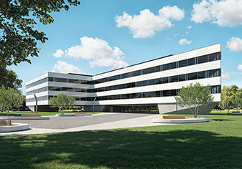
The Schüco AF VC forward-mounted, rear-ventilated façade protects against a range of weather influences, offers individual design options and utilises solar energy to generate power when coupled with the integration of Schüco BIPV modules.

Picture credits: Schüco International KG
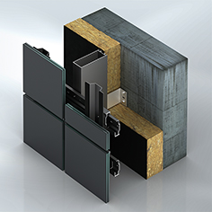
Concealed fixing design option: Here the façade units are installed with no additional frame construction. The individual BIPV modules or infill units are attached directly to the mullion-transom construction by means of a backrail system; the fixing components are concealed and therefore lend the façade a flush appearance.

Picture credits: Schüco International KG
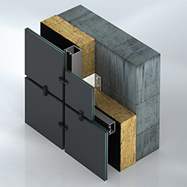
Point fixing design option: With this version, the façade units are fixed to the substructure by means of point fasteners. This type of fixing enables flexible and fast installation, without requiring a full frame.

Picture credits: Schüco International KG
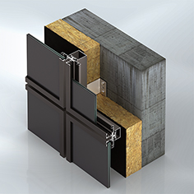
Full-frame fixing design option: With this version, infill units or BIPV modules are set in a stable frame, which holds the units securely in place. The frame is made from aluminium and ensures the precise fixing of the infill units and an even distribution of the load.

Picture credits: Schüco International KG
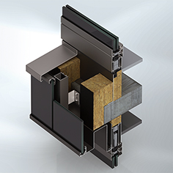
Two-sided fixing design option: For this, infill units or BIPV modules are held in place by aluminium strips on two sides arranged in a linear pattern. These bars running horizontally are fixed to the substructure. This type of fixing enables flexible and fast installation of the panels/modules, without requiring a full frame.

