Press release  May 2026 |  | Further information about publication:  Schüco International KG  Sandra Greiser  Karolinenstr. 1 – 15  33609 Bielefeld, Germany  Tel.: +49 (0)5217831174  E-mail: PR@schueco.com  www.schueco.de/presse  www.schueco.com/press

Foundation of a new Schüco subsidiary
Schüco Polymer Iberia S.L. strengthens PVC-U business in Spain and Portugal

Weißenfels/Valdemoro. With effect from 1 May 2026, Schüco Polymer Technologies KG is bringing together its PVC-U business in Spain and Portugal under the newly founded subsidiary, Schüco Polymer Iberia S.L. In doing so, the company is strengthening its presence on the Iberian peninsula and laying the foundations for an even more robust, market-specific product offering.

Schüco Polymer Iberia S.L. will take over the PVC-U business of Schüco Polymer Technologies KG in Spain and Portugal as of 1 May 2026. The aim of the new company is to further support and develop its partners in the Iberian markets and to strategically expand its service portfolio. The focus is on premium system solutions, even more flexible logistics and an enhanced range of services.

“With the foundation of Schüco Polymer Iberia S.L., we are making a decisive step towards strengthening our presence in Spain and Portugal. Greater proximity, service and added value for our partners,” explains Ricardo González, Head of the Polymer Iberia business unit at Schüco Polymer Iberia S.L.

The headquarters of Schüco Polymer Iberia S.L. are situated at the existing Schüco site in Valdemoro, which is in the greater Madrid area of Spain. This site features modern office spaces and a showroom. In addition, a new logistics hub with integrated warehouse for PVC-U systems will be constructed. This will enable the product portfolio to be specifically tailored to regional market requirements and will ensure faster availability.

The established teams in Valdemoro and Weißenfels, as well as close collaboration with the Schüco Iberia S.L. metal fabrication business, will continue to ensure reliable support for Schüco partners in future, too. In the process of setting up the new company, human resource capacities were strategically realigned and expanded in some areas, in order to further improve service quality and logistics performance.

www.schueco.com

Schüco – System solutions for windows, doors and façades
Based in Bielefeld, the Schüco Group develops and sells system solutions for the building envelope made from aluminium, steel and PVC-U. The product range includes window, door, façade, ventilation, security and sun shading systems as well as smart and networked solutions for residential and commercial projects. Schüco also offers consultation and digital solutions for all phases of a building project – from the initial idea, design, fabrication and installation all the way through to the after-sales service including maintenance and servicing. Fabrication machinery and excellent customer service complement the product range. As a leading company in the construction industry, Schüco is committed to being a pioneer in holistic sustainability and using its products and services to make an active contribution towards achieving climate neutrality and a circular economy in the building trade. Founded in 1951, Schüco is now active in more than 80 countries and achieved a turnover of 2.05 billion euros in 2024 with 6850 employees.
For more information, visit www.schueco.com

High resolution images are available to download in the Schüco Newsroom at www.schueco.com/press.

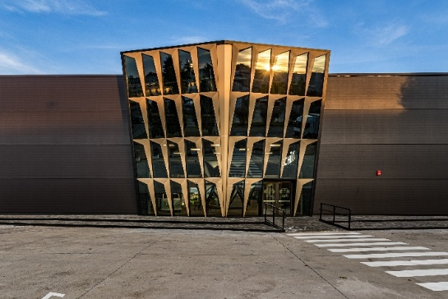
Usage rights: Schüco International KG

Schüco Polymer Iberia headquarters at the Schüco site in Valdemoro, south of Madrid.

Usage rights: Schüco International KG
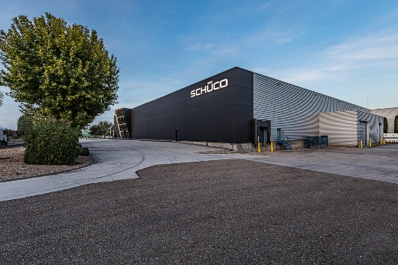

Regional warehouse and central logistics hub for PVC-U systems of Schüco Polymer Iberia S.L. in Valdemoro, Madrid.

Photographer: Matthias Schrumpf
Usage rights: Schüco Polymer Technologies KG


Ricardo González, Head of the Polymer Iberia business unit at Schüco Polymer Iberia S.L.

