Project report  April 2026 |  | Further information about publication:  Schüco International KG  Ute Minartz  Karolinenstr. 1 – 15  33609 Bielefeld  Tel.: + 49 (0) 521 783-6307  E-mail: PR@schueco.com  www.schueco.de/presse  www.schueco.com/press

76 Southbank, London/GB
Brutalist icon skilfully revitalised

Bielefeld. The former IBM headquarters building on London's South Bank is a prominent example of Brutalist architecture in the UK. In recent years, the listed complex has been sensitively extended, updated for energy efficiency and adapted to meet the requirements of a modern office environment – all while taking sustainability into account and with respect for its architectural significance.

Iconic ensemble under scrutiny
The dynamic South Bank area on the southern banks of the River Thames is at the heart of London's cultural scene. Among the most significant cultural establishments is the National Theatre, situated directly on the banks of the River Thames and constructed in 1976 in line with English architect Denys Lasdun's design. In 1983, Lasdun completed his architectural/urban planning vision on the neighbouring plot with the construction of the IBM Marketing Centre. The two buildings impress as a late Brutalist ensemble with strict horizontal lines, rough exposed concrete surfaces and imposing concrete structures. The symmetry of the two buildings delicately balanced by Lasdun can still be admired today from nearby Waterloo Bridge.
To prevent its partial demolition after IBM moved out, the City of London granted the former IBM building listed status in 2020, as it had the National Theatre in 1994. London-based architectural practice AHMM revised its conversion concept and promised a respectful renovation and the retention of 80% of the original fabric of the building.

Further development as a strategic aim
The asymmetric building structure of the old IBM complex featured offset storeys to the north and south, which created wide terraces. Two inner courtyards provided natural light in the office storeys. Brown bricks were applied beneath podium level, while in the upper storeys the continuous ribbon windows and exposed aggregate concrete spandrels matched the horizontal lines of the adjacent theatre. Plant towers with a pure concrete appearance formed sculptural elements on the roof.
For the strategic development of the project by Stanhope PLC, the project now known as “76 Southbank” provided all the key aspects for a site remodelling geared towards sustainability: retention of the existing structure and value enhancement through renovation, as well as revitalisation and reinvention of a building steeped in history in accordance with listed building requirements, with major benefits for urban renewal.

Analysis of the existing building and new plans
The new concept from AHMM envisaged a sensitive modernisation for the “76 Southbank” office complex. Following a low-carbon core renovation and energy efficiency upgrade, the floor space was to be increased by 11,000 m² by adding a new storey on top and by extending out to the south and east, creating new highly efficient, flexibly designed office spaces. To meet the exacting sustainability targets, the embedded carbon emissions in the existing building and the amount of waste generated during gutting needed to be reduced as much as possible. To do this, all of the construction materials from the existing structure and for the newbuild were subject to a comprehensive assessment with regard to their ecological footprint, with some extensive environmental compatibility tests being carried out if there were no EPDs available.

Carbon reduction during the renovation
Despite completely gutting and dismantling the basement and ground floor, it was possible to retain 80% of the concrete structure and therefore prevent carbon emissions that would have been caused by demolition. Over 200 façade units made from concrete or granite weighing up to 10 tonnes were dismantled and either reused in the project or elsewhere; as were 27,360 floor tiles, 95 tonnes of paving stones and 71 tonnes of bricks. New foundations were laid and new concrete supports were installed, with ground granulated blast furnace slag sand replacing 50% of the cement. Recycled steel beams and supports weighing a total of 42 tonnes were installed and recycled steel was also used for the cavity flooring in the offices. The Ultra Low Carbon aluminium from Schüco has saved over 100 tonnes of carbon emissions when compared to standard aluminium – which has had a positive impact on the carbon footprint for the Life Cycle Assessment (LCA) of the building. The annual carbon savings are equivalent to 425,000 m² of native forest.

Façade reduces carbon emissions
The façade accounts for a considerable proportion of the embodied carbon in the renovation project. That's why the construction of the new façade was so important when it came to meeting the sustainability targets. When dismantling the façade, it was possible to retain 62 of the listed façade panels and 20 core façade panels and reuse them in the reconstruction of the façade; all of the other concrete façade units had to be made from scratch. For the new exposed aggregate concrete panels, gravel from the original stone quarry was used and applied by hand.

Schüco supported the façade construction company Dane Architectural during the early analysis of the existing building by providing project-specific EPDs via the SchüCal calculation software and, in doing so, enabled the precise analysis and assessment of the carbon footprint of the window profiles. Another focus of the collaboration was the use of recycled materials on the project. “We met the high sustainability requirements with our Schüco ULC aluminium profiles which have an extremely low carbon footprint,” explains Stephen Newell, National Specification Manager for UK and Ireland. “The profiles have a GWP value of less than 1.99 kg CO₂ e per kg of aluminium and are manufactured from at least 75% recycled post-consumer material.” The façade of “76 Southbank” was constructed using the Schüco FWS 60.SI mullion/transom system in the version with surface-mounted cover strips. The Ultra Low Carbon (ULC) aluminium delivered by Schüco in accordance with the allotment process contributed to a saving of 100 tonnes of CO₂ in the carbon footprint.

Fit for the future – a new lease of life for an old building
The successful transformation has already received two awards*. With their innovative renovation strategy and respectful remodelling concept, the project stakeholders have given the concrete icon a bright future. “76 Southbank” expresses its gratitude with landscaped green façades and external terraces and an inviting entrance area, thereby ensuring new acceptance of austere concrete architecture in the creative quarters of the city.

Project details
Object: 76 Southbank
Location: 76 Southbank Upper Ground, London GB
Owner/developer: Wolfe Commercial Properties Southbank Ltd., London/GB
UK delivery partner: Stanhope PLC, London/GB
Architect: AHMM Allford Hall Monaghan Morris, London/GB
Main contractor: Multiplex, London/GB
Façade construction: Dane Architectural Systems Holdings Limited, Newcastle upon Tyne/GB
Certifications: BREEAM Outstanding for Office and Excellent for Retail Space, Nabers Design for Performance Standard 5* Rating, EPC A, Well v2 Rating
*Awards: 2024 WAFX Award – Reuse, 2022 New London Award for Conservation
Completion date: 2025

Schüco systems used
Mullion/
transom façade: Schüco FWS 50, FW 50⁺ SG, FWS 50.SI, FWS 60.SI
Windows: Schüco AWS 70.HI
Doors: Schüco ADS 90.SI/PL.SI, AD UP 75
Unitised façade: Schüco USC 65
Sun shading: Schüco ALB large louvre blade
Fire protection: Schüco ADS 80 FR30
Building automation: Access management, monitoring of opening and closing (magnetic switch)

Schüco – System solutions for windows, doors and façades
Based in Bielefeld, the Schüco Group develops and sells system solutions made of aluminium, steel and PVC-U for the building envelope. The product portfolio includes window, door, façade, ventilation, security and sun shading systems, as well as intelligent networked solutions for residential and commercial projects. Schüco also provides consultancy and digital solutions for all phases of a building project – from the initial idea through to design, fabrication and installation, as well as after sales with maintenance and servicing. Fabrication machinery and customer-oriented service complement the product portfolio. As one of the leading companies in the construction industry, Schüco is committed through its products and services to being a pioneer for comprehensive sustainability and actively contributing to climate neutrality and the circular economy within the construction sector. Founded in 1951, Schüco is now active in more than 80 countries and achieved a turnover of 2.05 billion euros in 2024 with 6850 employees.
For more information, visit www.schueco.com

High resolution images are available to download in the Schüco Newsroom at www.schueco.de/presse.

Photographer: Rob Parrish
Usage rights: Schüco International KG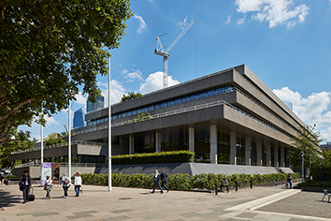
With extensively landscaped façades and external terraces and an inviting entrance area, 76 Southbank ensures new acceptance of the austere concrete architecture in the creative quarters of the city.

Copyright: Secchi Smith
Usage rights: Schüco International KG
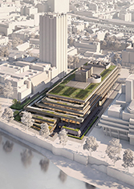
The revised renovation plan by AHMM Architects envisages an additional storey on top of the original 5 storey IBM building.

Photographer: Rob Parrish
Usage rights: Schüco International KG
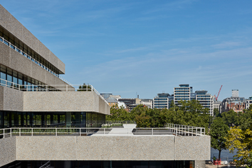
The strict Brutalist structure has been transformed into a sustainable, modern office building with a sensitive design and a successful landscaping concept.

Photographer: Rob Parrish
Usage rights: Schüco International KG
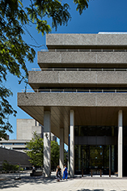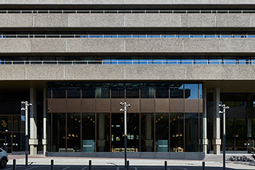
The newly designed ground floor aims to enhance the area surrounding the building and secure the pedestrianised access.

Photographer: Rob Parrish
Usage rights: Schüco International KG
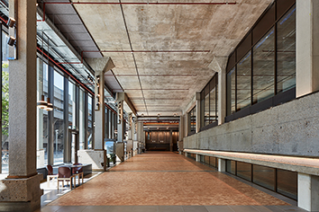
The interior has been completely redesigned and enables highly efficient, flexible use of the offices with state-of-the-art technologies.

