Project report  April 2026 |  | Further information about publication:  Schüco International KG  Ute Minartz  Karolinenstr. 1 – 15  33609 Bielefeld  Tel.: + 49 (0) 521 783-6307  E-mail: PR@schueco.com  www.schueco.de/presse  www.schueco.com/press

76 Southbank, London/GB
Brutalist icon skilfully revitalised

Bielefeld. The former IBM headquarters building on London's South Bank is a prominent example of Brutalist architecture in the UK. In recent years, the listed complex has been sensitively extended and adapted to meet the requirements of a modern office environment – whilst preserving the existing structure and carrying out energy-efficiency improvements, and with respect for its architectural significance.

Iconic ensemble under scrutiny
The dynamic South Bank area on the southern banks of the River Thames is at the heart of London's cultural scene. Among the most significant cultural establishments is the National Theatre, situated directly on the banks of the River Thames and constructed in 1976 in line with English architect Denys Lasdun's design. In 1983, Lasdun completed his architectural/urban planning vision on the neighbouring plot with the construction of the IBM Marketing Centre. The two buildings impress as a late Brutalist ensemble with strict horizontal lines, rough exposed concrete surfaces and imposing concrete structures. The symmetry of the two buildings delicately balanced by Lasdun can still be admired today from nearby Waterloo Bridge.
To prevent its partial demolition after IBM moved out, the City of London granted the former IBM building listed status in 2020, as it had the National Theatre in 1994. London-based architectural practice AHMM revised its conversion concept and promised a respectful renovation and the retention of 80% of the original fabric of the building.

Further development as a strategic aim
The asymmetric building structure of the old IBM complex featured offset storeys to the north and south, which created wide terraces. Two inner courtyards provided natural light in the office storeys. Brown bricks were applied beneath podium level, while in the upper storeys the continuous ribbon windows and exposed aggregate concrete spandrels matched the horizontal lines of the adjacent theatre. Plant towers with a pure concrete appearance formed sculptural elements on the roof. For Stanhope PLC’s strategic project development, the project – now known as ‘76 Southbank’ – brought together key requirements for the regeneration of a listed building complex: preserving the building’s integrity, revitalising it in accordance with heritage conservation principles, and reinventing a historic building, all of which would bring significant benefits to urban regeneration.

Analysis of the existing building and new plans
The new concept from AHMM envisaged a sensitive modernisation for the “76 Southbank” office complex. Following the complete renovation, the floor space was to be increased by 11,000 m² by adding a new storey on top and by extending out to the south and east, creating new highly efficient, flexibly designed office spaces. In order to reduce the CO₂ emissions embodied in the building fabric and the volume of waste generated during the gutting process, all building materials – both those from the existing building and those for the new development – were subjected to a comprehensive assessment, and in some cases detailed environmental impact assessments were carried out where Environmental Product Declarations (EPDs) were not available.

Carbon reduction during the renovation
Despite completely gutting and dismantling the basement and ground floor, it was possible to retain 80% of the concrete structure. Over 200 façade units made from concrete or granite weighing up to 10 tonnes were dismantled and either reused in the project or elsewhere; as were 27,360 floor tiles, 95 tonnes of paving stones and 71 tonnes of bricks. New foundations were laid and new concrete supports were installed, with ground granulated blast furnace slag sand replacing 50% of the cement. Recycled steel beams and supports weighing a total of 42 tonnes were installed. The ultra-low-carbon aluminium used by Schüco has a GWP of 1.99 kg CO₂e/kg of profile and has therefore saved over 100 tonnes of CO₂ emissions compared with Schüco’s standard aluminium profile, according to the EPD. *

Façade design
The façade is a key component of the building envelope, which is why its design and construction were of particular importance in this project. The aim was to ensure that the façade design was in line with the project’s defined requirements. When dismantling the façade, it was possible to retain 62 of the listed façade panels and 20 core façade panels and reuse them in the reconstruction of the façade; all of the other concrete façade units had to be made from scratch. For the new exposed aggregate concrete panels, gravel from the original stone quarry was used and applied by hand.

Even during the baseline analysis, Schüco supported the façade contractor Dane Architectural by providing project-specific EPDs via the SchüCal estimation software. The data provided served as the basis for analysing and assessing the environmental impact of the window profiles used. Another focus of the collaboration was the use of recycled materials on the project. “Schüco Ultra Low Carbon aluminium profiles were used to meet the project-specific requirements,” explains Stephen Newell, National Specification Manager for UK and Ireland. “According to the EPD, these profiles have a global warming potential of 1.99 kg CO₂e/kg of aluminium and consist of at least 75 per cent recycled post-consumer material.” * The façade of “76 Southbank” was constructed using the Schüco FWS 60.SI mullion/transom system in the version with surface-mounted cover strips.

Fit for the future – a new lease of life for an old building
The successful transformation has already received two awards*. With their innovative renovation strategy and respectful remodelling concept, the project stakeholders have given the concrete icon a bright future. “76 Southbank” expresses its gratitude with landscaped green façades and external terraces and an inviting entrance area, thereby ensuring new acceptance of austere concrete architecture in the creative quarters of the city.

* The supply of ultra-low-carbon aluminium is carried out in accordance with the Schüco quota system. This means that no distinction is made between material grades at the time of delivery. The profiles supplied may be made of standard, low
carbon, ultra-low-carbon or ultra-low-carbon+ aluminium, regardless of the specific order. The environmental performance figures stated relate to the quantity of material allocated under the quota system.

Project details
Object: 76 Southbank
Location: 76 Southbank Upper Ground, London GB
Owner/developer: Wolfe Commercial Properties Southbank Ltd., London/GB
UK delivery partner: Stanhope PLC, London/GB
Architect: AHMM Allford Hall Monaghan Morris, London/GB
Main contractor: Multiplex, London/GB
Façade construction: Dane Architectural Systems Holdings Limited, Newcastle upon Tyne/GB
Certifications: BREEAM Outstanding for Office and Excellent for Retail Space, Nabers Design for Performance Standard 5* Rating, EPC A, Well v2 Rating
*Awards: 2024 WAFX Award – Reuse, 2022 New London Award for Conservation
Completion date: 2025

Schüco systems used
Mullion/
transom façade: Schüco FWS 50, FW 50⁺ SG, FWS 50.SI, FWS 60.SI
Windows: Schüco AWS 70.HI
Doors: Schüco ADS 90.SI/PL.SI, AD UP 75
Unitised façade: Schüco USC 65
Sun shading: Schüco ALB large louvre blade
Fire protection: Schüco ADS 80 FR30
Building automation: Access management, monitoring of opening and closing (magnetic switch)

Schüco – System solutions for windows, doors and façades
Based in Bielefeld, the Schüco Group develops and sells system solutions made of aluminium, steel and PVC-U for the building envelope. The product portfolio includes window, door, façade, ventilation, security and sun shading systems, as well as intelligent networked solutions for residential and commercial projects. Schüco also provides consultancy and digital solutions for all phases of a building project – from the initial idea through to design, fabrication and installation, as well as after sales with maintenance and servicing. Fabrication machinery and customer-oriented service complement the product portfolio. Founded in 1951, Schüco is now active in more than 80 countries and achieved a turnover of 2.05 billion euros in 2024 with 6850 employees.
For more information, visit www.schueco.com

High resolution images are available to download in the Schüco Newsroom at www.schueco.de/presse.

Photographer: Rob Parrish
Usage rights: Schüco International KG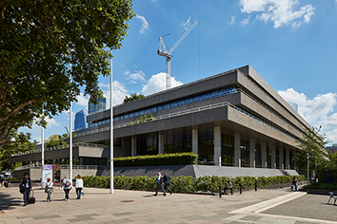
With extensively landscaped façades and external terraces and an inviting entrance area, 76 Southbank ensures new acceptance of the austere concrete architecture in the creative quarters of the city.

Copyright: Secchi Smith
Usage rights: Schüco International KG
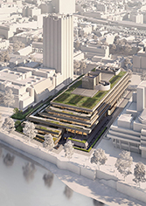
The revised renovation plan by AHMM Architects envisages an additional storey on top of the original 5 storey IBM building.

Photographer: Rob Parrish
Usage rights: Schüco International KG
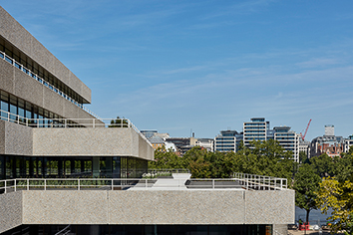
The strict Brutalist structure was retained and transformed through a successful landscaping scheme.

Photographer: Rob Parrish
Usage rights: Schüco International KG
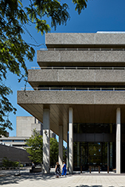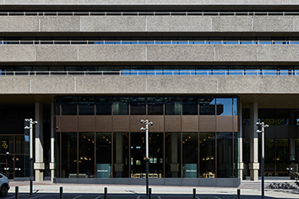
The newly designed ground floor aims to enhance the area surrounding the building and secure the pedestrianised access.

Photographer: Rob Parrish
Usage rights: Schüco International KG
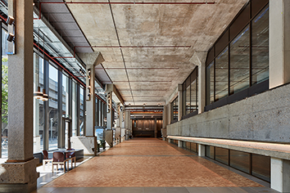
The interior has been completely redesigned and enables highly efficient, flexible use of the offices with state-of-the-art technologies.

