Press release  March 2026 |  | Further information about publication:  Schüco International KG  Ute Minartz  Karolinenstr. 1 – 15  33609 Bielefeld, Germany  Tel.: +49 (0)521/783-6307  E-mail: PR@schueco.com  www.schueco.com/press  www.schueco.com/press

Schüco Homes

Simply better living

Bielefeld. Windows, doors, and sliding doors shape our homes in many ways. They let in natural light, create pleasant room acoustics, protect what matters to us and can help to reduce a building’s energy consumption. They therefore have a significant impact on how comfortable we feel in our own homes. Whether it’s a new build or a renovation, “Schüco Homes” brings innovative technology to life.

Reading a book in peace whilst traffic flows by outside, enjoying cosy warmth on cold days or opening large sliding doors effortlessly – windows, doors and sliding doors have an enormous impact on the quality of our homes and lives. With your own construction or modernisation project, key questions therefore need to be addressed early on. How do windows contribute to comfort? What constitutes a good window design? What is the ideal way to combine security and convenience?

Dimensions of living
Effective thermal insulation (Schüco Insulation) helps to maintain a comfortable indoor temperature. The Schüco FocusIng MD (centre seal) window system achieves thermal insulation values of up to 1.0 W/(m²K) and is therefore suitable for building projects with high thermal insulation requirements.

Effective burglar resistance (Schüco Secure) is a key element in protecting people and property, ensuring that the building occupants feel safe and secure. In residential construction, burglar resistance to class RC 2 is generally sufficient and can be installed in all standard window, door and sliding door units from Schüco.

For effective interior design, floor-to-ceiling opening units can maximise the amount of (natural) light entering a space (Schüco Style). Light triggers the release of serotonin in the body – which, in turn, can have a positive effect on the user’s mood. The new Schüco LivIngSlide Perfect lift-and-slide door (with level threshold) impresses in terms of design and aesthetics.

Effective sound reduction (Schüco Silence) reduces the impact of outside noise in living spaces. For the building occupants, this improves their well-being as pleasant room acoustics enhance concentration, promote relaxation and convey a sense of privacy and comfort. Windows and sliding doors from the Schüco FocusIng system family can be installed with sound insulation of up to 48 dB, making them suitable even for projects with high sound reduction requirements.

Additional features: barrier-free access (Schüco Access), sun shading (Schüco Shade), ventilation (Schüco Airflow), and ease of use (Schüco Smart).

Personalised approach to clients
Whether it’s Panorama Design windows, doors with enhanced burglar resistance or sliding doors with convenient opening and closing options, Schüco helps turn your individual ideas into concrete product solutions – in person at the Schüco showrooms or online from the comfort of your own home. Thanks to the Schüco Configurator, you can easily record and configure your specific wishes and needs and turn them into a detailed enquiry without any specialist knowledge. Sound reduction, thermal insulation, security, design, barrier-free access, sun shading, ventilation and ease of use: in just a few steps, you can create a customised specification for windows, doors, or sliding units made of aluminium or PVC-U. It only takes one click to complete the configuration. This then notifies Schüco of the enquiry and a suitable partner in the region can be recommended.

www.schueco.com/homes
www.schueco-homes.de
www.schueco.com/configurator
Schüco – System solutions for windows, doors and façades
Based in Bielefeld, the Schüco Group develops and sells system solutions for the building envelope made from aluminium, steel and PVC-U. The product range includes window, door, façade, ventilation, security and sun shading systems as well as smart and networked solutions for residential and commercial projects. Schüco also offers consultation and digital solutions for all phases of a building project – from the initial idea, design, fabrication and installation all the way through to the after-sales service including maintenance and servicing. Fabrication machinery and excellent customer service complement the product range. Founded in 1951, Schüco is now active in more than 80 countries and achieved a turnover of 2.05 billion euros in 2024 with 6850 employees.
For more information, visit www.schueco.com

High resolution images are available to download in the Schüco Newsroom at www.schueco.com/press.

Picture credits: Schüco International KG
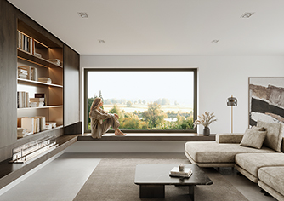
The Schüco Symbiotic hybrid design window, with its minimalist aluminium finish (outside) and high insulation PVC-U (inside) enables individual design options (Schüco Style; woman shown is AI-generated).

Picture credits: Schüco International KG
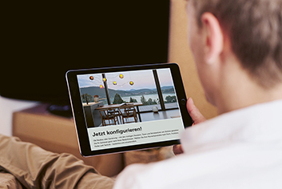
Schüco Configurator for personalised communication with clients.

Photographer: Marius Beck Dahle
Usage rights: Schüco International KG

Schüco Insulation.

Picture credits: Schüco International KG
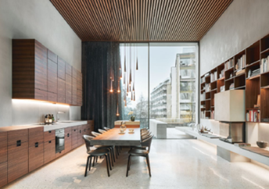
Schüco Silence: With a variety of configuration options, windows, doors, and sliding doors provide effective sound reduction in different insulation classes, which is particularly important in urban living spaces.

