Press release  March 2026 |  | Further information about publication:  Schüco International KG  Ute Minartz  Karolinenstr. 1 – 15  33609 Bielefeld, Germany  Tel.: +49 (0)521/783-6307  E-mail: PR@schueco.com  www.schueco.com/press  www.schueco.com/press

Focus on private residential construction

Schüco Homes: Architecture shapes quality of life

Bielefeld. Windows, doors, and sliding doors are architectural design elements for living spaces. They control natural light, shape acoustics, provide security and influence the energy consumption of a building. This means they have a significant impact on the individual well-being of the residents. At Fensterbau Frontale, Schüco will showcase its product portfolio for residential construction at Stand 7-507 in Hall 7. Under the umbrella of “Schüco Homes”, technical products will be presented in an engaging way – for the renovation of existing buildings as well as for new builds.

It is often only upon closer inspection that clients realise just how much of an impact windows, doors and sliding doors have on their own well-being and whether or not they want to spend time in a room. Features such as thermal insulation, burglar resistance, sound reduction or even how the light and the views are designed can significantly affect living comfort. For architects and fabricators, it is crucial to take these requirements into account at an early stage and to meet them with tailor-made solutions for their own clients. At Fensterbau Frontale, Schüco is launching its new residential campaign and demonstrating at its exhibition stand why the company is a reliable partner for residential construction.

Dimensions of living
Effective thermal insulation (Schüco Insulation) provides consistently pleasant indoor temperatures, whilst also ensuring energy efficiency and a better carbon footprint. Schüco FocusIng MD (centre gasket) will impress at Fensterbau with thermal insulation values of 1.0 W/(m²K), thereby meeting the highest energy efficiency standards.

Effective burglar resistance (Schüco Secure) is a key element in protecting people and property, ensuring that the building occupants feel safe and secure. In residential construction, burglar resistance to class RC 2 is generally sufficient and can be installed in all standard window, door and sliding door units from Schüco.

For effective interior design, floor-to-ceiling opening units can maximise the amount of (natural) light entering a space (Schüco Style). Light triggers the release of serotonin in the body – which, in turn, can have a positive effect on the user’s mood. See for yourself at the Schüco exhibition stand how the new Schüco LivIngSlide Perfect lift-and-slide door (with level threshold) impresses in terms of design and aesthetics.

Effective sound reduction (Schüco Silence) reduces the impact of outside noise in living spaces. For the building occupants, this improves their well-being as pleasant room acoustics enhance concentration, promote relaxation and convey a sense of privacy and comfort. Windows and sliding doors from the Schüco FocusIng system family can be installed with sound insulation of up to 48 dB, making them suitable even for projects with high sound reduction requirements.

Additional features: barrier-free access (Schüco Access), sun shading (Schüco Shade), ventilation (Schüco Airflow), and ease of use (Schüco Smart).

Launch of the residential campaign for end customers
The new “Schüco Homes” residential campaign that targets end consumers across all building materials will be unveiled at Fensterbau Frontale.
With a clear focus on private residential construction, the Schüco stand transforms a technical product into an emotional decision-making factor. “Schüco Homes” translates technology into quality of life, the key to more comfortable living, and with it sustainable market success. The end customer campaign is designed to consistently prioritise the perspective of the private client, increase awareness and transform value-driven communication into qualified demand. Digital touchpoints, a new website, a digital interactive configurator and contact options guide clients directly to the Schüco partner in their region – and, in turn, lead to qualified sales potential.

www.schueco.com/homes
www.schueco-homes.de
www.schueco.com/configurator

Schüco – System solutions for windows, doors and façades
Based in Bielefeld, the Schüco Group develops and sells system solutions for the building envelope made from aluminium, steel and PVC-U. The product range includes window, door, façade, ventilation, security and sun shading systems as well as smart and networked solutions for residential and commercial projects. Schüco also offers consultation and digital solutions for all phases of a building project – from the initial idea, design, fabrication and installation all the way through to the after-sales service including maintenance and servicing. Fabrication machinery and excellent customer service complement the product range. As a leading company in the construction industry, Schüco is committed to being a pioneer in holistic sustainability and using its products and services to make an active contribution towards achieving climate neutrality and a circular economy in the building trade. Founded in 1951, Schüco is now active in more than 80 countries and achieved a turnover of 2.05 billion euros in 2024 with 6850 employees.
For more information, visit www.schueco.com

High resolution images are available to download in the Schüco Newsroom at www.schueco.com/press.

Picture credits: Schüco International KG
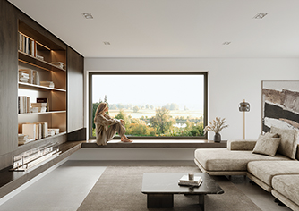
The Schüco Symbiotic hybrid design window, with its minimalist aluminium finish (outside) and high insulation PVC-U (inside) enables individual design options (Schüco Style; woman shown is AI-generated).

Picture credits: Schüco International KG
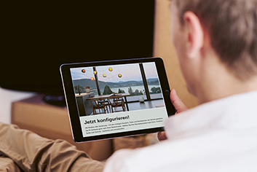
Schüco Configurator for personalised communication with clients.

Photographer: Marius Beck Dahle
Usage rights: Schüco International KG
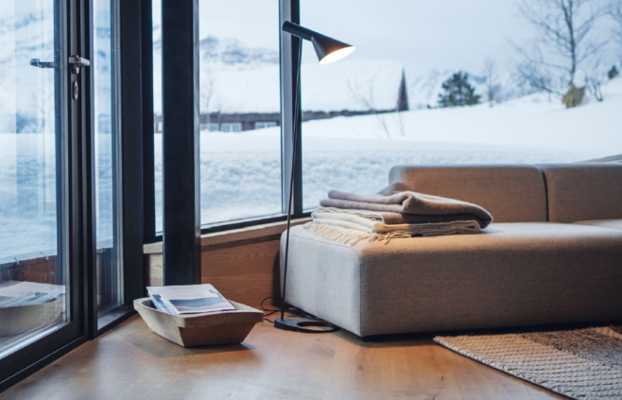
Thermal insulation with Schüco Insulation – for greater energy efficiency and comfort in your home.

Picture credits: Schüco International KG
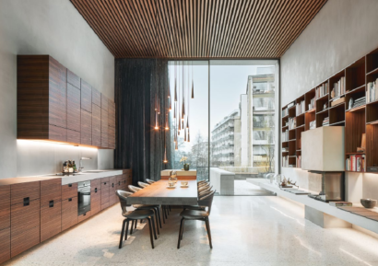
Schüco Silence: With a variety of configuration options, windows, doors, and sliding doors provide effective sound reduction in different insulation classes, which is particularly important in urban living spaces.

