Press release  March 2026 |  | Further information about publication:  Schüco International KG  Ute Minartz  Karolinenstr. 1 – 15  33609 Bielefeld, Germany  Tel.: +49 (0)521/783-6307  E-mail: PR@schueco.com  www.schueco.de/presse  www.schueco.com/press

Schüco wireless sensor for PVC-U windows
Compact monitoring of closing for smart homes

Bielefeld. With the new Schüco wireless sensor, PVC-U windows and doors become part of your smart home environment. The compact device is completely concealed when the window or door is closed and uses the Matter communication standard to communicate with conventional smart home devices from all manufacturers. The sensor is also equipped with a local alarm function.

Developed and manufactured entirely in Germany, the compact Schüco wireless sensor blends discreetly into your PVC-U windows and doors – whether installed at the factory or retrofitted. It can be installed in all Schüco windows with VarioTec Advanced fittings and, with the help of the pin adapter supplied, in all conventional windows with Euro fittings. Using a magnetic contact, the wireless sensor notifies the smart home system of the “open” or “closed” status of the units. This information then enables, for example, the automatic regulation of the heating or ventilation installations, if these are already integrated into the smart home network – even across manufacturers, thanks to the Matter standard. At the same time, the users can view the open status of their windows and doors via the smart home app at any time, anywhere they have an internet connection. A local acoustic alarm provides additional security. If the acceleration sensor integrated in the Schüco wireless sensor detects a mechanical break-in, a loud alarm sounds to scare off intruders.

Compatible with modern Matter smart home systems
Within the smart home environment, the Schüco wireless sensor communicates based on Matter, the common communication standard used by all conventional smart home manufacturers. As part of this, the wireless sensor uses the Thread network protocol, which establishes a mesh network rapidly and energy-efficiently. It makes the exchange of data faster, more stable and more user-friendly overall. Power is supplied to the Schüco wireless sensor via two standard AAA batteries. A power connection in the unit is not required. Its energy-saving operation ensures reliable performance.

www.schueco.com
www.schueco-homes.de

Schüco – System solutions for windows, doors and façades
Based in Bielefeld, the Schüco Group develops and sells system solutions for the building envelope made from aluminium, steel and PVC-U. The product range includes window, door, façade, ventilation, security and sun shading systems as well as smart and networked solutions for residential and commercial projects. Schüco also offers consultation and digital solutions for all phases of a building project – from the initial idea, design, fabrication and installation all the way through to the after-sales service including maintenance and servicing. Fabrication machinery and excellent customer service complement the product range. As a leading company in the construction industry, Schüco is committed to being a pioneer in holistic sustainability and using its products and services to make an active contribution towards achieving climate neutrality and a circular economy in the building trade. Founded in 1951, Schüco is now active in more than 80 countries and achieved a turnover of 2.05 billion euros in 2024 with 6850 employees.
For more information, visit www.schueco.com

High resolution images are available to download in the Schüco Newsroom at www.schueco.com/press

Picture credits: Schüco International KG
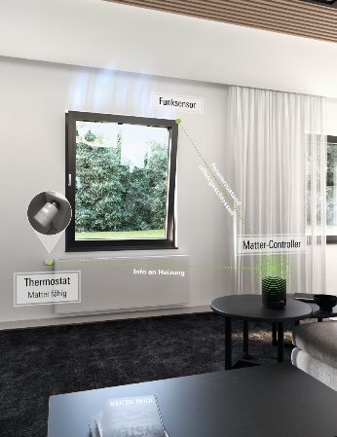
The Matter communication standard enables the Schüco wireless sensor to be integrated into virtually any conventional smart home system. The Thread network protocol allows fast and energy-saving integration into the home network.

Picture credits: Schüco International KG
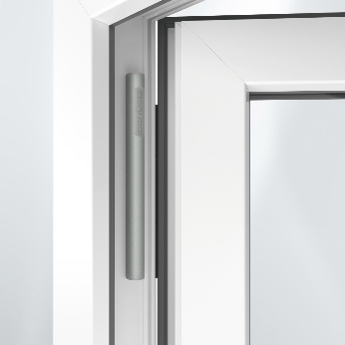
The Schüco wireless sensor is compact and can be completely concealed in all PVC-U windows and doors with VarioTec Advanced or Euro fittings. When the units are closed, the small sensor cannot be seen at all.

Picture credits: Schüco International KG
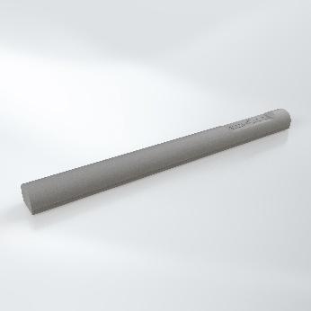
Two standard AAA batteries supply power to the energy-efficient Schüco wireless sensor. An additional power connection is not required. This makes installation easier and ensures a sleek look.

