Press release  March 2026 |  | Further information about publication:  Schüco International KG  Ute Minartz  Karolinenstr. 1 – 15  33609 Bielefeld, Germany  Tel.: +49 (0)521 783-6307  E-mail: PR@schueco.com  www.schueco.de/presse  www.schueco.com/press

Student accommodation in Créteil

Sustainable with bio-attributed PVC

Bielefeld. The new student accommodation in the French town of Créteil near Paris demonstrates that high environmental standards and economical construction do not have to be mutually exclusive. Schüco window profiles made from bio-attributed PVC contribute towards the project's low carbon footprint.

Modern architecture, generous communal areas with a gym, co-working spaces, a launderette, roof terrace, library and an adjoining relaxation area mean that the accommodation is far more than just functional housing for students. The 237 apartments, which should be completed in the autumn of 2026, offer living spaces with a high standard of comfort and quality in an architecturally appealing environment.

Despite clearly defined construction budgets, the building meets high standards in terms of energy efficiency and sustainability. “The project complies with the requirements of the RE2020 environmental building regulations, which were tightened in 2025 and are already due to be made stricter again in two years,” says architect Guillaume Margot-Duclot from the Paris-based architectural practice of the same name. The practice committed itself to decarbonisation at an early stage. Reduced use of materials, outstanding insulation and high-performance windows. “Optimisation takes place during the design phase, not afterwards,” states Margot-Duclot.

Rebate gasket system with 70 mm basic depth
The CT 70 profile system from Schüco was selected for the windows. The rebate gasket system with a basic depth of 70 mm is fitted with U_{g} = 1.0 W/(m²K) thermal insulation glass. With two continuous gasket planes and glass that is deeply set, the system achieves excellent thermal insulation of U_{w} = 1.3 W/(m²K). The narrow profiles enable large glazed areas, which capture solar heat and provide rooms with optimal levels of natural daylight.

The fabricator Claroplast supplied and installed 252 units in the student accommodation, spread across six floors. Measuring up to 1.70 x 2.00 m, the windows each consist of one or two fixed glazed sections as well as an opening vent. This enables natural ventilation for residents. Due to the building's proximity to a busy road, the units are equipped with enhanced sound reduction of R_{A,tr} = 42 dB.

Bio-attributed PVC: tall oil instead of crude oil
The special feature is that the window profiles are made from bio-attributed PVC, which substitutes fossil crude oil for tall oil. Tall oil is a renewable by-product of paper production from pine trees. PVC made from tall oil has the same properties and material benefits as conventional PVC but a significantly lower carbon footprint, with savings of up to 90% compared to the fossil-based raw material from the same manufacturer.

The raw materials used are mass-balanced with certified traceability in accordance with RSB (Roundtable on Sustainable Biomaterials). Sustainability is verified annually by independent certification bodies. Bio-attributed PVC also meets the requirements of the highest quality level (Level 4) of the DGNB certification for sustainable construction.

Carbon Control for demanding requirements
Bio-attributed PVC is part of the Schüco modular “Carbon Control” solution. Carbon Control was developed to identify the best possible solution for each individual project, allowing even very demanding certification requirements to be met. The key metric here is the Global Warming Potential (GWP), expressed as a CO₂ equivalent (CO₂e). It represents the global warming or greenhouse gas potential of a material, assessed comprehensively across its entire life cycle. Thierry Patour from Claroplast discussed the benefits of using bio-attributed PVC: “Choosing bio-based material is an ideal solution for ecological transformation [...] and enables us to reduce the carbon footprint of Claroplast.”

As an alternative to bio-attributed PVC, as part of Carbon Control customers can opt for a guaranteed recycled content in their profiles. Depending on the profile geometry, this can be up to 57%.

The impact of different material options on the greenhouse gas potential of a project can be determined using the new “Schüco Environmental Calculator” for PVC windows, which is expected to be available at the end of Q3 2026. The calculator takes into account factors like thermal insulation, profile sizes and surface finishes. Fittings are not taken into account for this.

More than five tonnes of CO₂ saved
By using bio-attributed PVC in the student accommodation, emissions caused by the window profiles were reduced to 5464 kg CO₂e (Scope A1–A3). This corresponds to a 64% reduction compared with standard Schüco Balanced PVC. The windows are an integral component of the sustainability concept and contribute to minimising the carbon footprint of the project.

www.schueco.com

Project details

Project: Résidence étudiante site du tri postal / CROUS de Créteil
Address: Avenue du Maréchal Foch, 94000 Créteil
Client: CROUS de Créteil, France
Architect: Margot-Duclot Architectes Associés, Paris
Fabricator: CLAROPLAST SAS, Troyes, France
Main contractor: EIFFAGE Construction Habitat, Clichy
Specialist planning (technical building equipment): BERIM, Paris
Operation & maintenance: IDEX, Boulogne-Billancourt
Landscape architecture: ERA Paysagistes, Ivry-sur-Seine
Usable area: 6201 m²
Windows: Schüco CT 70 (PVC, bio-attributed) spread across six floors

Schüco – System solutions for windows, doors and façades
Based in Bielefeld, the Schüco Group develops and sells system solutions for the building envelope made from aluminium, steel and PVC-U. The product range includes window, door, façade, ventilation, security and sun shading systems as well as smart and networked solutions for residential and commercial projects. Schüco also offers consultation and digital solutions for all phases of a building project – from the initial idea, design, fabrication and installation all the way through to the after-sales service including maintenance and servicing. Fabrication machinery and excellent customer service complement the product range. As a leading company in the construction industry, Schüco is committed to being a pioneer in holistic sustainability and using its products and services to make an active contribution towards achieving climate neutrality and a circular economy in the building trade. Founded in 1951, Schüco is now active in more than 80 countries and achieved a turnover of 2.05 billion euros in 2024 with 6850 employees.
For more information, visit www.schueco.com

High resolution images are available to download in the Schüco Newsroom at www.schueco.com/press

Image: Margot-Duclot Architectes Associés / My Lucky Pixel
Usage rights: Schüco International KG
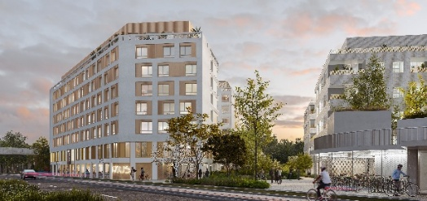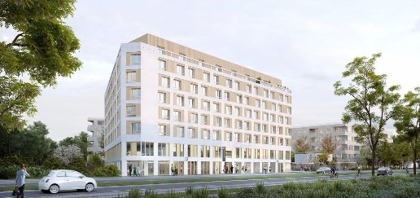
Construction project using bio-attributed PVC: The new-build student accommodation in Créteil near Paris demonstrates that high environmental standards and economical construction are not mutually exclusive.

Photographer: Charlotte Bommelaer
Usage rights: Schüco International KG

Architect of the student accommodation in Créteil: Guillaume Margot-Duclot, Architectes Associés, Paris.

Photographer: Charlotte Bommelaer
Usage rights: Schüco International KG
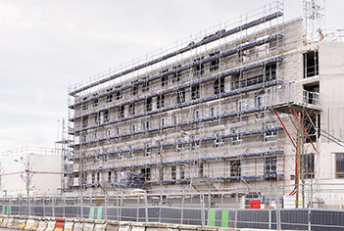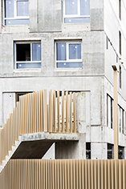
Under construction: The new-build student accommodation in Créteil nearing completion.

Photographer: Charlotte Bommelaer
Usage rights: Schüco International KG
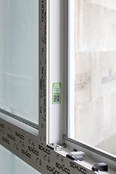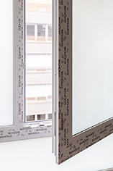
The Schüco CT 70 window profiles are made from bio-attributed PVC, which substitutes fossil fuel crude oil for tall oil and results in a significantly lower carbon footprint

Photographer: Charlotte Bommelaer
Usage rights: Schüco International KG
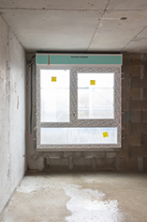
Sound reduction: Due to the proximity to a busy road, the window units are equipped with enhanced sound reduction of R_{A,tr} = 42 dB.

