Press release  March 2026 |  | Further information about publication:  Schüco International KG  Ute Minartz  Karolinenstr. 1 – 15  33609 Bielefeld, Germany  Tel.: +49 (0)521 783-6307  E-mail: PR@schueco.com  www.schueco.de/presse  www.schueco.com/press

High-tech metal fabrication with flexible configurations

VX 800 CNC profile processing centre

Bielefeld. The highly automated Schirmer | Schüco VX 800 profile processing centre, designed as a continuous feed machining centre, fabricates aluminium profiles and building components with exceptional precision and impressive speed. The highlight is that the system allows individual configurations and can be specifically assembled in accordance with the relevant manufacturing priorities of metal fabrication companies. Even at a later stage, the modular concept enables a wide range of extensions.

Ready for Industry 4.0 and fully networkable with SchüCal and remote support, the VX 800 continuous feed machining centre is a digital hub for the metal fabrication of tomorrow. The machine was developed in close collaboration with SCHIRMER Maschinen GmbH, a German company based in Verl in the East-Westphalia region.

The wide range of module options and combinations available for the VX 800 fabrication centre reflects the innovative strength of both companies. Based on a 3-axis processing unit with 9 tool positions, the system can be individually configured all the way up to 5-axis machining modules with 20 or 30 tool positions, including automatic changing of tools. Automatic clamping systems are also available, as well as an expansion of the profile magazine capacity and vacuum suction pads for small parts. With the appropriate configuration, even challenging profile geometries that deviate from the standard can be produced.

Sophisticated hardware and software
Key components of the VX 800 machine are the fully automatic 4-axis saw and the O module. The saw is equipped with a saw blade with a diameter of 600 mm. With six high-frequency spindles and integrated vibration sensors, the O module automates a wide range of fabrication technologies in 360-degree processing, including milling/thread milling, drilling and flow drilling.

Efficient fabrication
With a reliable welded construction, automated feed systems and high-precision measuring devices, the VX 800 machine is designed to significantly speed up machining processes and maximise productivity, while maintaining the highest standards in quality and innovative safety features. Maximum processing speeds can be achieved thanks to optimal tool clamping that is tailored to each profile section. From loading to labelling, everything is done automatically, which saves time, reduces costs and creates new opportunities for personnel to carry out other tasks. Intelligent measurement technology combined with automatic tolerance detection enables perfect cutting and ensures maximum utilisation of materials without refinishing. The intuitive 3D HMI control panel makes complex processes easy to understand, even for beginners. SchüCal production data can also be directly accessed here.

www.schueco.de/machinery

Schüco – System solutions for windows, doors and façades
Based in Bielefeld, the Schüco Group develops and sells system solutions for the building envelope made from aluminium, steel and PVC-U. The product range includes window, door, façade, ventilation, security and sun shading systems as well as smart and networked solutions for residential and commercial projects. Schüco also offers consultation and digital solutions for all phases of a building project – from the initial idea, design, fabrication and installation all the way through to the after-sales service including maintenance and servicing. Fabrication machinery and excellent customer service complement the product range. As a leading company in the construction industry, Schüco is committed to being a pioneer in holistic sustainability and using its products and services to make an active contribution towards achieving climate neutrality and a circular economy in the building trade. Founded in 1951, Schüco is now active in more than 80 countries and achieved a turnover of 2.05 billion euros in 2024 with 6850 employees. For more information, visit www.schueco.com

High resolution images are available to download in the Schüco Newsroom at www.schueco.de/presse.

Picture credits: Schüco International KG
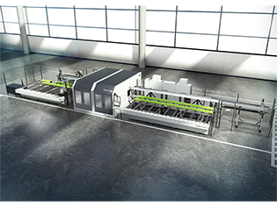
High-tech metal fabrication:
VX 800 CNC profile processing centre.

Picture credits: Schüco International KG
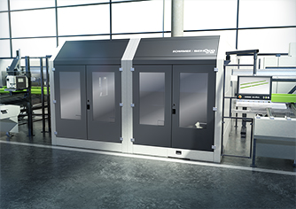
The VX 800 continuous feed machining centre is ready for Industry 4.0 and can be fully networked with SchüCal.

