Press release  February 2026 |  | Further information about publication:  Schüco International KG  Sandra Greiser  Karolinenstr. 1 – 15  33609 Bielefeld  Tel.: +49 (0)5217831174  E-mail: PR@schueco.com  www.schueco.de/presse  www.schueco.com/press

Expansion of licence agreement in Southern Europe
Schüco grants sales licence for Greece
to AluKönigStahl

Bielefeld/Vienna. Schüco International KG is extending the licencing agreement with its long-standing licencing partner AluKönigStahl to include sales of the Schüco portfolio in Greece and Cyprus.

Schüco International KG in Bielefeld and Schüco Polymer Technologies KG in Weißenfels are expanding their long-standing licencing partnership with AluKönigStahl GmbH in Vienna. On 1 July 2026, Schüco will transfer market support for the metal construction and PVC-U portfolio for Greece and Cyprus to AluKönigStahl, thereby adding two further countries to their existing contract territory. At the same time, AluKönigStahl will acquire 100 percent of the shares in Schüco International KG Hellas M.E.P.E. in Athens. The Austrian company has announced that it will take on all the staff employed at Schüco Hellas and, in so doing, continue to build on the expertise and experience of the local team. For Greek partners and customers, this will ensure that contacts remain unchanged and existing relationships are maintained.

Schüco and AluKönigStahl have now enjoyed a successful licencing partnership for 68 years, which was extended on a long-term basis in 2024. Through this new expansion, AluKönigStahl’s licencing territory will now include Greece and Cyprus in addition to Austria, Bulgaria, Romania, Hungary, Slovenia, Croatia, Serbia, Montenegro, Bosnia and Herzegovina, Kosovo, North Macedonia, Moldova and Albania. The existing licencing agreements remain unchanged.

During this long partnership, AluKönigStahl has demonstrated how successfully it develops markets, particularly in Southeast Europe. This planned expansion will enable AluKönigStahl to further consolidate its strong regional presence, benefit from additional synergies and develop the markets in Greece and Cyprus in a targeted way. This creates clear added value for Schüco: in future, market development will be in the hands of a partner that is very familiar with regional requirements and can leverage growth potential effectively. Both companies expect this expansion to build tangible business momentum and provide direct benefits for customers, architects and market partners.

“We are confident that by expanding our long-standing, trusting partnership with AluKönigStahl to the Greek markets, we will be able to offer our customers the best possible support and promising market opportunities. I am also very thankful that this will give our employees on site long-term prospects,” said Andreas Engelhardt, Managing Partner and CEO of Schüco International KG.

"First of all, we would like to thank Schüco for the trust they have placed in us. The expansion of our licence area to include Greece and Cyprus is a significant step forward for AluKönigStahl in our long-standing collaboration and also an expression of our partnership that has grown over 68 years. As in many Southeast European markets, we will draw upon our experience to promote sustainable growth and fully support our local partners in implementing their projects successfully. We are focused on continuity, personal support and a collaborative partnership on an equal footing," Philip König, Chief Executive Officer, König Holding AG.

www.schueco.com

Schüco – System solutions for windows, doors and façades
Based in Bielefeld, the Schüco Group develops and sells system solutions made of aluminium, steel and PVC-U for the building envelope. The product portfolio includes window, door, façade, ventilation, security and sun shading systems, as well as intelligent networked solutions for residential and commercial projects. Schüco also provides consultancy and digital solutions for all phases of a building project – from the initial idea through to design, fabrication and installation, as well as after sales with maintenance and servicing. Fabrication machinery and customer-oriented service complement the product portfolio. As one of the leading companies in the construction industry, Schüco is committed through its products and services to being a pioneer for comprehensive sustainability and actively contributing to climate neutrality and the circular economy within the construction sector. Founded in 1951, Schüco is now active in more than 80 countries and achieved a turnover of 2.05 billion euros in 2024 with 6850 employees.
For more information, visit www.schueco.com

High-resolution pictures are available to download in the Schüco Newsroom at www.schueco.com/press

Usage rights: Schüco International KG
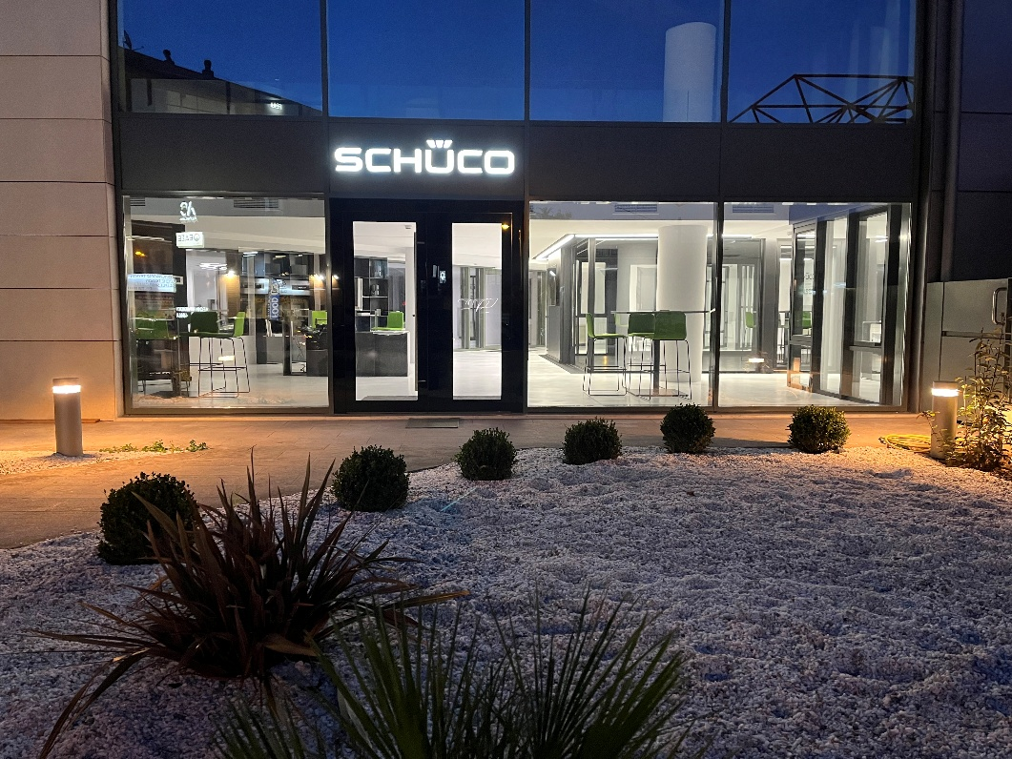
Schüco International KG Hellas M.E.P.E. in Athens.

Photographer: Frank Peterschröder
Usage rights: Schüco International KG
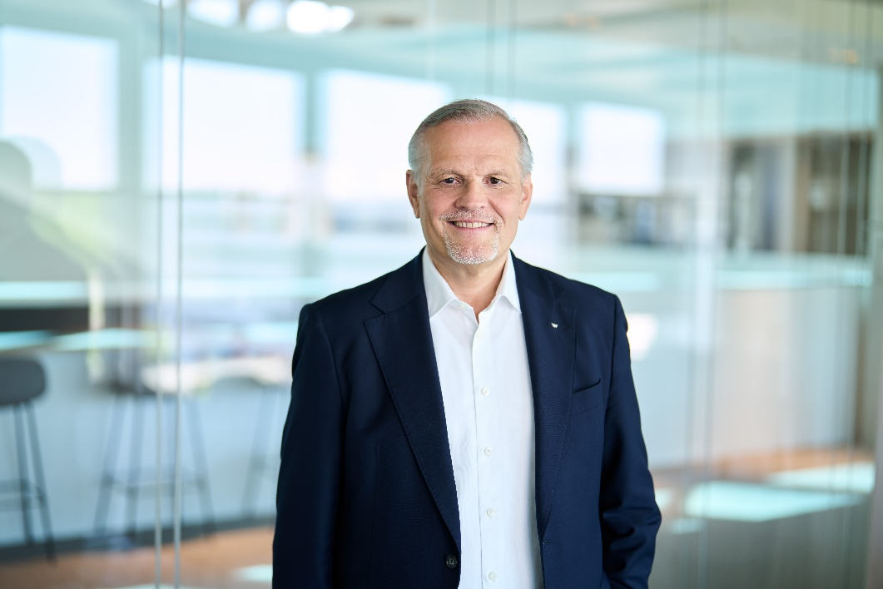
Andreas Engelhardt, CEO & Managing Partner Schüco International KG.

Photographer: Violetta König
Usage rights: König Holding AG
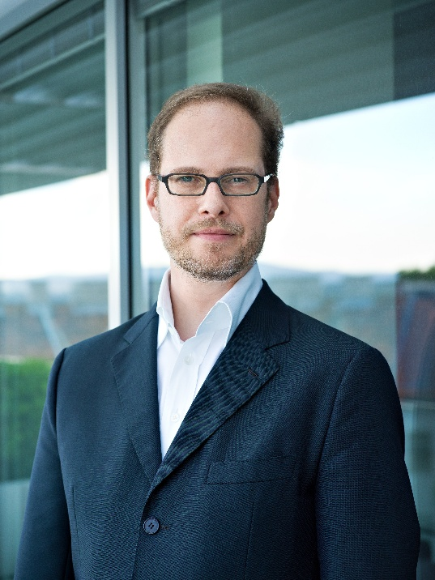
Philip König, Chief Executive Officer, König Holding AG.

