Press release  February 2026 |  | Further information about publication:  Schüco International KG  Ute Minartz  Karolinenstr. 1 – 15  33609 Bielefeld, Germany  Tel.: +49 (0)521 783-6307  E-mail: PR@schueco.com  www.schueco.de/presse  www.schueco.com/press

Schüco launches financial package campaign

Special funding and construction incentives alone will not build buildings

Bielefeld/Germany. Public and private investors in Germany are facing a new reality. Special state funding and accelerated approval processes are making billions of euros available. However, despite having the means and political will, the crucial question remains: how can economical construction projects be planned and delivered efficiently?

This is precisely where the new financial package campaign from Schüco comes in. With this incentive, the provider of system solutions for the building envelope is addressing everyone involved in the construction and aims to considerably reduce complexity in planning, specification, realisation and operation. Instead of considering the building envelope as an isolated individual element, Schüco sees it as an integrated system throughout the entire life cycle of the building.
Based on this, Schüco offers concrete solutions for all relevant project categories – from educational facilities and residential buildings right through to military premises. The focus is not on the individual product, but rather clearly defined system solutions that structure and accelerate processes.

Concrete support throughout the entire building life cycle
With the financial package campaign, Schüco is making a concrete contribution towards the efficient use of the available financial resources. The company combines its technical system expertise with comprehensive support throughout all project phases, from the analysis of the existing building right through to operation, dismantling and recycling:
- Early project phase: Schüco provides the basis for making decisions, for example when evaluating existing buildings or deriving renovation strategies. The aim is to provide clarity at an early stage, minimise risks and safeguard investment decisions.
- Planning and specification: Tested window, door and façade systems, EPDs and technical certificates create planning reliability. Specification texts that are ready for use in tender documents, as well as support with standards, safety and sustainability, take the pressure off specifiers, clients and public contracting authorities.
- Implementation: Easy-to-install systems with a high degree of pre-fabrication enable efficient implementation – supported by technical advice, training and reliable delivery, even for large quantities.
- Operation: Durable, low-maintenance systems with a service life of 30 to 50 years reduce operating costs and ensure the building envelope is fully functional. The integration of the digital twin via the IoF ID tag, which is applied to every Schüco unit, provides additional transparency during operation and for future maintenance or conversion work.

An additional leverage point is the Schüco network with its partner companies. As the largest network of its kind in Germany, it provides further efficiency benefits in construction projects thanks to short channels and a high level of implementation expertise.

Two action areas, one basic principle
With this campaign, Schüco is making a wide range of information available. This includes white papers and information brochures about key building categories such as educational facilities, residential buildings and military premises. In addition, comprehensive information on two closely linked websites is used:

- www.schueco.de/finanzpaket: Processes to keep the project on-time and on-budget are the focus – in other words, a high degree of planning reliability for all public construction projects.
- www.schueco.de/bau-turbo: Solutions for accelerated, standardised and scalable construction are the focus. This includes reconciling conflicting objectives and making affordable, sustainable living space easier to plan and implement.

All of the solutions follow the same basic principles – reduce complexity and accelerate implementation to have an impact over the entire life cycle.

Schüco also has a special offer for inventory-taking of existing buildings. Interested parties in local authorities can receive up to 50 percent funding for energy consulting and planning services.

In this way, all the elements of the financial package campaign provide practical answers to the key challenge: translating complex processes and specifications into the efficient, sustainable and predictable implementation of construction projects.

Schüco – System solutions for windows, doors and façades
Based in Bielefeld, the Schüco Group develops and sells system solutions for the building envelope made from aluminium, steel and PVC-U. The product range includes window, door, façade, ventilation, security and sun shading systems as well as smart and networked solutions for residential and commercial projects. Schüco also offers consultation and digital solutions for all phases of a building project – from the initial idea, design, fabrication and installation all the way through to the after-sales service including maintenance and servicing. Fabrication machinery and excellent customer service complement the product range. As a leading company in the construction industry, Schüco is committed to being a pioneer in holistic sustainability and using its products and services to make an active contribution towards achieving climate neutrality and a circular economy in the building trade. Founded in 1951, Schüco is now active in more than 80 countries and achieved a turnover of 2.05 billion euros in 2024 with 6850 employees.
For more information, visit www.schueco.com

High resolution images are available to download in the Schüco Newsroom at www.schueco.de/presse.

Picture credits: Schüco International KG
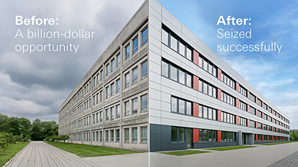
The Schüco financial package campaign translates complex specifications into practical, efficient and sustainable solutions for the implementation of construction projects.

Picture credits: Schüco International KG
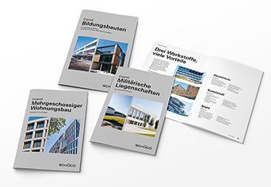
Brochures on educational facilities, multi-storey residential buildings and military premises bring together building-specific requirements and show how Schüco solutions create economical added value with a high level of planning reliability throughout the entire life cycle.

