Press release  January 2026 |  | Further information about publication:  Schüco International KG  Sandra Greiser  Karolinenstr. 1 – 15  33609 Bielefeld, Germany  Tel.: +49 (0)5217831174  E-mail: PR@schueco.com  www.schueco.de/presse  www.schueco.com/press

Selling aluminium and steel systems

Schüco and Jansen are extending and expanding their long-term partnership

Bielefeld/Oberriet. Schüco International KG and Jansen AG are extending their long-term partnership. In doing so, both companies affirm the success of their collaboration and are expanding their strategic cooperation further.

Based in Bielefeld, Schüco International KG has been providing system solutions made from aluminium, steel and PVC-U for 75 years. The company represents the highest level of quality and a holistic approach to sustainability, with comprehensive solutions and services covering the entire life cycle of buildings.
With their headquarters in Oberriet, Jansen AG is a traditional Swiss company with a history spanning more than 100 years. Jansen develops and produces steel profile systems for windows, doors, fire protection and façade constructions.

As part of the Swissbau exhibition, the two companies announced the extension of their partnership agreement on 22 January 2026. Within the aluminium sector, the partnership grants Jansen exclusive distribution rights for Schüco aluminium systems in Switzerland and Liechtenstein. At the same time, Schüco will continue to retain exclusive distribution rights for Jansen steel systems in Germany, Luxembourg, the UK, Ireland, Scandinavia, Finland, the Baltic states and Greece. Extending these agreements highlights the success of the partnership for both companies. The sales partnership has been in place in the aluminium sector since 1978 and in the steel sector since 2000.
A new sales partnership has also been added in the steel sector. As of 1 January 2026, Schüco International S.C.S., which is the Schüco subsidiary in France, is distributing the majority of the steel systems from the former RP Technik GmbH in France and the French overseas territories. The RP Technik range offers its own steel system for windows, doors, fire protection and façade constructions. Schüco International KG has already held the licence to distribute this range in the same markets as for Jansen systems since 2024.
Thanks to the renewed confirmation and expansion of the partnership with Jansen, Schüco can continue to offer sustainable aluminium and steel solutions to its customers in the respective markets, covering the entire life cycle of buildings.
“This year, Schüco is celebrating its 75th anniversary. Partnerships with companies that share our high standards of quality, service and innovative strength have always been important for our long-term success. We have shared these values with Jansen, a family-owned company just like Schüco, for more than 45 years. I am delighted that we are continuing and further expanding our trusted partnership into the future,” says Andreas Engelhardt, CEO and Managing Partner of Schüco International KG.
“Stable partnerships are particularly important in times of great change and uncertainty. Schüco and Jansen have been living this for almost 50 years. Our partnership is based on shared goals and values, always with a focus on our customers. I am therefore delighted that we extend and further develop this partnership,” says Christoph Jansen, CEO and Board Director of Jansen AG.

Schüco – System solutions for windows, doors and façades
Based in Bielefeld, the Schüco Group develops and sells system solutions for the building envelope made from aluminium, steel and PVC-U. The product range includes window, door, façade, ventilation, security and sun shading systems as well as smart and networked solutions for residential and commercial projects. Schüco also offers consultation and digital solutions for all phases of a building project – from the initial idea, design, fabrication and installation all the way through to the after-sales service including maintenance and servicing. Fabrication machinery and excellent customer service complement the product range. As a leading company in the construction industry, Schüco is committed to being a pioneer in holistic sustainability and using its products and services to make an active contribution towards achieving climate neutrality and a circular economy in the building trade. Founded in 1951, Schüco is now active in more than 80 countries and achieved a turnover of 2.05 billion euros in 2024 with 6850 employees.

www.schueco.com

High resolution images are available to download in the Schüco Newsroom at www.schueco.de/presse.

Photographer: Sara Barth
Usage rights: Schüco International KG

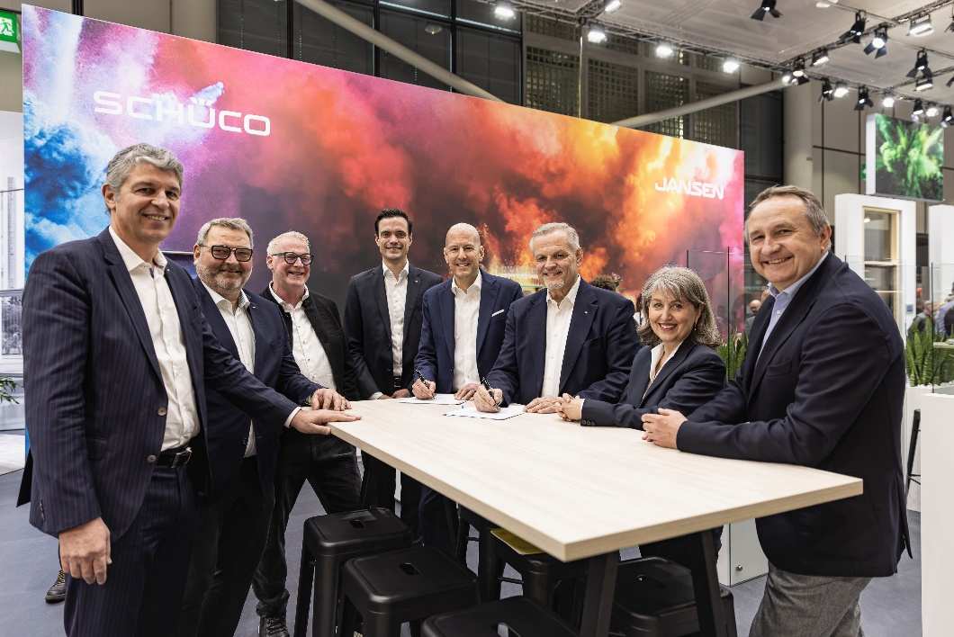

Image caption
Contract extension for the partnership between Schüco and Jansen (left to right):
Jacques Lladós, CEO Schüco International S.C.S., Andreas Graf, Head of Steel Division Schüco International KG, Elmar Gollers, Director of Business, Jansen AG, Hendrik Pahlsmeyer, Chief Commercial Officer Metal Business Central Europe Schüco International KG, Christoph Jansen, CEO and Board Director Jansen AG, Andreas Engelhardt, CEO and Managing Partner Schüco International KG, Christel Marchiando, Head of Key Partner Management Europa, Jansen AG, Guido Wortmeier, Director of Sales, Jansen AG.

