Building report  December 2025 |  | Further information about publication:  Schüco International KG  Ute Minartz  Karolinenstr. 1 – 15  33609 Bielefeld, Germany  Tel.: + 49 (0) 521 783-6307  E-mail: pr@schueco.com  www.schueco.de/presse  www.schueco.com/press

“FOUR Frankfurt”, Frankfurt (Main)
Large-scale project with the highest fire safety requirements

Bielefeld. With the design and realisation of the ‘FOUR Frankfurt’ neighbourhood complex, ARGE UNS + HPP accomplished a challenging task: to reshape the face of the metropolis of Frankfurt in an inner-city area that had been dominated by banks for decades. Projects of this magnitude always pose a particular challenge in terms of fire protection. The architects at UNS and HPP relied on Schüco's high level of consulting expertise and experience in implementing innovative fire protection solutions for large-scale projects.

Four high-rise buildings were constructed in the centre of Frankfurt, creating a multifunctional building complex that is revitalising the increasingly isolated Frankfurt banking district as an urban location. Dutch architect Ben Van Berkel, founder of UN Studio, describes this commission as a gift, because “as an architect, you don't often get the opportunity to develop a design for a location with so much untapped potential.” On the former Deutsche Bank site, 16,141 square metres have been divided into four real estate sections, creating a “city within a city” with 213,000 m² of gross floor area. The four towers, which stretch up to 233 metres high, are connected at their base and offer space for almost 600 apartments, prestigious office floors, a lifestyle hotel, a long-stay hotel, a day-care centre and an urban mix of retail outlets.
In addition, local amenities and restaurants such as the food hall establish the basis for a lively and diverse neighbourhood with great appeal. The complex opens up to the city on all sides, which creates invisible bridges to the neighbouring districts.

Multifunctional – even in its fire protection
In general, fire protection is of enormous importance in large-scale projects. The focus here is that fire protection compartments should be divided in a way that is as inconspicuous and barrier-free as possible. Due to the diverse requirements and changes of use that are frequently expected, “FOUR Frankfurt” also required highly flexible, multifunctional solutions. The architects that make up the planning entity of UNS+HPP, hhpberlin, together with the client Groß & Partner Grundstücksentwicklungsgesellschaft decided to work closely with Schüco to tackle the issue of fire protection.

Schüco covers the preparatory work
Given the demanding project requirements of “FOUR Frankfurt,” in-depth expertise was needed: all fire protection partitions must be tested for fire protection in their entire construction. From a fire protection perspective, a situation with “dry walling on the right and a connection to a concrete wall on the left” cannot be considered as effective as a connection to a concrete wall on both sides.

Where necessary, separate fire protection tests may be required. These tests are both time-consuming and expensive. To avoid any unnecessary disruption to the construction process that may be caused by these tests, especially in the case of short-term planning changes, Schüco conducts all necessary fire protection tests on the most common installation situations. Additionally, there is already plenty of information available regarding the selected FireStop ADS 90 FR 30 and FR 90 multifunctional fire and smoke doors.

Tasks taken care of in advance
When it comes to extensive products like FireStop, not all installation situations or design versions (installed fittings, for example) can be tested in advance for fire protection purposes. This is where the architectural consulting team at Schüco proves to be a huge advantage. “With large-scale projects, we are often in close contact with those involved in the planning process at a very early stage,” says Jochen Kluge, Security Project Manager at Schüco. “In some instances, we already brought detailed plans to the table and, if there is something that needs checking in terms of fire protection, we can get started straight away – even without placing orders to cover costs,” adds Kluge. Thanks to our long-standing collaborations, this approach is familiar to many architects and knowing that valuable time would not be lost having to complete the required subsequent inspections was one of the main reasons for working together with Schüco on “FOUR Frankfurt.”
Frank Burkhardt from RFE Rauch- und Feuerschutz-Elemente, which is the company that manufactured the fire doors, goes on to add that: “The open rebate profile of FireStop is something special. The doors can also still be converted after they are installed and commissioned. This was another important argument in favour of awarding the contract for the product.”

In short, those involved on the project opted for Schüco because of the high level of consulting expertise as well as their profile system, which boasts unique flexibility and fire protection technology. In keeping with the principle of “open profiles for open architecture”, the Schüco FireStop fire and smoke doors are now an essential component of the fire protection concept.

Information about the product:

Virtually invisible and highly variable
The acronym ADS stands for "Aluminium Door Systems". The installations can be equipped with FR 30 or 90 (Fire Resistance). The respective duration of protection of 30 or 90 minutes meets requirements according to EI classification, which stands for protection against fire, gas and smoke (E) and thermal insulation (I).

The thermally broken profiles have a basic depth of only 90 mm and visible face widths of 127 mm, meaning the door systems integrate seamlessly into the architecture and perfectly complement all of the other glazing components without fire and smoke protection. As standard, they are designed with no threshold and therefore meet the barrier-free access and visual requirement of “invisibility”. The profiles of the door leaves are mitre-cut, while the toplights and sidelights are usually butt-joined and connected to each other discreetly using T-cleats. Thanks to this technology, complete fire walls can be constructed efficiently.

Easily retrofitted – without any loss of certification
The FireStop ADS 90 FR 30 and FR 90 fire and smoke doors have an innovative open-rebate profile geometry. This enables easy and even retrospective installation of integrated closers, concealed door hinges, fittings and locks without having to machine the profiles in advance. The same applies for subsequent laying of cables. The additional work is limited only by the length adjustment of the cover piece. In the event of a fire, the cover piece expands to ensure that the doors form a secure fire and smoke barrier.
The option to make changes during ongoing operation and without loss of existing certifications is a new feature and a unique selling point of FireStop ADS 90 FR 30 and FR 90.

Project details

Project: FOUR Frankfurt
Location: Gallus-/Neue Schlesinger-/Junghofstraße, Frankfurt (Main)
Client: Groß & Partner Grundstücksentwicklungsgesellschaft mbH, Frankfurt (Main)
Architectural practice: UNS, Amsterdam
Architectural designs: Planning entity of UNS+HPP FOUR Frankfurt (comprising architects from both UNS and HPP), Frankfurt (Main)
Fire protection: hhpberlin – Ingenieure für Brandschutz GmbH, Düsseldorf
Metal fabricator: RFE Rauch- und Feuerschutz- Elemente GmbH, Stockstadt
Fire protection systems used: FireStop ADS 90 FR 30 / FR 90
System supplier/manufacturer: Schüco, Bielefeld
Completion date: 2024

Schüco – System solutions for windows, doors and façades
Based in Bielefeld, the Schüco Group develops and sells system solutions for the building envelope made from aluminium, steel and PVC-U. The product range includes window, door, façade, ventilation, security and sun shading systems as well as smart and networked solutions for residential and commercial projects. Schüco also offers consultation and digital solutions for all phases of a building project – from the initial idea, design, fabrication and installation all the way through to the after-sales service including maintenance and servicing. Fabrication machinery and excellent customer service complement the product range. As a leading company in the construction industry, Schüco is committed to being a pioneer in holistic sustainability and using its products and services to make an active contribution towards achieving climate neutrality and a circular economy in the building trade. Founded in 1951, Schüco is now active in more than 80 countries and achieved a turnover of 2.05 billion euros in 2024 with 6850 employees. www.schueco.com

High resolution images are available to download in the Schüco Newsroom at www.schueco.de/presse.

Photographer: HGEsch
Usage rights: Schüco International KG
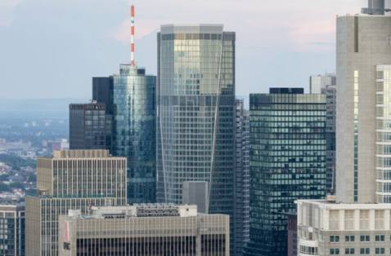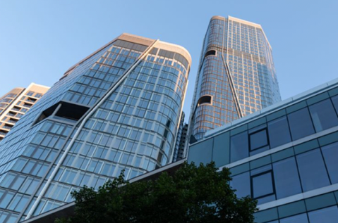
With FOUR Frankfurt, a multifunctional new urban district has been created in the heart of the bankers' city. It opens up to the city on all sides. The complexity of the overall construction combined with its open-plan architecture required the highest levels of fire protection.

Photographer: HGEsch
Usage rights: Schüco International KG
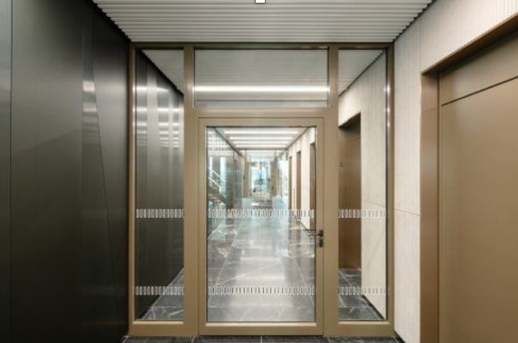
The Schüco FireStop ADS 90 FR 30 and FR 90 fire and smoke doors are custom-made for this architectural concept.

