Press release  October 2025 |  | Further information about publication:  Schüco International KG  Sandra Greiser  Karolinenstr. 1 – 15  33609 Bielefeld, Germany  Tel.: +49 (0)5217831174  E-mail: PR@schueco.com  www.schueco.de/presse  www.schueco.com/press

Officially sustainable
Schüco wins the 2026 German Sustainability Award in the Construction industry company category

Bielefeld. Schüco International KG has triumphed at the 2026 German Sustainability Awards. A panel of experts chose the company as the winner in the “Construction industry company” category, recognising the holistic sustainability strategy of the Bielefeld building envelope specialist with its clear climate targets and eco-friendly product development strategy.

The German Sustainability Award for Companies honours the key players in sustainable transformation. Companies are selected based on a comprehensive analysis of publicly available sustainability data, with some 240 experts from science, economics and civil society then selecting the winners from this shortlist.
For 2026, the judges picked Schüco for one of the coveted awards in the “Company” category.
In so doing, the panel of experts acknowledges the long-term commitment of Schüco in driving forward the issues of decarbonisation, the circular economy and resource conservation in the construction industry, and thereby provides an independent validation of the company's pioneering role.

“This award confirms our commitment to a sustainable future and shows that we are on the right path as a company. The prize is both a motivation and an obligation for us to continue to push our sustainability targets with innovation and passion,” says Andreas Engelhardt, Managing Partner of Schüco International KG.
Since 2017, Schüco has regularly produced a sustainability report that offers transparency on its strategic sustainability activities. Schüco has introduced low carbon material classes for both the aluminium and PVC-U system solutions and firmly established these in the marketplace. These are circular materials with a carbon footprint that is more than 70% lower than the European average. Through its offer to collect and recycle products, Schüco also enables the materials to be fed back into the material cycle at the end of their life cycle. With more than 95 Cradle-to-Cradle certified aluminium systems currently, the company is a pioneer for the principle of a circular economy in the construction sector.

Thanks to the holistic approach – from planning and construction through to a comprehensive range of services whilst the building is in operation, as well as the dismantling and recycling of the installed materials – Schüco is setting new standards in terms of sustainability in the building industry and with regard to support for customers throughout the entire life cycle of a building.

Schüco – System solutions for windows, doors and façades
Based in Bielefeld, the Schüco Group develops and sells system solutions for the building envelope made from aluminium, steel and PVC-U. The product range includes window, door, façade, ventilation, security and sun shading systems as well as smart and networked solutions for residential and commercial projects. Schüco also offers consultation and digital solutions for all phases of a building project – from the initial idea, design, fabrication and installation all the way through to the after-sales service including maintenance and servicing. Fabrication machinery and excellent customer service complement the product range. As a leading company in the construction industry, Schüco is committed to being a pioneer in holistic sustainability and using its products and services to make an active contribution towards achieving climate neutrality and a circular economy in the building trade. Founded in 1951, Schüco is now active in more than 80 countries and achieved a turnover of 2.05 billion euros in 2024 with 6850 employees.
For more information, visit www.schueco.com

High resolution images are available to download in the Schüco Newsroom at www.schueco.de/presse.

Usage rights: German Sustainability Award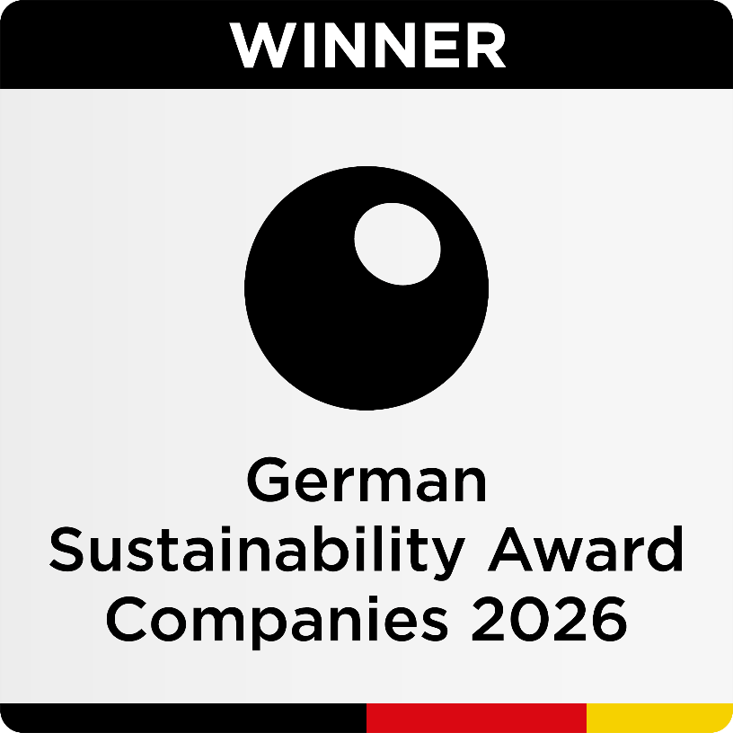
Schüco wins the 2026 German Sustainability Award in the Company category.

Photographer: Stefan Brückner
Usage rights: Schüco International KG
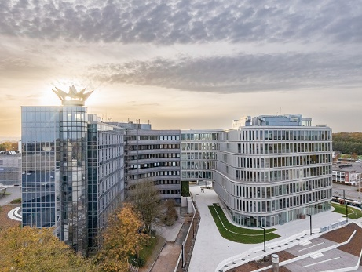
Schüco wins the 2026 German Sustainability Award in the Company category.

