Press release  August 2025 |  | Further information about publication:  Schüco International KG  Jan Banze  Karolinenstr. 1 – 15  33609 Bielefeld  Tel.: +49 (0) 521 7831155  E-mail: PR@schueco.com  www.schueco.de/presse  www.schueco.com/press

Concealed fire protection for external use
Schüco FireStop ADS 90 FR 90-CE

Bielefeld. For preventing the spread of fire between buildings and securing emergency escape routes – fire protection solutions are not only required indoors, but also in external areas. With the new Schüco FireStop ADS 90 FR 90-CE fire door, the Bielefeld-based system house has expanded its portfolio with a solution for external applications with 90 minutes of protection. The special feature is the CE-classified door system, which combines concealed fire protection with stability and lightweight properties. The new fire-resistant glass reduces the weight of the door significantly. At the same time, the system stands out with class 4, the highest level of mechanical strength, for use with particularly heavy loads.

Schüco FireStop ADS 90 FR 90-CE has been specially developed for areas that are subject to heavy use, such as hospitals, schools and kindergartens. The fire protection system with 90 minutes of fire resistance enables flexible application options in a range of environments thanks to its high physical load-bearing capacity. Achieving class 4, it meets the highest category for mechanical strength in accordance with DIN EN 1192. Thanks to the innovative fire-resistant insulating mat and the new SchücoFlam 90 L fire-resistant glass, the Schüco FireStop ADS 90 FR 90-CE is one of the most lightweight 90-minute doors on the market. The new fire-resistant glass alone achieves a reduction in weight (10 mm reduction in glass thickness) of around 40 percent compared to existing fire-resistant glass (from 82 kg/m² to 49 kg/m²). This low weight provides a number of benefits. For example, elderly people and children are also able to comfortably open the fire door without having to exercise great force. The low weight means that material wear is reduced, enabling a low requirement for maintenance, less damage and a long service life for the doors. Thanks to the reduction in weight, the fabricator also benefits from easier handling during fabrication and installation.

High-performance system
As expected from the Fire Stop platform, the new fire door also impresses with its high performance values in watertightness, wind resistance, thermal insulation and air permeability. In addition, the usual high level of burglar resistance is possible in class RC2 or RC2n, with or without a panic function. The performance characteristics have been tested for different threshold solutions, locking types and door hinges. Barrier-free doors, for example, can therefore be adapted flexibly to meet any project requirement. The concealed fittings allow for a consistent look across the entire project. The open rebate profile geometry, identical profiles and fittings and low weight help to simplify the fabrication and installation processes.

Schüco – System solutions for windows, doors and façades
Based in Bielefeld, the Schüco Group develops and sells system solutions for the building envelope made from aluminium, steel and PVC-U. The product range includes window, door, façade, ventilation, security and sun shading systems as well as smart and networked solutions for residential and commercial projects. Schüco also offers consultation and digital solutions for all phases of a building project – from the initial idea, design, fabrication and installation all the way through to the after-sales service including maintenance and servicing. Fabrication machinery and excellent customer service complement the product range. As a leading company in the construction industry, Schüco is committed to being a pioneer in holistic sustainability and using its products and services to make an active contribution towards achieving climate neutrality and a circular economy in the building trade. Founded in 1951, Schüco is now active in more than 80 countries and achieved a turnover of 2.11 billion euros in 2023 with 6750 employees.
For more information, visit www.schueco.com

High resolution images are available to download in the Schüco Newsroom at www.schueco.de/presse.

Picture credits: Schüco International KG
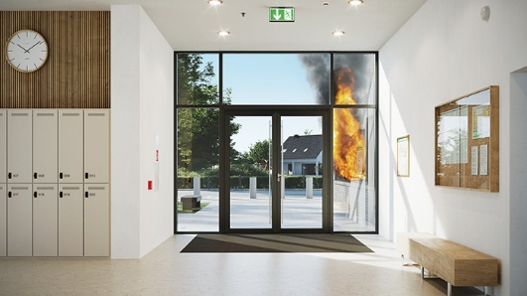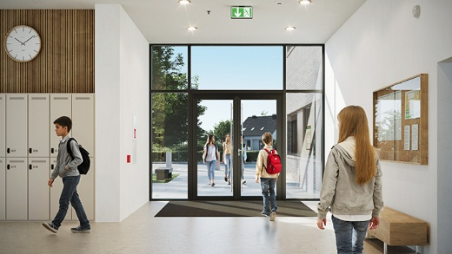
Schüco FireStop ADS 90 FR 90-CE has been specially developed for areas that are subject to heavy use, such as schools and kindergartens.

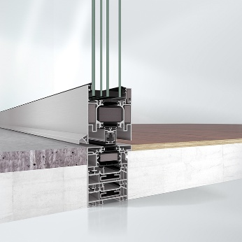
The Schüco FireStop ADS 90 FR 90-CE fire door can also be designed with a level threshold for convenience and security in one system.

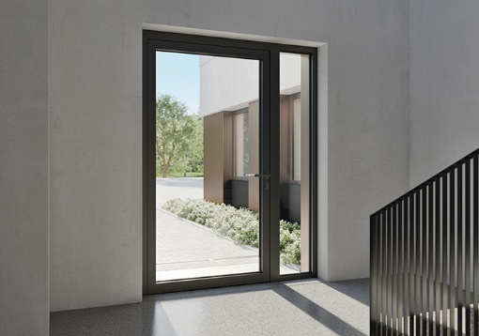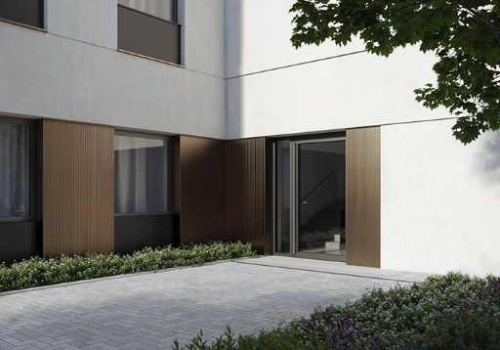
The fire protection system with 90 minutes of fire resistance enables flexible application options in a range of environments thanks to its high physical load-bearing capacity.

