Press release  July 2025 |  | Further information about publication:  Schüco International KG  Sandra Greiser  Karolinenstr. 1 – 15  33609 Bielefeld  Tel.: +49 (0)5217831174  E-mail: PR@schueco.com  www.schueco.de/presse  www.schueco.com/press

Automating the installation process:
Schüco CC 800 four-headed corner crimping machine

Bielefeld. Schüco is laying the foundation for simple, efficient and fast installation with the fully automatic Schüco CC 800 four-headed corner crimping machine featuring automatic infeed and outfeed. Every 70 seconds, a manually fed frame can be punched precisely and fed out – regardless of whether it is a small window measuring 380 x 420 mm or large façade and sliding units up to 4000 x 6500 mm in size.

With the Schüco CC 800 corner crimping machine, fabricators benefit from a fully automated punching process suitable for a wide range of profile geometries. Thanks to the machine's high process reliability, a frame can be fabricated every 70 seconds. Manually fed frames with a profile height of up to 250 mm are punched precisely and fed out. Even profiles with a pre-inserted gasket can be processed with ease. Operation is particularly user-friendly thanks to the simple controls via SchüCal, combined with data entry using barcodes or matrix codes. The corner crimping machine also features integrated, fully automated profile tolerance compensation. What's more, the CC 800 also makes it possible to easily process profiles with a difference in height without the need for special blades.

Flexible use
The CC 800 can be used in a variety of workshop layouts and is particularly suited to production line manufacturing, whether for window, door or façade units. Preventive maintenance, supported by logbook entries and pneumatic monitoring, also ensures the machine's longevity and reliability.

Schüco – System solutions for windows, doors and façades
Based in Bielefeld, the Schüco Group develops and sells system solutions for the building envelope made from aluminium, steel and PVC-U. The product range includes window, door, façade, ventilation, security and sun shading systems as well as smart and networked solutions for residential and commercial projects. Schüco also offers consultation and digital solutions for all phases of a building project – from the initial idea, design, fabrication and installation all the way through to the after-sales service including maintenance and servicing. Fabrication machinery and excellent customer service complement the product range. As a leading company in the construction industry, Schüco is committed to being a pioneer in holistic sustainability and using its products and services to make an active contribution towards achieving climate neutrality and a circular economy in the building trade. Founded in 1951, Schüco is now active in more than 80 countries and achieved a turnover of 2.05 billion euros in 2024 with 6850 employees.
For more information, visit www.schueco.com

High resolution images are available to download in the Schüco Newsroom at www.schueco.de/presse.

Picture credits: Schüco International KG
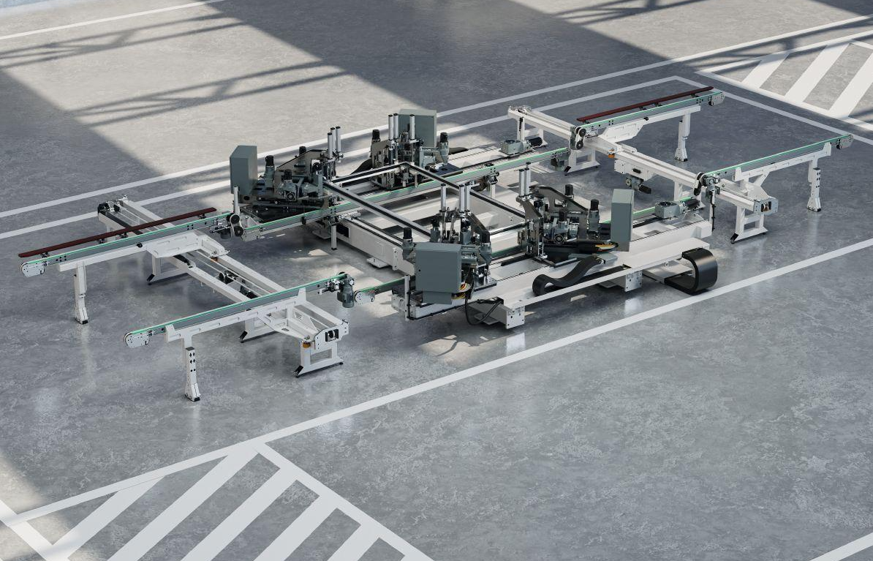
The Schüco solution for the efficient installation of windows, doors and façades – the fully automatic Schüco CC 800 four-headed corner crimping machine including automatic infeed and outfeed.
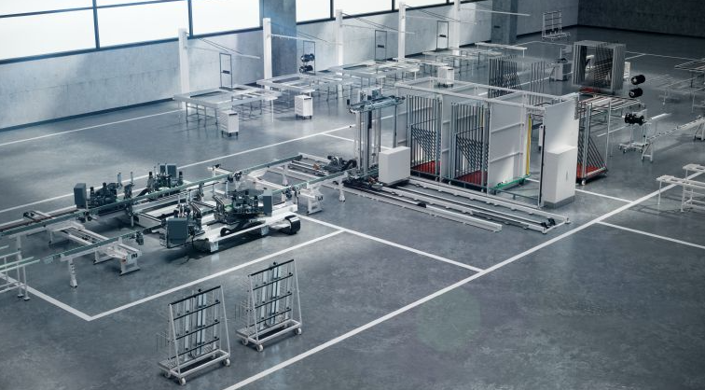
The Schüco CC 800 four-headed corner crimping machine can be used in a variety of workshop layouts and is particularly suited to production line manufacturing.

