Press release  April 24, 2025 |  | Further information about publication:  Schüco International KG  Sandra Greiser  Karolinenstr. 1 – 15  33609 Bielefeld  Tel.: +49 (0)5217831174  Mail: PR@schueco.com  www.schueco.de/presse  www.schueco.com/press

High-performance windows for versatile building applications
Schueco and LIXIL Strengthen Their Business Partnership in Japan to Reduce CO₂ Emissions in the Construction Industry

Bielefeld/Tokyo. LIXIL Corporation, maker of pioneering products for the water and housing industry, and Schueco International KG are expanding their business partnership to jointly reduce the emissions generated throughout the entire life cycle of a building. This is in line with the Japanese government's goal of achieving climate neutrality by 2050.

Schueco, headquartered in Germany, offers highly insulated aluminum windows, curtain walls and other products that meet the stringent building requirements across Europe. Committed to sustainability, Schueco offers a range of low-carbon aluminum profiles in Europe, adhering to its strict CO₂ emission standards.

Schüco and LIXIL founded Schueco Japan, a joint venture, in August 2021 with the aim of developing and marketing solutions, especially windows, for the requirements in Japan. Schueco Japan combines advanced European technology and design with LIXIL's expertise in the Japanese market, considering specific local needs and standards. This ensures that the high-performance characteristics and quality are maintained when customising the systems for Japan. In addition, the partnership utilises LIXIL's manufacturing, assembly and distribution network as well as its nationwide fabricator network to strengthen the domestic supply chain and business foundation.

According to the International Energy Agency (IEA), the building sector is responsible for approximately 37per cent of global CO₂ emissions. With a view to achieving international climate targets, the construction industry plays a key role in reducing CO₂ emissions over the entire life cycle of a building.

In addition, the Japanese government is planning to introduce a new regulation that obliges developers and building owners to calculate the CO₂ emissions of buildings above a certain size over their entire lifespan using a life cycle analysis. In Europe, the European Green Deal, like the Japanese government, calls for climate neutrality by 2050, while in Germany this target is to be achieved by 2045.
To meet these requirements, Schueco and LIXIL are further expanding their partnership.

LIXIL distributes Schueco products in the Japanese market, including the Schueco ASE 60 high-performance aluminum window and the Schueco FWS 50.SI curtain walling system. The system solutions are suitable for various building applications, such as residential and commercial buildings, and offer excellent thermal insulation, airtightness and design flexibility. In addition, these products are certified by the Passive House Institute and fulfil its strict energy efficiency standards. Both systems have also been awarded Cradle to Cradle certification and can be separated by material type easily at the end of their useful life to return the materials to the material cycle. Schueco has been focusing on Cradle to Cradle design since 2016 and currently offers 95 certified systems.

LIXIL and Schueco Japan will gradually introduce further highly thermally insulated units to the Japanese market, such as the Schueco AS FD 90.HI folding door, with a maximum leaf size of 1.5 m wide x 3.5 m high, and the highly thermally insulated Schueco AWS 90 BS.SI+ window with a Uw value of 0.8 (with triple glazing with a Ug value of 0.5, 1.5m x 2.7m). With the introduction of these products, LIXIL and Schueco Japan will significantly expand its range of highly thermally insulated system solutions for the building envelope, particularly in the commercial building segment. LIXIL aims to achieve a domestic portfolio share of 50 per cent of highly thermally insulated building products with a Uw value of 1.9 or less, including Schueco products, by FYE 2040. Looking to the future, the business partnership is looking at expanding the Schueco product range to meet the needs of the growing refurbishment market.

Kinya Seto, President and CEO of LIXIL: “We strive to create an impact on the environment and society, both through our initiatives and collaborations with our partners, aiming for further business growth alongside addressing social challenges. LIXIL has been promoting the adoption of window products designed to effectively reduce CO₂ emissions based on LCA, tailored to Japan's diverse regional climates. By strengthening our partnership with Schueco, we can further expand the provision of high-performance insulation products for any type of building. Combining our expertise and technologies, we are committed to accelerating whole life carbon reduction in buildings across Japan, advancing a sustainable future.”

Andreas Engelhardt, CEO of Schueco International KG: "Schueco has been a pioneer in the continuous development of thermally insulated systems for the building envelope since the 1960s. Regulations in Germany have ambitiously promoted the topic of energy efficiency in recent years. As a result, Germany has already achieved high levels of energy efficiency by international standards, especially in newbuilds. With our products, we want to contribute to significantly reducing CO₂ emissions in the operation of buildings. We also want to offer this range to international markets to support the goal of climate neutrality worldwide. We are currently expanding our portfolio to include highly thermally insulated solutions specifically for renovations in order to make existing buildings more energy efficient."

www.schueco.com

Further information about publication:
Yuka Okamoto
Japan Communications
LIXIL Corporation
yuka.okamoto@lixil.com
TEL: +81-50-1791-2712
Schüco – System solutions for windows, doors and façades
Based in Bielefeld, the Schüco Group develops and sells system solutions made of aluminum, steel and PVC-U for the building envelope. The product portfolio includes window, door, façade, ventilation, security and sun shading systems, as well as intelligent networked solutions for residential and commercial projects. Schüco also provides consultancy and digital solutions for all phases of a building project – from the initial idea through to design, fabrication and installation, as well as after sales with maintenance and servicing. Fabrication machinery and customer-oriented service complement the product portfolio. As one of the leading companies in the construction industry, Schüco is committed through its products and services to being a pioneer for comprehensive sustainability and actively contributing to climate neutrality and the circular economy within the construction sector. Founded in 1951, Schüco is now active in more than 80 countries and achieved a turnover of 2.11 billion euros in 2023 with 6750 employees.
For more information, visit www.schueco.com

About LIXIL
LIXIL makes pioneering water and housing products that solve everyday, real-life challenges, making better homes a reality for everyone, everywhere. Drawing on our Japanese heritage, we create world-leading technology and innovate to make high quality products that transform homes. But the LIXIL difference is how we do this; through meaningful design, an entrepreneurial spirit, a dedication to improving accessibility for all, and responsible business growth. Our approach comes to life through industry leading brands, including INAX, GROHE, American Standard, and TOSTEM. Approximately 53,000 colleagues operating in more than 150 countries are proud to make products that touch the lives of more than a billion people every day. Learn more at www.lixil.com

High-resolution pictures are available to download in the Schüco Newsroom at www.schueco.com/press

Picture credits: LIXIL
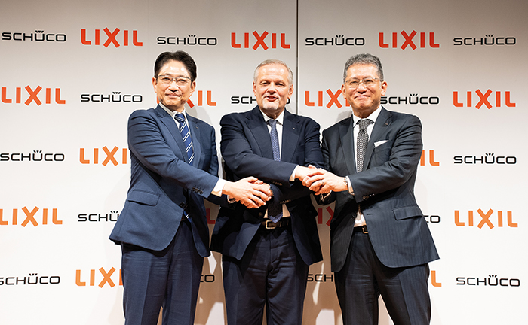
(f. l. t. r.) Satoshi Yoshida, Executive Officer, LIXIL Housing Technology (LHT), LIXIL, Andreas Engelhardt, CEO of Schueco International KG, and Kinya Seto, Director, President, and CEO of LIXIL

