Press release  April 2025 |  | Further information about publication:  Schüco International KG  Sandra Greiser  Karolinenstr. 1 – 15  33609 Bielefeld  Tel.: +49 (0)5217831174  E-mail: PR@schueco.com  www.schueco.de/presse  www.schueco.com/press

Promoting glass recycling

Schüco partnership with Saint-Gobain Glass

Bielefeld. Whether it's conservation of resources, saving energy or sustainability: the reuse of glass is becoming increasingly important in the construction industry. To promote the recycling of glass, Schüco and Saint-Gobain Glass Germany have formed a collaboration. Together, the two companies want to make use of waste glass from existing buildings to develop the material cycle and consolidate the flow of material.

The Saint-Gobain Group is a pioneer in sustainable construction and is on a mission to make the world a better place to live. To achieve this, Saint-Gobain Glass is capitalising on the recycling of flat glass, among other things. From collection, recycling and the production of CO₂-reduced ORAÉ glass to sustainable production processes, Saint-Gobain Glass makes a significant contribution to the closing of the material cycle.

Glass recycling plays a crucial role in the sustainable construction industry. Valuable natural resources such as sand, soda and lime can be conserved and energy consumption can be considerably reduced thanks to the re-use of recycled glass. Melting recycled glass requires less energy than manufacturing new glass, which contributes significantly to a reduction in carbon emissions. The aim of this collaboration is to avoid consumption of non-renewable resources and reduce carbon emissions, as well as lower the ecological footprint of the building.

“We take back every unit, regardless of whether it is made from aluminium or PVC-U, and return the materials to the material cycle. This is not just limited to the profiles, but also includes the glass. We are delighted to have found an experienced partner in Saint-Gobain Glass, to help us actively contribute to the circular economy,” says Andreas Engelhardt, Managing Partner and CEO of Schüco. Raimund Heinl, CEO of Saint-Gobain Germany and Austria adds: “Conserving raw materials through a consistent circular economy is at the heart of Saint-Gobain's sustainability initiative. This collaboration with Schüco will give our sustainability concept an additional boost. The expertise from both Saint-Gobain and Schüco can combined perfectly. Thanks to this partnership, Saint-Gobain Glass can increase the proportion of recycled glass in glass production and thereby move one step closer to its goal of carbon neutral glass production.”

Schüco – System solutions for windows, doors and façades
Based in Bielefeld, the Schüco Group develops and sells system solutions for the building envelope made from aluminium, steel and PVC-U. The product range includes window, door, façade, ventilation, security and sun shading systems as well as smart and networked solutions for residential and commercial projects. Schüco also offers consultation and digital solutions for all phases of a building project – from the initial idea, design, fabrication and installation all the way through to the after-sales service including maintenance and servicing. Fabrication machinery and excellent customer service complement the product range. As a leading company in the construction industry, Schüco is committed to being a pioneer in holistic sustainability and using its products and services to make an active contribution towards achieving climate neutrality and a circular economy in the building trade. Founded in 1951, Schüco is now active in more than 80 countries and achieved a turnover of 2.11 billion euros in 2023 with 6750 employees.
For more information, visit www.schueco.com

Saint-Gobain – Leader in sustainable construction
As a global leader in sustainable construction, Saint-Gobain develops, produces and distributes materials and services for the construction and industrial markets. Their integrated solutions for the renovation of public and private buildings, lightweight construction and the decarbonisation of both the construction sector and industry are developed in a continuous innovation process. They offer sustainability and performance. The Saint-Gobain Group, which is celebrating its 360th anniversary in 2025, remains more committed than ever to its purpose of “MAKING THE WORLD A BETTER HOME”.
The Saint-Gobain Group has more than 161,000 employees across 80 countries and achieved a turnover of 46.6 billion euros in 2024. The company has pledged to achieve carbon neutrality worldwide by 2050.

High resolution images are available to download in the Schüco Newsroom at www.schueco.de/presse.

Picture credits: Schüco International KG
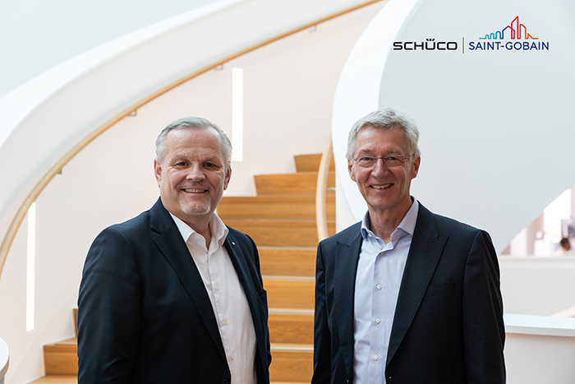
Andreas Engelhardt, Managing Partner and CEO of Schüco, and Raimund Heinl, CEO of Saint-Gobain Germany and Austria, are eager to promote glass recycling in the construction industry through this collaboration.

