Project report  April 2025 |  | Further information about publication:  Schüco International KG  Lisa Kottmann  Karolinenstr. 1 – 15  33609 Bielefeld  Tel.: +49 (0)5217837366  E-mail: PR@schueco.com  www.schueco.de/presse  www.schueco.com/press

“Square” Learning Centre newbuild, HSG St. Gallen
Learning bathed in light

Bielefeld. Open, transparent, flexible and simple. Designed by star Japanese architect Sou Fujimoto, this is the impression made by the new “Square” Learning Centre at the University of St. Gallen (HSG). The floor-to-ceiling glazed façade units with special Schüco AWS 90.SI CCF (Closed Cavity Façade) profiles required the highest level of precision in prefabrication, transportation and installation from all of the construction specialists involved.

Sou Fujimoto, who was born in Japan in 1971, is known for his radical way of thinking within architecture. The question that has driven him since the beginning of his career is: What must architecture and space look like to meet natural human needs? For him, success can be encouraged by spaces that allow people to interact, communicate and participate with each other. These social success factors are now also considered to be pioneering in education and corporate culture.

Maximum transparency for new types of learning
The new campus building, called the “Square”, is not intended to be a traditional university building, but instead a place for “inspiring encounters and lively dialogue across social, disciplinary and cultural boundaries”, as stated by the HSG on its website. To ensure that these principles are not an empty promise, Sou Fujimoto has designed a multi-level building volume on a square grid of 10 x 10 metres. It is not only characterised by maximum transparency on the inside, both vertically and horizontally, but also through its use of the most neutral materials. This makes the architecture so transparent, flexible and open that it encourages students to engage in creative, interdisciplinary and participatory learning. “Universities play an essential role,” says ‘Artistic Director’ Philippe Narval, “in providing the best possible training for young leaders, because the demands are so much higher than they were 30 years ago.”

All façade units connected to one another
To achieve the greatest possible degree of transparency and light in the interior and, in particular, on the façade, a sophisticated building envelope with glazed floor-to-ceiling, spandrel-free façade units was required. These are completely separate from the open building structure and directly connected to each other. While spandrels allow for adjustments and higher tolerances, the façade construction of the “Square” was only allowed to have the smallest possible tolerances. Aepli AG pre-fabricated the façade units in a closed cavity façade (CCF) in the factory using special profiles from Schüco. It is based on the Schüco AWS 90.SI (Super Insulated) window system.

A perfectly suited profile system
The Schüco AWS 90.SI aluminium window system perfectly meets structural requirements while offering the greatest possible design freedom – and was used here in the form of large, almost completely frameless windows to achieve the desired visual transparency. A further advantage for ambitious specifiers and architects when using Schüco AWS 90.SI is the wide range of profiles within the system platform, including corner and structural profiles, symmetrical and asymmetrical mullions, as well as additional combination options, such as with Schüco sun shading and ventilation systems.

For high levels of continuous loading
For the doors, the Schüco ADS 75 HD.HI (Heavy Duty.High Insulation) aluminium door system was used. It combines high durability with multiple functions and attractive design options – perfect for challenging commercial buildings with high security requirements. The extremely stable Heavy Duty system is designed specifically for heavy or oversized door leaves with large opening widths and high continuous loads. Additionally, it can be used as a multifunctional door, including integration in building security and automation, e.g. as a panic door in office and public buildings, hospitals and schools.

Project details

Client:
HSG Stiftung, St. Gallen
Architect:
Sou Fujimoto Architects, Tokyo and Paris
Local architect:
Burckhardt + Partner AG Architekten Generalplaner, Zürich
Main contractor:
HRS Real Estate AG, St. Gallen
Façade design:
Emmer Pfenninger Partner AG, Münchenstein BL
Façade construction:
Aepli AG, Gossau SG
Profiles used for the façade, including doors:

Bespoke profiles based on Schüco AWS 90.SI CCF
Schüco ADS 75 HD.HI doors

Schüco – System solutions for windows, doors and façades
Based in Bielefeld, the Schüco Group develops and sells system solutions for the building envelope made from aluminium, steel and PVC-U. The product range includes window, door, façade, ventilation, security and sun shading systems as well as smart and networked solutions for residential and commercial projects. Schüco also offers consultation and digital solutions for all phases of a building project – from the initial idea, design, fabrication and installation all the way through to the after-sales service including maintenance and servicing. Fabrication machinery and excellent customer service complement the product range. As a leading company in the construction industry, Schüco is committed to being a pioneer in holistic sustainability and using its products and services to make an active contribution towards achieving climate neutrality and a circular economy in the building trade. Founded in 1951, Schüco is now active in more than 80 countries and achieved a turnover of 2.11 billion euros in 2023 with 6750 employees.
For more information, visit www.schueco.com

Under the name Schüco Jansen Steel Systems, Schüco sells steel systems from the Swiss company Jansen AG exclusively in Germany, Denmark, Sweden, Norway, Finland, Iceland, Luxembourg, the UK, Greece, Cyprus (South) and the Baltic States. In return, Jansen AG sells Schüco products in Switzerland.

High resolution images are available to download in the Schüco Newsroom at www.schueco.de/presse.

Photography: Studio Gataric Photography, Zürich
Usage rights: Schüco International KG
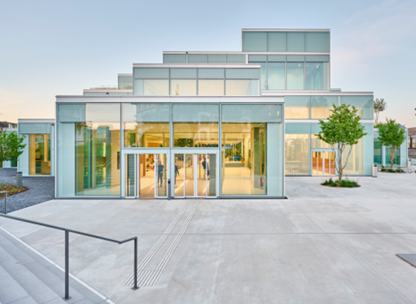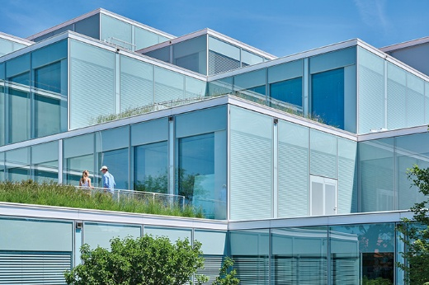
The high degree of transparency in the Learning Centre was achieved with the help of special profiles based on Schüco AWS 90.SI CCF.

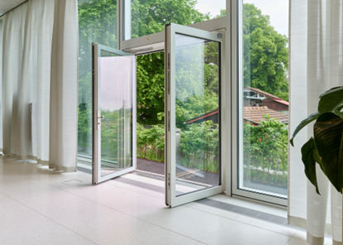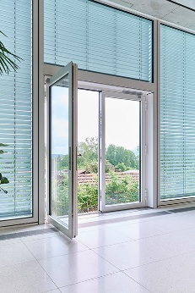
The Schüco ADS 75 HD.HI (Heavy Duty.High Insulation) aluminium door system used combines durability with multiple functions and attractive design options. It is perfect for challenging commercial buildings, including those with high security requirements.

