Press release  January 2025 |  | Further information about publication:  Schüco International KG  Lisa Kottmann  Karolinenstr. 1 – 15  33609 Bielefeld  Tel.: +49 (0)5217837366  E-mail: PR@schueco.com www.schueco.de/presse www.schueco.com/press

Protecting human lives and property
Schüco Deflame

Bielefeld. Schüco Deflame is a fire-resistant spandrel area that prevents the vertical fire spread to the upper floor in the event of a fire. In addition to stopping the unrestricted spreading of fire, the complete spandrel area of the façade also prevents the transfer of a critical temperature to the upper floors. The fire-resistant solution could only be used previously in the Schüco FWS 50/60 mullion/transom façades, but now it is also available for use in the Schüco AF UDC 80 unitized façades (Aluminium Façade, Unitized Dynamic Construction), including for the SG construction option with full height glazing elements.

The Schüco Deflame fire-resistant spandrel panel is characterised by thermal separation and special inserts for the cavities, which reliably restrict the spread of fire and temperature to the floors above if a fire occurs. As a result, adjacent components are also prevented from spontaneously igniting. With Schüco Deflame, curtain walls with a fire-resistant spandrel area can be easily realized, offering system-tested safety in fire resistance classes from EI 30 to EI 120.

Fire protection and design freedom
Schüco Deflame is fully integrated in the opaque area of the façade construction. This means the protected area is visually indistinguishable from the parts without fire-resistant requirements on the spandrel area of the façade. The panel also offers design freedom: the opaque exterior can be designed with non-combustible materials such as sheet metal or glass. Floor-to-ceiling views are still also possible with Schüco Deflame. This is because the fire-resistant spandrel area of a façade can be designed as a lower or upper spandrel solution. A combination of both options is also possible − for flexible planning and façade design.

Fabrication and installation
Schüco Deflame is supplied to size together with the prefabricated mullion insert profiles, as well as other articles for sealing the hollow chambers. No specific tools or machinery are required. As usual, the required steel sheets and insulation materials are procured by the fabricators themselves. A special certification is not required for the fabricator of Schüco Deflame, as it is a classified system according to the product standard for façades.

Importance of fire-resistant spandrel areas
If a fire starts, it can result in the critical temperature spreading through the floor slab, the gap between the floor slab and the façade, through openings and through the façade itself. Even if the façade is built entirely from non-combustible materials, this does not guarantee safety. Passive fire resistance measures such as Schüco Deflame, which prevent the spread of fire, are therefore particularly useful and necessary in curtain walls. This makes it possible to contain the fire in the respective fire compartments and prevent it from spreading to the floors above. Everyone involved in the planning, construction and maintenance of a building is responsible for the use of effective fire resistance measures.

Schüco Deflame is a system solution that has been tested in accordance with the latest European standards and can be used as an effective fire barrier and compartmentation in Schüco curtain walls to protect human life and property.

Schüco – System solutions for windows, doors and façades
Based in Bielefeld, the Schüco Group develops and sells system solutions made of aluminium, steel and PVC-U for the building envelope. The product portfolio includes window, door, façade, ventilation, security and sun shading systems, as well as intelligent networked solutions for residential and commercial projects. Schüco also provides consultancy and digital solutions for all phases of a building project – from the initial idea through to design, fabrication and installation, as well as after sales with maintenance and servicing. Fabrication machinery and customer-oriented service complement the product portfolio. As one of the leading companies in the construction industry, Schüco is committed to being a pioneer for comprehensive sustainability and to making an active contribution to climate neutrality and the circular economy within the construction sector through its products and services. Founded in 1951, Schüco is now active in more than 80 countries and achieved a turnover of 2.11 billion euros in 2023 with 6750 employees. For more information, visit www.schueco.com

High-resolution pictures are available to download in the Schüco Newsroom at www.schueco.com/press

Picture credits: Schüco International KG
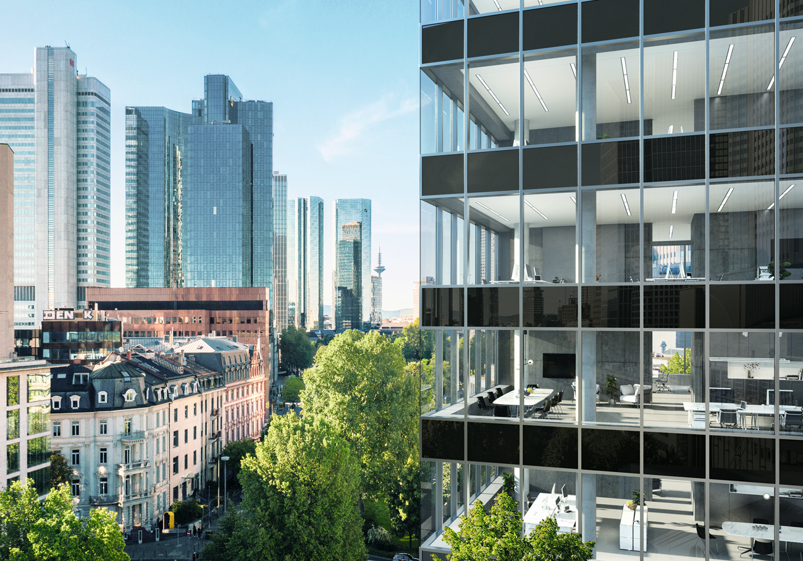
The Schüco Deflame fire-rated panel is a fire-resistant, fully integrated spandrel panel which spandrel area which prevents the vertical fire spread to upper levels.

Picture credits: Schüco International KG
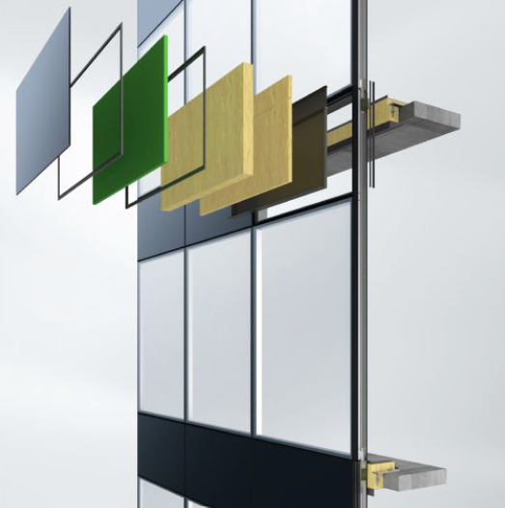
With Schüco Deflame, curtain walls can be constructed with a fire-resistant spandrel area for system-tested safety in fire resistance classes from EI 30 to EI 120.

