Press release  January 2025 |  | Further information about publication:  Schüco International KG  Sandra Greiser  Karolinenstr. 1 – 15  33609 Bielefeld  Tel.: +49 (0)5217831174  E-mail: PR@schueco.com  www.schueco.com/press  www.schueco.com/press

For modernisation projects and newbuilds

Schüco FocusIng

Bielefeld/Weißenfels. Schüco FocusIng, the sustainable and performance-optimised PVC-U window system, is now available for purchase and can already be found in the Schüco Homes web special. The system with its linear design is particularly suitable for modernisation projects thanks to its basic depth of 70/76 millimetres. It is presented digitally in individual construction situations and can be used as a visual consulting tool. Thanks to a sustainable and resource-optimised PVC-U formula that consists of up to 50 percent recycled material, Schüco FocusIng also contributes to a lower carbon footprint.

With FocusIng, Schüco offers a PVC-U window system with a medium basic depth and excellent structural values. It has been designed to contain as much recycled material as possible and to make efficient use of materials. The PVC-U profiles are manufactured with a proportion of at least 50% recycled materials. The recycled material comprises either end-of-life PVC – in other words, old window materials which were already installed in buildings and then recycled – or production remnants from the manufacture of PVC-U profiles and windows. Schüco FocusIng is also distinguished by the Vinyl-verified label, which makes it easy for clients to identify sustainable PVC-U products. Those who would like to further reduce their carbon footprint have the additional option to order Schüco FocusIng made from bio-attributed PVC from renewable raw materials. With bio-attributed PVC, crude oil is replaced by tall oil, which is a by-product of paper production. The various PVC options are part of Schüco Carbon Control, which is the initiative to minimise the carbon footprint of the building envelope.

Familiar machining positions and the best thermal insulation values
To ensure optimum work processes, a high degree of compatibility with the Schüco LivIng and Schüco CT 70 systems was also ensured during the development of Schüco FocusIng. Attachment and supplementary profiles as well as steel reinforcements and standard glazing beads can be used in the same way on all the system platforms. Moreover, the recesses for ventilation and drainage on all the main profiles are identical and the machining positions for Schüco FocusIng remain unchanged from those for Schüco LivIng. Overall, this results in less work for fabrication and warehouse storage, whilst maintaining the usual high level of process reliability. Pre-fitted gaskets and optimised accessories complete the well-thought-out design.

Structurally, Schüco FocusIng boasts a 5 or 6-chamber profile design with an optimised chamber geometry, the option to install triple glazing and a central or rebate gasket with two weldable drainage levels. The basic depth of the outer frame is 70 millimetres with a vent frame of 76 millimetres. Glazing between 10 and 54 millimetres is possible. Schüco FocusIng is therefore suitable for use in both modernisation projects and newbuilds. A wide range of unit options including single-field and multi-field windows, tilt/slide windows, window doors and side entrance doors mean that it can be used in very diverse construction scenarios. The system also achieves a U_{f} value to 1.1 W/(m²K) and a Uw value of below 0.80 W/(m²K) with the appropriate triple glazing. Overall, Schüco FocusIng can reduce energy loss and also contribute to a reduction in heating costs in (modernisation) projects, as well as help preserve the value of the buildings. Schüco FocusIng is available up to burglar resistance class RC2.

Give your home that feel-good factor
Alongside its structural properties, Schüco FocusIng also impresses with its appearance. Over 300 different surface finish designs as standard and special foils with metallic, single colour and woodgrain finishes enable individual design freedom. The modern design with clear, linear contours and narrow, flat rebates also offers a stylish aluminium look. The SELECTED by Schüco on-trend foils impress with their unparalleled aluminium and timber feel. The design possibilities are endless, which is why it can also be seamlessly combined with other Schüco systems made of PVC-U and aluminium. Along with its outstanding appearance, Schüco FocusIng offers excellent acoustics as the system enables sound reduction of up to 48 decibels. Regardless of the source of the noise outside, the interior stays pleasantly quiet. With the optional Schüco VentoAir, VentoAir+ and VentoTherm Twist ventilation systems (in co-operation with Renson), self-ventilating solutions are available that also allow effective room ventilation without having to open the window. For window door units, there are optional level thresholds available which guarantee ease of access for maximum comfort.

www.schueco.de/focusing
www.schueco-homes.com

Schüco – System solutions for windows, doors and façades
Based in Bielefeld, the Schüco Group develops and sells system solutions made of aluminium, steel and PVC-U for the building envelope. The product portfolio includes window, door, façade, ventilation, security and sun shading systems, as well as intelligent networked solutions for residential and commercial projects. Schüco also provides consultancy and digital solutions for all phases of a building project – from the initial idea through to design, fabrication and installation, as well as after sales with maintenance and servicing. Fabrication machinery and customer-oriented service complement the product portfolio. As one of the leading companies in the construction industry, Schüco is committed through its products and services to being a pioneer for comprehensive sustainability and actively contributing to climate neutrality and the circular economy within the construction sector. Founded in 1951, Schüco is now active in more than 80 countries and achieved a turnover of 2.11 billion euros in 2023 with 6750 employees.
For more information, visit www.schueco.com

High-resolution pictures are available to download in the Schüco Newsroom at www.schueco.com/press

Usage rights: Schüco International KG
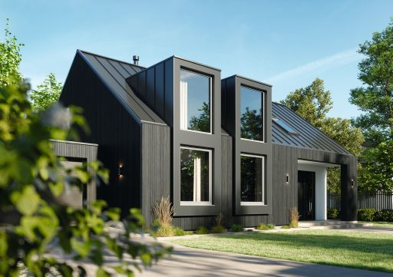
The Schüco FocusIng PVC-U system boasts a modern appearance, a high proportion of recycled material and excellent thermal insulation values.

Usage rights: Schüco International KG
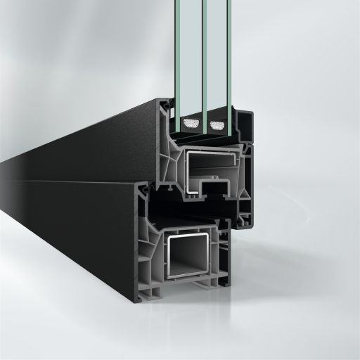
Harmonious appearance: Schüco FocusIng with a dark surface finish and grey PVC-U frame profiles.

Usage rights: Schüco International KG
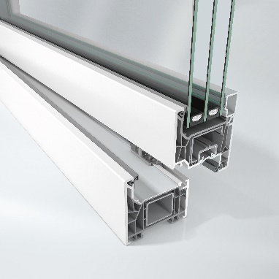
Sustainable material: Schüco FocusIng is made from a sustainable, resource-optimised PVC-U formula consisting of up to 50% recycled material and is also available with bio-attributed PVC-U.

Usage rights: Schüco International KG
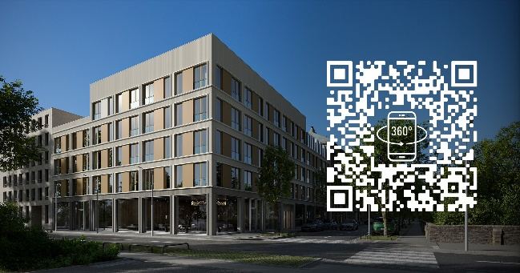
The Schüco FocusIng system can be experienced as a 360° digital tour on the "Schüco Homes" website.

