Press release  January 2025 |  | Further information about publication:  Schüco International KG  Sandra Greiser  Karolinenstr. 1 – 15  33609 Bielefeld  Tel.: +49 (0)5217831174  E-mail: PR@schueco.com  www.schueco.com/press  www.schueco.com/press

For modernisation projects and newbuilds

Schüco FocusIng – sustainable PVC-U windows

Bielefeld/Weißenfels. FocusIng is the new sustainable window system from Schüco that has a wide variety of design options. Whether it is used for modernisation projects or newbuilds, the series is sure to impress with its excellent thermal insulation values, low carbon footprint and over 300 surface finishes, from a stylish aluminium look and warm woodgrain finishes to colourful accents. On the Schüco Homes website, the different design options for Schüco FocusIng can be explored for your own four walls with 360-degree views. Optional ventilation systems, barrier-free thresholds and burglar resistance up to resistance class RC2 provide additional convenience and security.

With FocusIng, Schüco has developed a PVC-U series which impresses aesthetically as well as with optimum performance characteristics. Over 300 different surface finish designs as standard and special foils with metallic, single colour and woodgrain finishes enable individual design freedom. The modern design with clear, linear contours and narrow, flat rebates also offers a stylish aluminium look. With the SELECTED by Schüco on-trend foils, there is a high-quality selection of surface finishes which, in addition to the look, also impress with a realistic feel reminiscent of aluminium or wood. The design possibilities are endless and it can also be combined with different PVC-U and aluminium Schüco systems to achieve a seamless appearance.
It is therefore possible to replace individual windows without having to make compromises on the design. Along with its outstanding appearance, Schüco FocusIng offers excellent acoustics in that the system enables sound reduction of up to 48 decibels. Regardless of the source of the noise outside, the inside spaces remain comfortably quiet. With the optional Schüco VentoAir, VentoAir+ and VentoTherm Twist ventilation systems (in co-operation with Renson), self-ventilating solutions are available to provide effective room ventilation without having to open the window. Schüco FocusIng can be designed with burglar resistance up to RC2, which provides an additional level of security. For balcony or terrace doors in the series, barrier-free zero-level thresholds are available that guarantee maximum convenience. For inspiration, Schüco FocusIng with all its features and design options can be explored in a 360-degree virtual tour at www.schueco-homes.de.

Sustainable and energy-efficient
In terms of design, Schüco FocusIng has a medium basic depth combined with optimum performance properties. Glazing between 10 and 54 millimetres is possible. Schüco FocusIng is suitable for use in both modernisation projects and newbuilds. A wide range of unit options including single-field and multi-field windows, tilt/slide windows, window doors and side entrance doors mean that it can be used in a diverse range of construction scenarios, from modern newbuilds to historical country homes. The series impresses with excellent thermal insulation values. The U_{f} value (thermal insulation of the window without glass) is 1.1 W/(m²K) and the U_{w} value (thermal insulation with glass) is under 0.80 W/(m²K) with the appropriate triple glazing. Overall, Schüco FocusIng systems can reduce energy loss in a home and also contribute to a reduction in heating costs in modernisation projects, as well as help preserve the value of the building.

Schüco FocusIng features a low carbon footprint thanks to its high proportion of recycled content and efficient material use. The PVC-U frame profiles are manufactured with a proportion of at least 50% recycled materials. The recycled material comprises either end-of-life PVC – in other words, old window materials which were already installed in buildings and then recycled – or production remnants from the manufacture of PVC-U profiles and windows. Schüco FocusIng is also distinguished by the Vinyl-verified label, which makes it particularly easy to identify sustainable PVC-U products. Those who would like to further reduce the carbon footprint of their new windows have the additional option to order Schüco FocusIng made from bio-attributed PVC from renewable raw materials. With bio-attributed PVC, crude oil is replaced by tall oil, which is a by-product of paper production. This is a renewable, non-fossil raw material made from pine trees. For each delivery of this material variant, a certificate detailing the proportion of bio-attributed PVC and the corresponding CO₂ savings will be issued.

www.schueco-homes.com

Schüco – System solutions for windows, doors and façades
Based in Bielefeld, the Schüco Group develops and sells system solutions made of aluminium, steel and PVC-U for the building envelope. The product portfolio includes window, door, façade, ventilation, security and sun shading systems, as well as intelligent networked solutions for residential and commercial projects. Schüco also provides consultancy and digital solutions for all phases of a building project – from the initial idea through to design, fabrication and installation, as well as after sales with maintenance and servicing. Fabrication machinery and customer-oriented service complement the product portfolio. As one of the leading companies in the construction industry, Schüco is committed to being a pioneer for comprehensive sustainability and to making an active contribution to climate neutrality and the circular economy within the construction sector through its products and services. Founded in 1951, Schüco is now active in more than 80 countries and achieved a turnover of 2.11 billion euros in 2023 with 6750 employees.
For more information, visit www.schueco.com

High-resolution pictures are available to download in the Schüco Newsroom at www.schueco.com/press

Usage rights: Schüco International KG
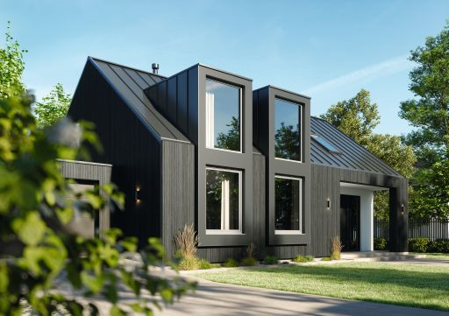
The Schüco FocusIng PVC-U system boasts a modern appearance, a high proportion of recycled material and excellent thermal insulation values.

Usage rights: Schüco International KG
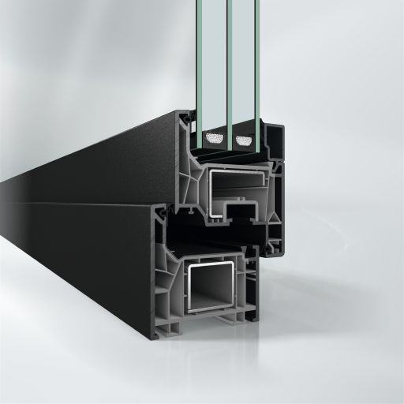
Harmonious appearance: Schüco FocusIng with a dark surface finish and grey PVC-U frame profiles.

Usage rights: Schüco International KG
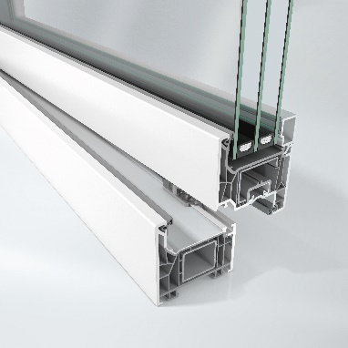
Sustainable material: Schüco FocusIng is made from a sustainable, resource-optimised PVC-U formula consisting of up to 50% recycled material and is also available with bio-attributed PVC-U.

Usage rights: Schüco International KG
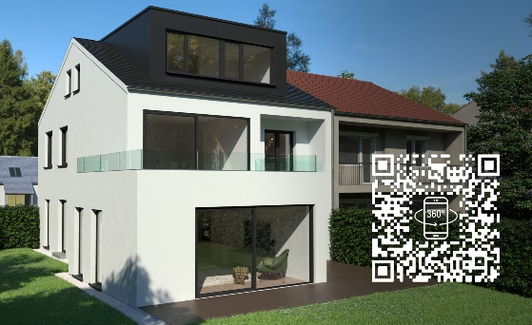
The Schüco FocusIng system can be experienced as a 360° digital tour on the "Schüco Homes" website.

