Press release  January 2025 |  | Further information about publication:  Schüco International KG  Sandra Greiser  Karolinenstr. 1 – 15  33609 Bielefeld  Tel.: +49 (0)5217831174  E-mail: PR@schueco.com  www.schueco.com/press  www.schueco.com/press

For renovation projects and newbuilds

Schüco FocusIng

Bielefeld/Weißenfels. Schüco FocusIng, the sustainable and resource-optimised PVC-U system for window units, is now available for purchase. The linear system is suitable for both renovation projects and newbuilds with a basic depth of 70/76 millimetres and impresses with its excellent thermal insulation values and a low carbon footprint. Whether it is a stylish aluminium look, warm woodgrain finishes or a colourful accent, there are suitable design options for every building.

With FocusIng, Schüco now offers a PVC-U system with a medium basic depth, but excellent structural values. The system impresses with a 5 or 6-chamber profile design, the option of triple glazing and a central or rebate gasket with two weldable drainage levels. The basic depth of the outer frame is 70 millimetres with a vent frame of 76 millimetres. Glazing between 10 and 54 millimetres is possible. Schüco FocusIng is suitable for use in both renovation projects and newbuilds. A wide range of unit options including single-field and multi-field windows, tilt/slide windows, window doors and side entrance doors mean that it can be used in very diverse construction scenarios, from modern commercial projects to historical country homes. The system also boasts excellent thermal insulation properties with a U_{f} value to 1.1 W/(m²K) and a Uw value of below 0.80 W/(m²K) with the appropriate triple glazing. Overall, Schüco FocusIng can reduce energy loss, contribute to a reduction in heating costs in modernisation projects and help preserve the value of the building. Schüco FocusIng is available up to resistance class RC2.

In its construction, Schüco FocusIng is designed to have the highest possible proportion of recycled content and efficient material use. The PVC-U profiles are manufactured with a proportion of at least 50% recycled materials. The recycled material comprises either end-of-life PVC – in other words, old window materials which were already installed in buildings and then recycled – or production remnants from the manufacture of PVC-U profiles and windows. Schüco FocusIng is also distinguished by the Vinyl-verified label, which makes it easy for clients to identify sustainable PVC-U products. Those who would like to further reduce their carbon footprint have the additional option to order Schüco FocusIng made from bio-attributed PVC from renewable raw materials. With bio-attributed PVC, crude oil is replaced by tall oil, which is a by-product of paper production. The various PVC options are part of Schüco Carbon Control, which is the initiative to minimise the carbon footprint of the building envelope.

Focus on design and comfort
Alongside structural characteristics, Schüco FocusIng also impresses with its appearance. Over 300 different surface finish designs as standard and special foils with metallic, single colour and woodgrain finishes enable individual design freedom. The modern design with clear, linear contours and narrow, flat rebates also offers a stylish and aesthetically pleasing aluminium look. The SELECTED by Schüco on-trend foils also impress with their unparalleled aluminium and timber feel. The design possibilities are endless and it can also be easily combined with different Schüco PVC-U and aluminium systems to achieve a seamless appearance. Along with its outstanding appearance, Schüco FocusIng offers excellent acoustics as the system enables sound reduction of up to 48 decibels. Regardless of the source of the noise outside, the interior stays pleasantly quiet. With the optional Schüco VentoAir, VentoAir+ and VentoTherm Twist ventilation systems (in co-operation with Renson), self-ventilating solutions are available that also allow effective room ventilation without having to open the window. For window door units, there are optional level thresholds available which guarantee ease of access for maximum comfort.

www.schueco.de/focusing
www.schueco-homes.com

Schüco – System solutions for windows, doors and façades
Based in Bielefeld, the Schüco Group develops and sells system solutions made of aluminium, steel and PVC-U for the building envelope. The product portfolio includes window, door, façade, ventilation, security and sun shading systems, as well as intelligent networked solutions for residential and commercial projects. Schüco also provides consultancy and digital solutions for all phases of a building project – from the initial idea through to design, fabrication and installation, as well as after sales with maintenance and servicing. Fabrication machinery and customer-oriented service complement the product portfolio. As one of the leading companies in the construction industry, Schüco is committed to being a pioneer for comprehensive sustainability and to making an active contribution to climate neutrality and the circular economy within the construction sector through its products and services. Founded in 1951, Schüco is now active in more than 80 countries and achieved a turnover of 2.11 billion euros in 2023 with 6750 employees.
For more information, visit www.schueco.com

High-resolution pictures are available to download in the Schüco Newsroom at www.schueco.com/press

Usage rights: Schüco International KG
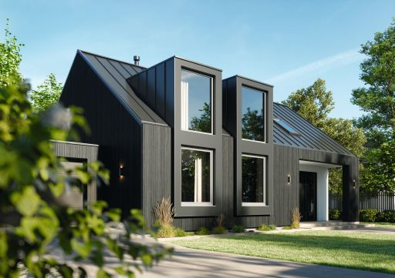
The Schüco FocusIng PVC-U system boasts a modern appearance, a high proportion of recycled material and excellent thermal insulation values.

Usage rights: Schüco International KG
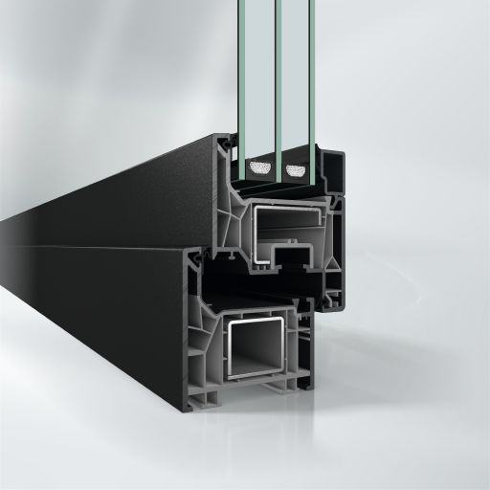
Harmonious appearance: Schüco FocusIng with a dark surface finish and grey PVC-U frame profiles.

Usage rights: Schüco International KG
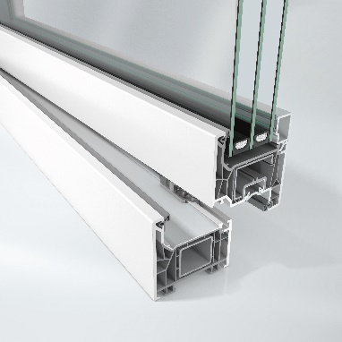
Sustainable material: Schüco FocusIng is made from a sustainable, resource-optimised PVC-U formula consisting of up to 50% recycled material and is also available with bio-attributed PVC-U.

Usage rights: Schüco International KG
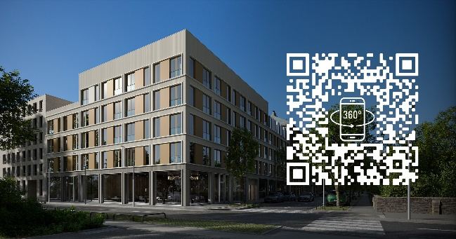
The Schüco FocusIng system can be experienced as a 360° digital tour on the "Schüco Homes" website.

