Press release  January 2025 |  | Further information about publication:  Schüco International KG  Sandra Greiser  Karolinenstr. 1 – 15  33609 Bielefeld  Tel.: +49 (0)5217831174  E-mail: PR@schueco.com  www.schueco.com/press  www.schueco.com/press

Schüco AOC 50 / 60 Reno

Efficient upgrading of mullion/transom and transom/transom façades

Bielefeld. Schüco is expanding its contribution to adaptive reuse with the AOC 50 / 60 Reno refurbishment solution. The new project-specific custom façade design enables a functional and energy-efficient upgrade of existing mullion/transom and transom/transom façades that are structurally still in very good condition – without complex dismantling of the old system. Using adapter profiles, the tried-and-tested Schüco AOC add-on construction, including a completely new sealing and insulation level, is built over the existing load-bearing structures. It is both cost-effective and time-efficient.

The AOC 50 / 60 Reno system allows for façade refurbishment even while the building is still in use, without lengthy interruptions or renovation work in the indoor spaces. The interior attachments remain undisturbed throughout the refurbishment. Once the cover caps have been taken off, the glass is removed from the old existing façade followed by the gaskets and glass carriers. The new façade system is then attached to the existing load-bearing structure from the outside and screwed in place. Thanks to the use of individual adapter profiles, the add-on construction can be installed over the old Schüco mullion/transom or transom/transom façade, or it can also be installed on a third-party system that is not from Schüco. AOC 50 / 60 Reno is also suitable for the functional and energy-efficient refurbishment of glass roofs.
The positive effects of upgrading in terms of operation and energy efficiency are achieved by replacing the glazing, as well as the infill panels and isolators if necessary, which leads to a significant improvement in the U_{CW} values of the façade. The continuous gasket system of the add-on construction provides a whole new sealing and insulation level, which achieves a thermal insulation value U_{f} to 0.75 W/(m²K) with a glass or infill thickness of 8 to 70 millimetres. The excellent values for air permeability (Class AE 1950) and watertightness (Class RE 1950) also resolve further potential weaknesses of the old system.

Functional upgrades for pioneering properties
Alongside improvements in weathertightness and thermal insulation, new functions can also be integrated into the building envelope which provide sustainable and forward-looking enhancements to the property. Changes in the façade fields enable the use of opening elements, sun shading or building-integrated photovoltaics (BIPV).
There are further benefits in fabrication and installation as building over existing building attachments and pre-punched profiles, which do not require any additional drilling, saves time when installing the new functional level. It can also be cut to size on site, which makes it easier to adjust to individual conditions. A high number of identical parts for profiles and gaskets as well as the tried-and-tested Schüco AOC gasket system, which offers a gasket for every requirement, round off the benefits for time-saving and efficient fabrication.

www.schueco.com

Schüco – System solutions for windows, doors and façades
Based in Bielefeld, the Schüco Group develops and sells system solutions made of aluminium, steel and PVC-U for the building envelope. The product portfolio includes window, door, façade, ventilation, security and sun shading systems, as well as intelligent networked solutions for residential and commercial projects. Schüco also provides consultancy and digital solutions for all phases of a building project – from the initial idea through to design, fabrication and installation, as well as after sales with maintenance and servicing. Fabrication machinery and customer-oriented service complement the product portfolio. As one of the leading companies in the construction industry, Schüco is committed to being a pioneer for comprehensive sustainability and to making an active contribution to climate neutrality and the circular economy within the construction sector through its products and services. Founded in 1951, Schüco is now active in more than 80 countries and achieved a turnover of 2.11 billion euros in 2023 with 6750 employees.
For more information, visit www.schueco.com

High-resolution pictures are available to download in the Schüco Newsroom at www.schueco.com/press

Usage rights: Schüco International KG
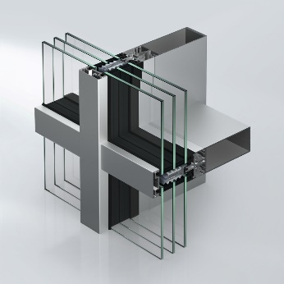
Schüco AOC 50 / 60 Reno enables façade refurbishment even while the building is still in use, without lengthy interruptions or renovation work in the indoor spaces.

Usage rights: Schüco International KG
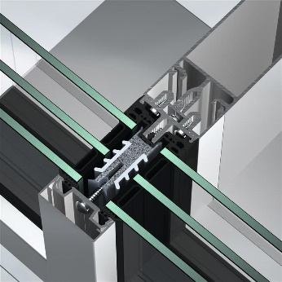
The upgrade benefits of the Schüco AOC 50 / 60 Reno system are achieved by replacing the glazing, as well as infill panels and isolators if necessary.

Usage rights: Schüco International KG
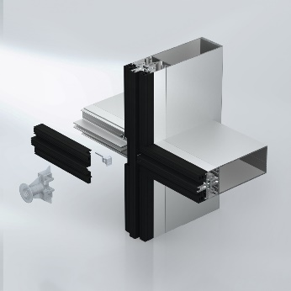
AOC 50 / 60 Reno can be installed over the old Schüco mullion/transom or transom/transom façade thanks to the use of individual adapter profiles, or it can also be installed on a third-party system that is not from Schüco.

Usage rights: Schüco International KG
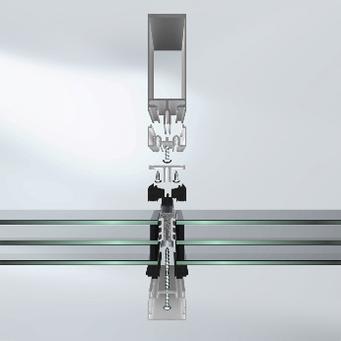
The new Schüco AOC 50 / 60 Reno façade system is then attached to the existing load-bearing structure from the outside and screwed in place.

