Press release  January 2025 |  | Further information about publication:  Schüco International KG  Sandra Greiser  Karolinenstr. 1 – 15  33609 Bielefeld  Tel.: +49 (0)521783-1174  E-mail: PR@schueco.com  www.schueco.com/press  www.schueco.com/press

Sliding systems made from high-performance materials:

Luxury brand Venuro debuts at BAU 2025

Bielefeld. The Schüco brand portfolio is growing. From January 2025, Schüco is offering customised sliding systems as high-quality, unique products made from glass fibre and carbon fibre-reinforced composite materials under the newly founded brand Venuro. This will give the Schüco Group access to the luxury segment. Venuro AG is headquartered in Wädenswil, Switzerland.

The launch of the Venuro brand adds the luxury segment to the Schüco Group portfolio with a focus on German-speaking and select international markets. This brand targets private clients and architects with highly sophisticated architectural visions. The Venuro product range is distinguished by a distinct aesthetic together with extraordinary structural properties. “Our aim is to create exceptional residential architecture with our unique sliding systems, for customers who value that something special,” comments Dr Daniel Thaden, Managing Director of Venuro AG.

Venuro prioritises a high level of craftsmanship, with every product being unique and handmade with passion and precision in Switzerland’s Wädenswil near Zurich. What’s special about the sliding systems is that they are made from high-performance glass fibre and carbon fibre-reinforced polymers and ensure very slim sightlines, high stability and outstanding thermal insulation properties. It is therefore possible to make very large sliding units with concealed frames for a high degree of transparency and guaranteed ease of access.

www.venuro.com

Schüco – System solutions for windows, doors and façades
Based in Bielefeld, the Schüco Group develops and sells system solutions made of aluminium, steel and PVC-U for the building envelope. The product portfolio includes window, door, façade, ventilation, security and sun shading systems, as well as intelligent networked solutions for residential and commercial projects. Schüco also provides consultancy and digital solutions for all phases of a building project – from the initial idea through to design, fabrication and installation, as well as after sales with maintenance and servicing. Fabrication machinery and customer-oriented service complement the product portfolio. As one of the leading companies in the construction industry, Schüco is committed through its products and services to being a pioneer for comprehensive sustainability and actively contributing to climate neutrality and the circular economy within the construction sector. Founded in 1951, Schüco is now active in more than 80 countries and achieved a turnover of 2.11 billion euros in 2023 with 6750 employees.
For more information, visit www.schueco.com

High-resolution pictures are available to download in the Schüco Newsroom at www.schueco.com/press

Picture credits: Venuro AG
Usage rights: Schüco International KG

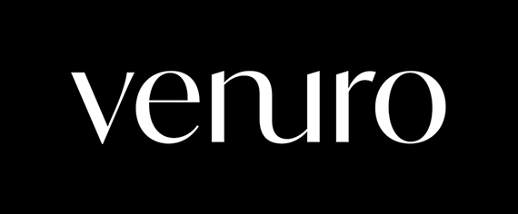
Venuro logo.

Picture credits: MPG Media Picture Group: Kevin Krefta
Usage rights: Schüco International KG


Venuro: Unique sliding systems made from glass fibre and carbon fibre-reinforced composite materials for exceptional residential architecture.

