Press release  January 2025 |  | Further information about publication:  Schüco International KG  Ute Minartz  Karolinenstr. 1 – 15  33609 Bielefeld  Tel.: +49 (0)521783-6307  E-mail: PR@schueco.com  www.schueco.com/press  www.schueco.com/press

Extended product range

Schüco Perfect: One system – A world of possibilities

Bielefeld. Schüco Perfect is a window or sliding unit which functions as a complete solution for all trades with integrated, important additional functions. It is suitable for newbuilds and for renovation measures that increase value. At BAU 2025, the company is presenting an enhanced range of products using PVC-U and aluminium units.

If window and sliding units are combined with additional components – such as sun shading or a flyscreen, a window sill, a safety barrier or a level threshold – multiple trades often have to be linked together, which can result in more planning, fabrication and installation work. The Schüco Perfect solution, which all comes from a single source, is a complete solution across interfaces and materials, which combines a high level of planning reliability with a fabrication and construction process that is optimised in terms of time and costs.

Schüco Perfect modular all-in-one solution
Schüco Perfect consists of a window or sliding unit and a façade-mounted “Perfect module” made from aluminium. This is available in system basic depths of 130 mm and 190 mm for the lateral guide tracks, which means different add-ons can be selected and combined as required depending on the construction project and individual requirements. The three sun shading options available for this are: external blinds (for targeted light control), roller shutter blinds (for perfect darkening of rooms) or textile Zip Design Screen sun shading (for an individual colour design). For residential buildings of less than 200 m², wireless control via remote control or an app is now possible. All sun shading options can be time or sensor-controlled and react to the respective weather conditions to automatically move into the optimum position. Along with sun shading, a flyscreen can be installed either as a vertical roller shutter or as a horizontal pleated blind. As a seal with the floor, the module can be fitted with a feature window sill, a safety barrier in the form of an integrated glass or balustrade design, or a level threshold with a drainage channel (option for a 20 mm threshold). Subsequently, it is also possible to exchange components at any time.

New: Schüco LivIng Perfect PVC-U units
The Perfect complete solution can now also be installed with Schüco LivIng PVC-U window systems and Schüco LivIngSlide lift-and-slide door systems. This means that various user-oriented add-ons can be integrated as required without interfaces to other trades. A uniform colour design of the complete system is easy to achieve using powder coating.

New: Schüco Perfect aluminium ribbon windows
Until now, only the Schüco aluminium window system with a basic depth of 75 mm (AWS 75.SI+ system) and the aluminium sliding unit (Schüco ASE 60/80.HI sliding system) could be designed as a Schüco Perfect unit. To increase the planning and installation efficiency of ribbon window solutions, the building envelope specialist from Bielefeld is now also introducing the Schüco AWS 75.SI+ Perfect ribbon window solution. In contrast to the individual version, the adaptive Schüco Perfect add-on components in the ribbon window solution are guided along the continuous locating groove of the aluminium window. This benefits from a reduction in material and weight, and also in the structural components. Making its debut at BAU 2025, the Schüco AWS 75.SI+ Perfect ribbon window is expected to be available for purchase by the end of the year.

www.schueco.com/perfect-en

Schüco – System solutions for windows, doors and façades
Based in Bielefeld, the Schüco Group develops and sells system solutions made of aluminium, steel and PVC-U for the building envelope. The product portfolio includes window, door, façade, ventilation, security and sun shading systems, as well as intelligent networked solutions for residential and commercial projects. Schüco also provides consultancy and digital solutions for all phases of a building project – from the initial idea through to design, fabrication and installation, as well as after sales with maintenance and servicing. Fabrication machinery and customer-oriented service complement the product portfolio. As one of the leading companies in the construction industry, Schüco is committed to being a pioneer for comprehensive sustainability and to making an active contribution to climate neutrality and the circular economy within the construction sector through its products and services. Founded in 1951, Schüco is now active in more than 80 countries and achieved a turnover of 2.11 billion euros in 2023 with 6750 employees.
For more information, visit www.schueco.com

High-resolution pictures are available to download in the Schüco Newsroom at www.schueco.com/press

Picture credits: Schüco International KG

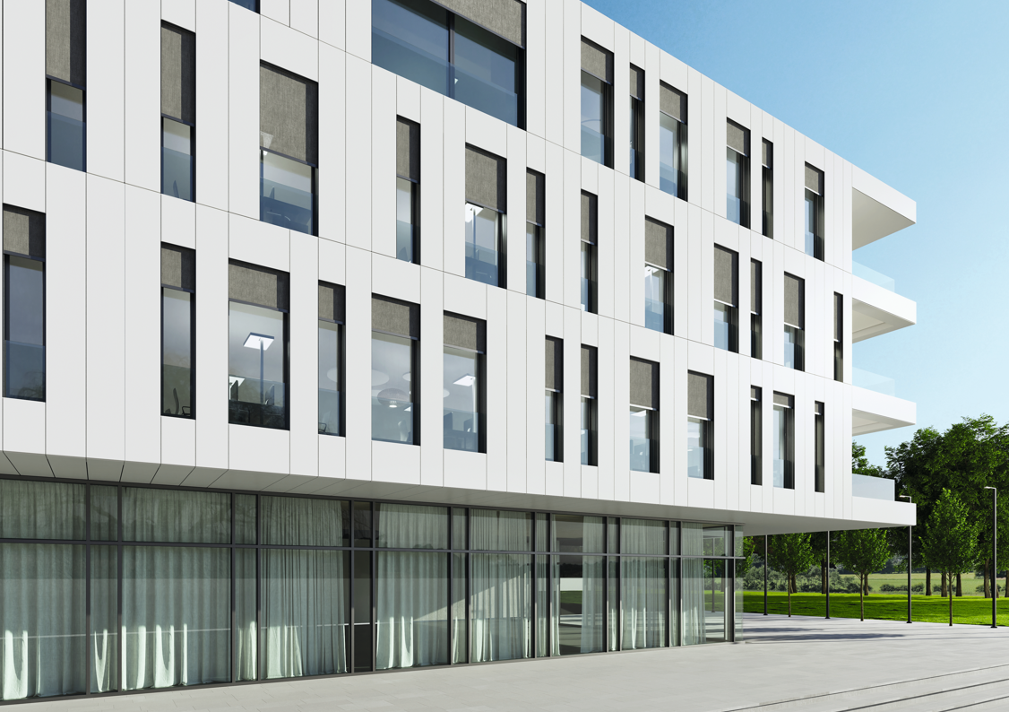
Schüco Perfect is the combination of a Schüco window or sliding unit (made from aluminium or PVC-U) with the façade-mounted, patented Perfect module as a fully integrated unit.

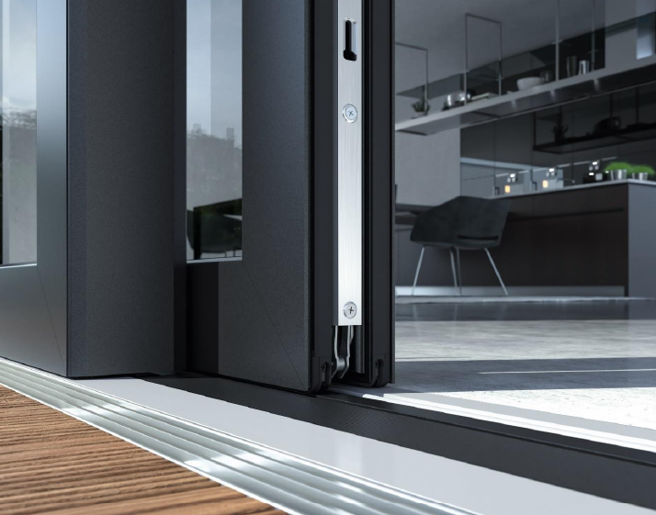
Schüco Perfect sliding unit with a barrier-free, zero-level threshold.

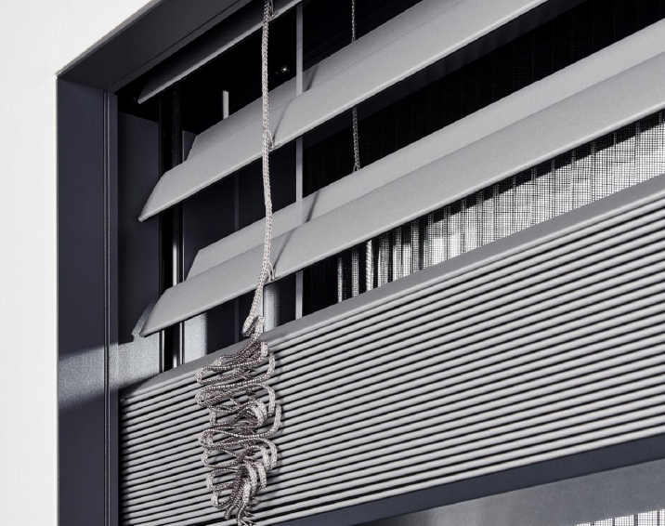
Schüco Perfect window unit with an external blind.

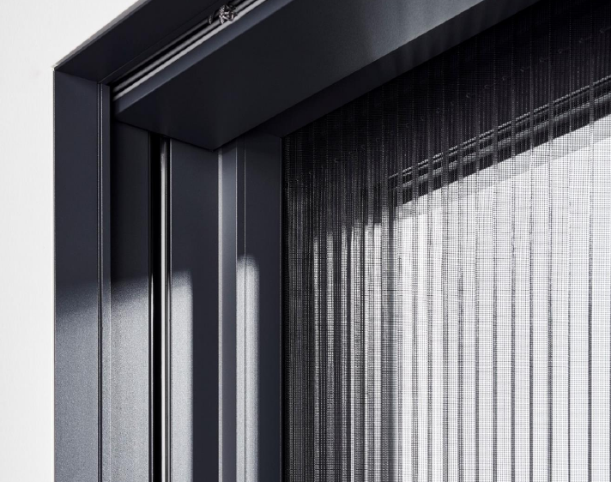
Schüco Perfect window unit with a flyscreen.

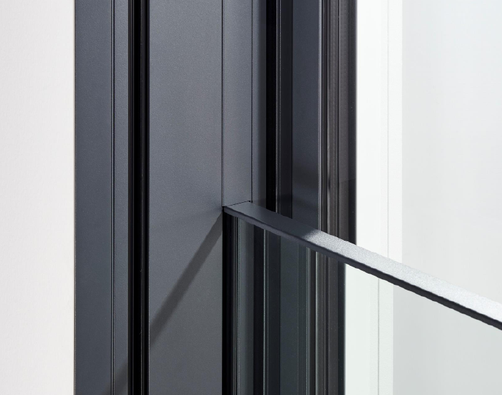
Schüco Perfect window door with an integrated safety barrier.

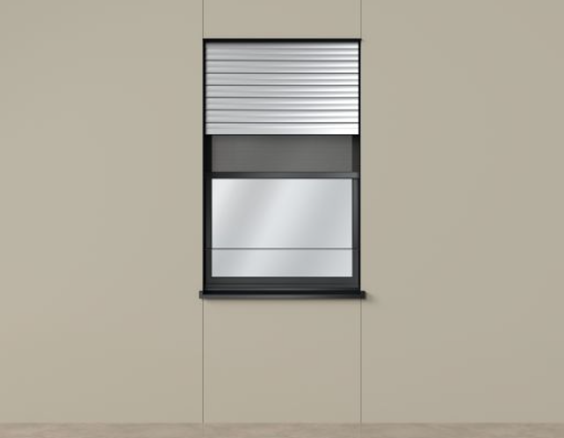
Schüco LivIng Perfect: supplemented with PVC-U.

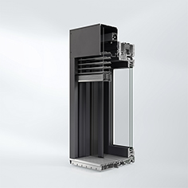
Schüco LivIngSlide Perfect: supplemented with PVC-U.

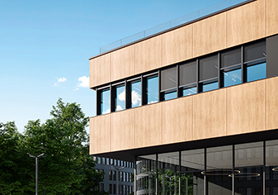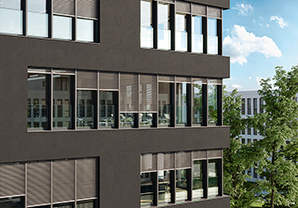
Schüco AWS 75.SI⁺ Perfect ribbon window.

