Press release  January 2025 |  | Further information about publication:  Schüco International KG  Sandra Greiser  Karolinenstr. 1 – 15  33609 Bielefeld  Tel.: +49 (0)5217831174  E-mail: PR@schueco.com  www.schueco.de/presse  www.schueco.com/press

Maintaining and increasing value

Schüco Value Up

Bielefeld. The buildings of the past are the buildings of the future. In order to meet the requirements of changing climate conditions, increasing security and new usage types, existing buildings need to be renovated and continually maintained. This is the only way to ensure properties retain their value in the long term. It's a complex task with many people involved. Schüco has developed a range of solutions specifically for this purpose, in order to create a value-enhancing, project-specific renovation process. From the analysis, planning and renovation right through to the operation of the building, Schüco Value Up offers products and services for the building envelope to decision-makers throughout all stages of the renovation process.

The current building stock contains a wealth of material resources and billions of invested capital. According to estimations by the European Commission, 85% to 95% of the current existing buildings will still be standing in 2050. Responsible handling of existing buildings, and the retention and increase of their value, are therefore becoming key challenges for the construction industry. However, this also presents opportunities. There is a great deal of economic potential in existing buildings. In the coming years, higher rates of growth are expected for this segment than for newbuilds. Driven by the European Green Deal with the aim of achieving climate neutrality in Europe by 2050, the focus is also on renovating buildings to be more energy efficient. This must be reconciled with the requirements for cost effectiveness, comfort and aesthetics in order to create buildings that retain their value in the long term.

Schüco Value Up
With Schüco Value Up, the Bielefeld-based building envelope specialist offers all those involved in the construction reliable products and services for all phases of the renovation process. Schüco divides the four phases into Analyse to Upgrade, Plan to Upgrade, Rebuild to Upgrade and Maintain to Upgrade.

At the start of the project, a high degree of transparency is paramount, in order to make the right long-term, profitable investment decisions for the renovation measures. That is why the analysis phase is so important. In the planning phase which follows, the foundations are laid for the subsequent implementation and, in particular, the long-term operation and functionality of the building. By bringing all of the possible parameters into harmony, the aim is to reduce planning complexity. The preparations from the first two phases then pay off during the subsequent implementation phase and help provide greater certainty and economic efficiency for the trades carrying out the work. Sustainability, however, is demonstrated above all through a long service life and functioning of a building. In the operation phase, continual maintenance and servicing of the units in line with requirements is therefore essential.

Analyse to Upgrade
Greater transparency in investment decisions
The basis for transparent investment decisions is a precise and detailed analysis of the building stock. This makes the renovation potential of the building envelope visible and measurable. With Value Up, Schüco provides investors and building operators with comprehensive analyses of the existing buildings for sound, economically viable decision-making. For this is the only way to retain and increase the value of a property in the long term.

To this end, Schüco offers a project-specific analysis of the existing building. Trained Schüco staff and partners consider the condition of the building and give advice regarding possible renovation concepts. Schüco then suggests suitable partner companies to carry out the work. The range of services for the comprehensive analysis of existing buildings comprises three flexible service package options specifically for the asset management of apartment buildings and non-residential buildings: inventory of the existing building, rough assessment of the energy efficiency and technical solutions with specific suggestions of renovation measures for windows, doors and façades. The measures range from minimally invasive interventions through to complete renovations. The carbon footprint, recycling values and subsidy options are incorporated into the calculation. The analysis of the existing building is rounded off by the Schüco subsidy service. Many of the Schüco products are eligible for funding in accordance with the German Federal Funding for Efficient Buildings programme (BEG). Free consultancy and individual subsidy checks for the materials aluminium, PVC-U and steel result in cost savings, greater profitability and therefore reduced associated risks when committing equity.

Plan to Upgrade
Reduced planning complexity
Schüco Value Up reduces complexity in the planning phase. With precise simulation and planning tools, architects and specialist planners can quickly and clearly understand project requirements. This means that uncertainty is minimised right from the early planning phase. Experienced Schüco experts support the development of tailored renovation concepts and individual solutions which fulfil requirements in terms of function, design and conservation of resources.

In order to establish sustainable raw material cycles for building products, Schüco gives advice during the early planning stage of renovation projects for environmentally friendly and economical recycling. Decision-makers receive a comprehensive, project-specific recycling concept, which includes the identification of the components and materials to be recycled, a quantity analysis of the material flows and an efficient logistics concept. In addition, a preliminary calculation of revenue from scrap, an estimate of the expected recycling rates and a description of the proof of recovery and certificates related to recycling are presented. In order to minimise risks, Schüco also offers renovation guidelines as an advisory document for fabricators. The guidelines clarify the responsibilities of the client and contractor, from consultancy to execution, including the analysis of the existing building and the definition of the work result as well as the limitation of liability. This reduces uncertainty in the planning of renovation projects and helps to minimise the rate of complaints.

Another service provided by the Technical Support teams is building physics calculations. The calculation of isotherms is a significant consideration in terms of building physics for avoiding damage to the building. These calculations require extensive specialist knowledge and experience, in particular when considering factors such as materials, temperature differences, humidity and the interaction of different components. Schüco experts provide support with precise and detailed calculations for the renovation project.

Schüco Building Physics Solver (BPS), the cloud-based calculation tool, enables reliable planning of renovation measures with just one click. With the free BPS tool, architects and planners can quickly and reliably simulate the project-specific suitability of Schüco aluminium window and façade systems in a single step during the early planning stage. This creates a reliable, efficient basis for planning individual renovation concepts. The offering is rounded off with the Schüco Data Hub, which is a cloud-based data interface between planners, metal fabricators and Schüco consultants. The Data Hub enables the exchange of 3D building plans for model-based calculations and communication between all those involved in the planning, for quicker project processing and a clear overview of the project history.

Rebuild to Upgrade
Greater security and efficiency in the execution
Whether refurbishing, replacing units or carrying out a complete renovation, Schüco Value Up offers project-specific solutions for the reliable implementation of renovation projects. This minimises interface problems, which makes it easier for the trades to work together and speeds up construction processes considerably. This means that every renovation measure can be implemented reliably and economically.

Schüco enables energy efficient refurbishments to be carried out by replacing the installed, old aluminium Royal S series vent frame with an energy-efficient, optimised AWS vent frame with a new centre gasket and glazing gasket, and new fittings. The old outer frame remains the same, which means that the renovation can take place, without any major interruptions, while the building is in use. The high level of pre-fabrication and minimal dismantling work makes this form of refurbishment a cost-effective and efficient way to improve the energy balance. The same applies to Schüco AWS 75 SI+ Reno, a renovation outer frame made from aluminium for efficient modernisation. After the upgrade of the old window vent using special outer frame profiles, the new window frame is installed on the existing outer frame from the inside of the building – all without extensive work around the window. The outer frame can be used for all old windows made from timber, PVC-U or aluminium with a functional wall attachment.

In addition to windows, mullion/transom façades can also be refurbished using Schüco AOC Reno. With the aid of adapter profiles, the Schüco AOC add-on construction, including a completely new sealing and insulation level, is built over the old load-bearing structure (Schüco or third-party system). It is therefore not necessary to dismantle the old façade, and the work can be implemented while the building is in use. The interior wall attachments remain unaffected – as with all minimally invasive refurbishment solutions from Schüco.

When replacing units, modular and special solutions offer maximum flexibility and adaptability. Schüco Perfect is a cross-trade product solution for window and sliding systems made from aluminium and PVC-U. This solution combines multiple trades in a single system and minimises interface problems across different trades. The modular components are already cut to size and pre-drilled, which makes installation efficient. Schüco Perfect has a wide-range of combination options with different add-ons such as sun shading, flyscreens, window sills, safety barriers and thresholds.

If refurbishing and replacing units is not sufficient to maintain or increase the value of the building, a complete renovation is required. Schüco has a broad portfolio of existing and new products for this. For example, the system house offers balcony renovation glazing with the Schüco AS FD folding sliding system for complete renovations or usage enhancements. High heat losses through balconies and façades can make it necessary to renovate the balcony. This renovation is often laborious and expensive. With the thermally insulated Schüco folding sliding system in the form of ribbon windows, the energy efficiency of the building envelope can be upgraded cost effectively. Schüco AS FD functions as a thermal building envelope without restricting the use of the balcony and, depending on the building regulations, can even provide extra living space.

A further renovation solution is the Schüco AF VC ventilated façade for the renovation of opaque areas, e.g. using BIPV modules to generate energy. Schüco AF VC is a basic construction which can be attached to a ribbon window or mullion/transom façade with four different glazing methods: full-frame, two-sided, bolted or structural.

For complete renovations while the building is still in use, Schüco offers project-specific solutions for double-skin façades. Using pilasters, a new, functional façade level with ventilated and non-ventilated areas is installed in front of the old, existing façade. The old window units are removed retrospectively. This renovation work is eligible for subsidies and results in no additional costs due to a loss of rent or labour time, and the noise levels are also kept as low as possible during the renovation.

Maintain to Upgrade
Greater functionality and efficiency for building operation
Keeping a building functional and operating efficiently is critical to maintain value and increase the useful life of buildings. Schüco Value Up provides digital tools and minimally invasive renovation measures for this. Regular maintenance and repairs safeguard the value of the property for the long term. Innovative systems lower operating costs, increase user comfort and improve energy efficiency.

Schüco service technicians professionally maintain and, if necessary, repair systems from all of the standard manufacturers in a structured way and in accordance with a maintenance log. This extends the lifecycle of the product and ensures safety in accordance with the regional building regulations. In addition to maintenance, Schüco systems can also be retrofitted. Based on a detailed analysis, a concept is developed in order to design the building to be fit for the future. The original opening units remain in the building structure. With the Schüco IoF (Internet of Façades) ID, the maintenance and retrofitting of Schüco systems is particularly easy. Irrespective of whether the product is made from aluminium, PVC-U or steel, the IoF ID gives every Schüco unit in a building a digital twin where all the information about the unit is saved. From 2025, the Schüco IoF ID will even be integrated in series into Schüco aluminium systems. It will therefore be possible to clearly identify, locate and automatically link a component to all the information and documentation related to the product, such as maintenance history or recyclability. This means all those involved in the building project will be able to access the data easily and digitally, which makes communication easier and reduces potential sources of error.

Schüco – System solutions for windows, doors and façades
Based in Bielefeld, the Schüco Group develops and sells system solutions made of aluminium, steel and PVC-U for the building envelope. The product portfolio includes window, door, façade, ventilation, security and sun shading systems, as well as intelligent networked solutions for residential and commercial projects. Schüco also provides consultancy and digital solutions for all phases of a building project – from the initial idea through to design, fabrication and installation, as well as after sales with maintenance and servicing. Fabrication machinery and customer-oriented service complement the product portfolio. As one of the leading companies in the construction industry, Schüco is committed to being a pioneer for comprehensive sustainability and to making an active contribution to climate neutrality and the circular economy within the construction sector through its products and services. Founded in 1951, Schüco is now active in more than 80 countries and achieved a turnover of 2.11 billion euros in 2023 with 6750 employees.
For more information, visit www.schueco.com

High-resolution pictures are available to download in the Schüco Newsroom at www.schueco.com/press

Picture credits: Schüco International KG
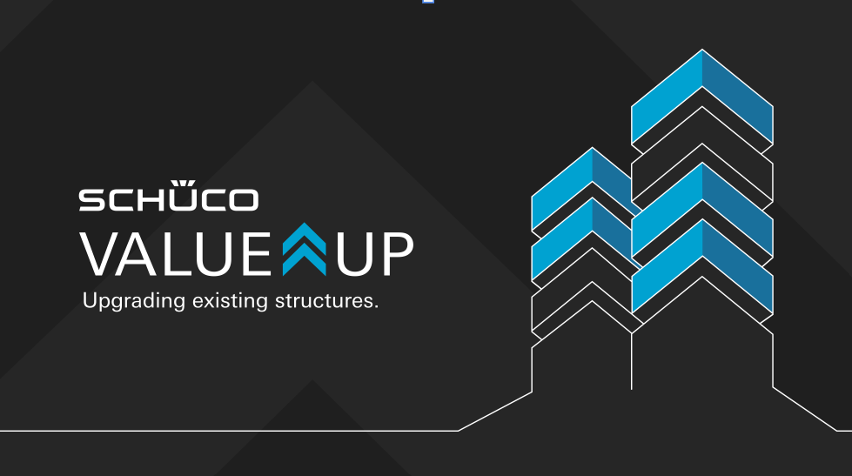
Schüco Value Up enables a value-enhancing, project-specific renovation process.
Picture credits: Schüco International KG
From the analysis, planning and renovation right through to the operation of the building, Schüco Value Up offers products and services for the building envelope to everyone involved on the building project throughout all stages of the renovation process.

Picture credits: Schüco International KG
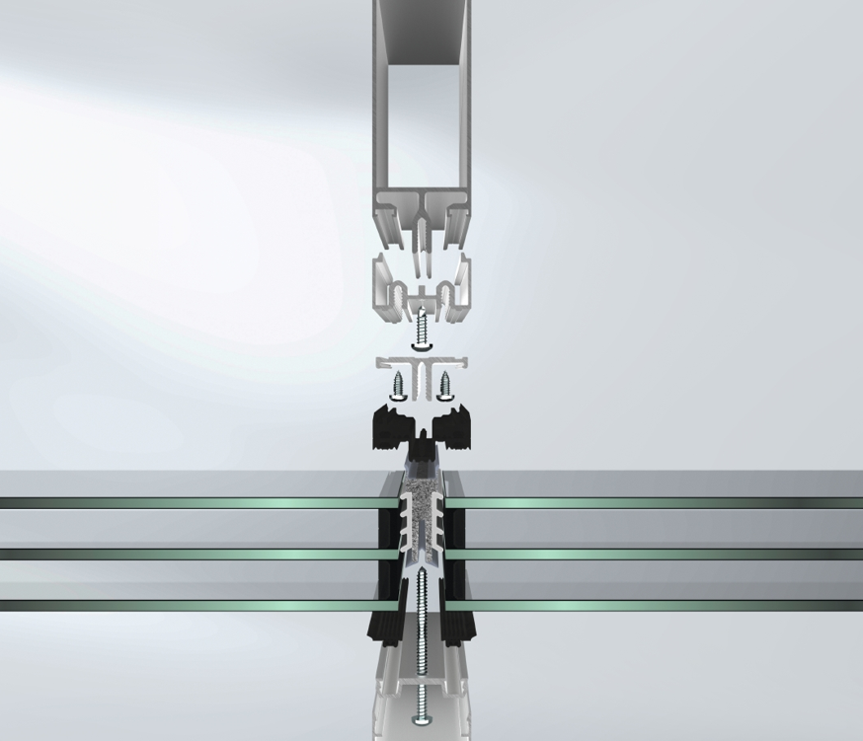
Mullion/transom façades can be optimised in terms of energy efficiency with Schüco AOC Reno simply and potentially with funding without interrupting the operation of the building.

Picture credits: Schüco International KG
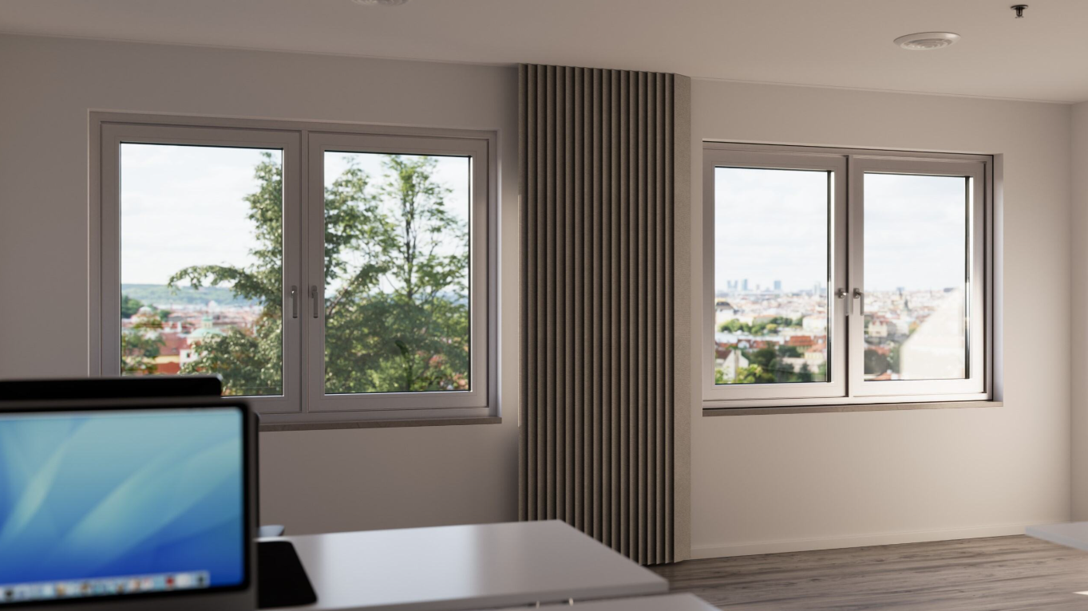
Schüco AWS 75.SI+ Reno is a renovation outer frame made from aluminium for efficient modernisation of old windows made from timber, PVC-U or aluminium with a functional wall attachment.

Picture credits: Schüco International KG
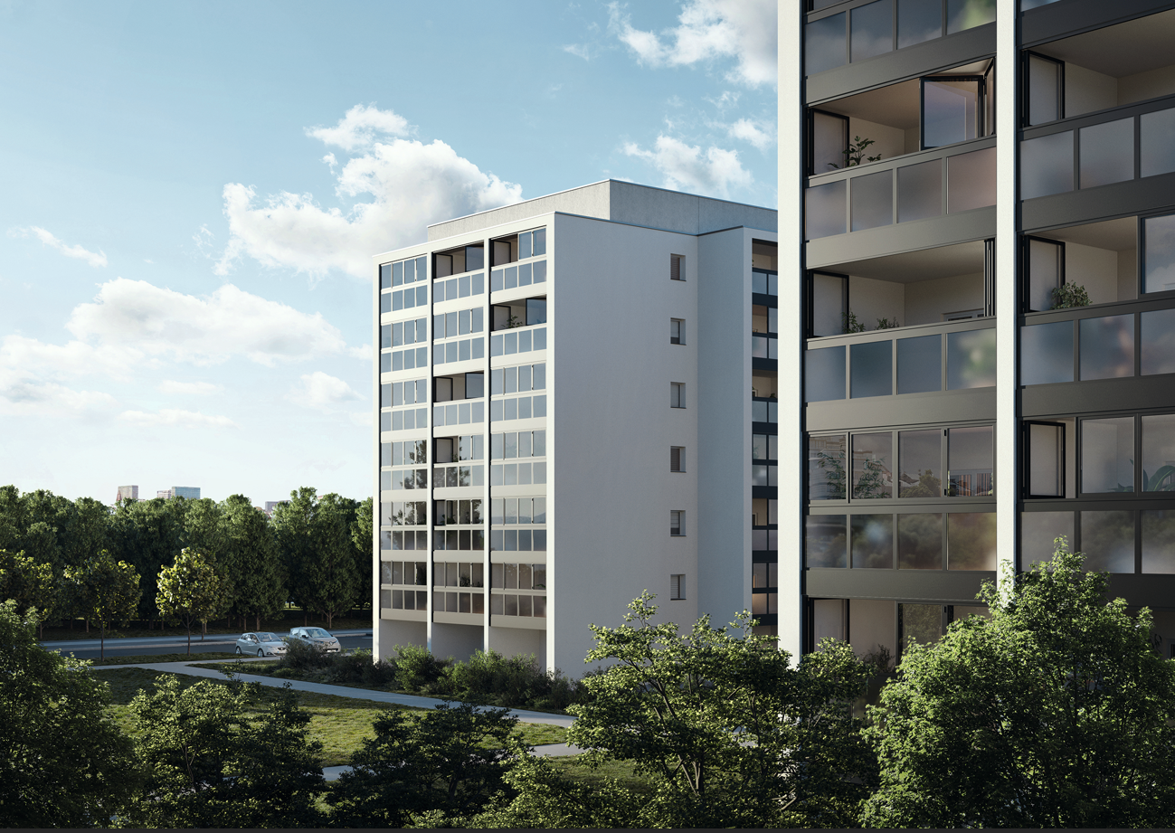
The system house offers balcony renovation glazing with the Schüco AS FD 75/90.HI folding sliding system for complete renovations or usage enhancements.

