Press release  6. January 2025 |  | Further information about publication:  Schüco International KG  Sandra Greiser  Karolinenstr. 1 – 15  33609 Bielefeld  Tel.: +49 (0)5217831174  Mail: PR@schueco.com  www.schueco.de/presse  www.schueco.com/press

Sale of Borgholzhausen furniture and industrial supplier
Schüco Interior Systems KG goes to Rheingold Capital

Bielefeld / Borgholzhausen. Schüco International KG is separating from its subsidiary Schüco Interior Systems KG with its production site in Borgholzhausen. The company is being taken over by Rheingold Capital. This marks the conclusion of the search begun last May for a strategic partner for the furniture and industrial supplier business owned by Schüco.

From its site in Borgholzhausen, Schüco Interior Systems KG produces and sells products and furnishing systems for industrial customers, including those in the furniture and automotive industries, and is a subsidiary of Schüco International KG. The Schüco Group, which is based in Bielefeld, develops and sells system solutions worldwide for the building envelope.

In May 2024, the parent Group in Bielefeld started looking for a strategic partner for Schüco Interior Systems KG, in order to focus the production and sales of the subsidiary in Borgholzhausen on the specific requirements of the furniture, automotive and industrial supplier industries.

Rheingold Capital is based in Cologne and will take over 100% ownership of the former Schüco Interior Systems KG on 1 February 2025.
The company will continue to operate as a manufacturing and sales company based in Borgholzhausen. There are no changes to the working conditions of the employees as a result of the sale.

Rheingold Capital is an investor that specialises in spin-offs from large conglomerates and owns companies in countries including Germany, Spain, Switzerland, the United Arab Emirates and Singapore. Rheingold Capital has a permanent capital base, which is provided by wealthy families.

Daniel Aazami, Investment Director at Rheingold Capital:
“We are convinced that Schüco Interior Systems has everything needed to be successful in the future. Long-standing customer relationships and an experienced workforce are core elements of this future success. We have seen a great deal of manufacturing expertise and innovation at the site in Borgholzhausen and we will work with the employees to support the company on its successful path into the future.”

Philipp Neuhaus, Chief Financial Officer of Schüco International KG:
“We are delighted to have found a very experienced investor in Rheingold Capital for the former Schüco Interior Systems KG. The production company in Borgholzhausen is a perfect fit for their portfolio and we are certain that the company will be managed successfully in the future and that we have taken the best course of action for the people on site, as well as the customers and partners.”

Peter Sagemüller, Managing Director of Schüco Interior Systems KG:
“We are relieved that the period of uncertainty is now past and we can concentrate fully on our core business. This is good for our employees, but also for our customers and partners. We want to continue to be a reliable partner with a high commitment to quality and I am very pleased that Rheingold Capital is supporting us on this journey.”

Rheingold Capital is an industrial holding company based in Switzerland and with sites in Western and Southern Europe. Its focus is the acquisition of conglomerate spin-offs that have significant strategic and/or operational potential for improvement. It has already made over 20 acquisitions, many of which are production, trade and service companies.

Schüco Interior Systems KG sells aluminium furnishing systems for a holistic interior design. The Schüco partition wall, shelf and furniture systems are multifunctional and can be used flexibly in almost any situation.

Schüco – System solutions for windows, doors and façades
Based in Bielefeld, the Schüco Group develops and sells system solutions made of aluminium, steel and PVC-U for the building envelope. The product portfolio includes window, door, façade, ventilation, security and sun shading systems, as well as intelligent networked solutions for residential and commercial projects. Schüco also provides consultancy and digital solutions for all phases of a building project – from the initial idea through to design, fabrication and installation, as well as after sales with maintenance and servicing. Fabrication machinery and customer-oriented service complement the product portfolio. As one of the leading companies in the construction industry, Schüco is committed to being a pioneer for comprehensive sustainability and to making an active contribution to climate neutrality and the circular economy within the construction sector through its products and services. Founded in 1951, Schüco is now active in more than 80 countries and achieved a turnover of 2.11 billion euros in 2023 with 6750 employees.
For more information, visit www.schueco.com

High-resolution pictures are available to download in the Schüco Newsroom at www.schueco.com/press

Photographer: Malte Blum / Schnittfest GmbH
Usage rights: Schüco International KG
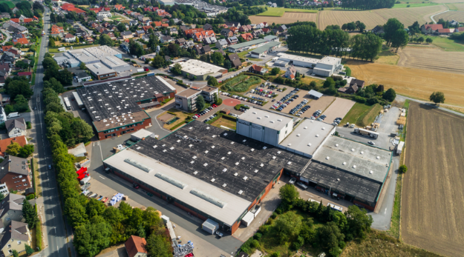
Aerial photograph of the Schüco Interior Systems site in Borgholzhausen

