Press release  November 2024 |  | Further information about publication:  Schüco International KG  Lisa Kottmann  Karolinenstr. 1 – 15  33609 Bielefeld  Tel.: +49 (0)5217837366  E-mail: PR@schueco.com  www.schueco.de/presse  www.schueco.com/press

The entrance door for commercial projects

Schüco AD UP 75 Commercial

Bielefeld. Simple, fast and cost-effective – Schüco has added an option for commercial buildings subject to frequent use to the AD UP door platform (Aluminium Door Universal Platform) with the Commercial version for the 75 mm basic depth. The special feature of Schüco AD UP 75 Commercial is that it is especially simple and straightforward to fabricate and install. At the same time, the entrance door impresses with the familiar high level of stability and easy attachment to the façade and window systems.

With Schüco AD UP 75 Commercial, the Bielefeld-based building envelope specialist is simplifying the planning and fabrication process for doors and responding to the increasing shortage of skilled workers. Reduced material and more identical parts minimises warehouse storage and simplifies the selection of individual components. This saves money and time and makes work processes more efficient. At the same time, low material consumption also reduces the GWP value (Global Warming Potential). A long lifecycle and usage phase of the door elements ensures sustainability. This is because the changing usage requirements can be easily met during ongoing operation and the installed door system can be flexibly adapted to them. The AD UP 75 Commercial entrance door with its 3-chamber leaf offers scalable thermal insulation values to respond to individual project requirements in a customised manner. Smoke protection is also possible, for example, for open stairwells or covered exterior walkways. Despite its low complexity, AD UP Commercial boasts the customary system features of the platform, including a high degree of weathertightness, barrier-free access thanks to the level threshold and burglar resistance up to RC 3, as well as the panic and partial-panic function.

One platform – many fabrication benefits
The Commercial version is based on the Schüco AD UP door platform, which is available for all basic depths and is continually being further developed. The focus here is on routine and reliable fabrication. This is achieved by using the same design principle across all basic depths and through the extensive use of identical parts resulting from the symmetrical profile composition. Thanks to the symmetrical design principle, the fittings can be fixed directly and securely in the aluminium regardless of the basic depth or version of the platform. In addition to significantly increased extraction values, the central arrangement of fittings leads to considerably improved opening circles, even with larger basic depths.

Schüco – System solutions for windows, doors and façades
Based in Bielefeld, the Schüco Group develops and sells system solutions made of aluminium, steel and PVC-U for the building envelope. The product portfolio includes window, door, façade, ventilation, security and sun shading systems, as well as intelligent networked solutions for residential and commercial projects. Schüco also provides consultancy and digital solutions for all phases of a building project – from the initial idea through to design, fabrication and installation, as well as after sales with maintenance and servicing. Fabrication machinery and customer-oriented service complement the product portfolio. As one of the leading companies in the construction industry, Schüco is committed to being a pioneer for comprehensive sustainability and to making an active contribution to climate neutrality and the circular economy within the construction sector through its products and services. Founded in 1951, Schüco is now active in more than 80 countries and achieved a turnover of 2.11 billion euros in 2023 with 6750 employees.
For more information, visit www.schueco.com

High-resolution pictures are available to download in the Schüco Newsroom at www.schueco.com/press

Picture credits: Schüco International KG
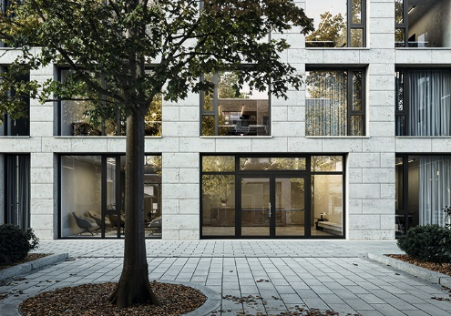
Tailored and functional: the Schüco AD UP 75 Commercial door system is ideal for entrances subject to heavy use.

Picture credits: Schüco International KG
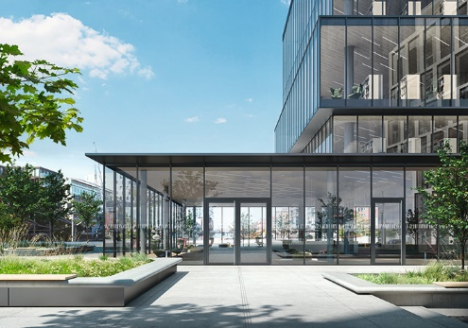
With the Schüco AD UP 75 Commercial door system, different requirements and project demands can be met with higher fabrication efficiency.

Picture credits: Schüco International KG
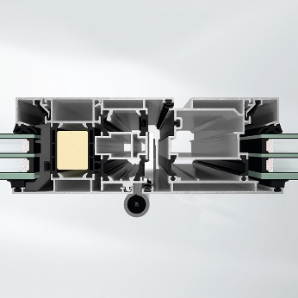
View of the 3-chamber profile of the Schüco AD UP 75 Commercial door system.

Picture credits: Schüco International KG
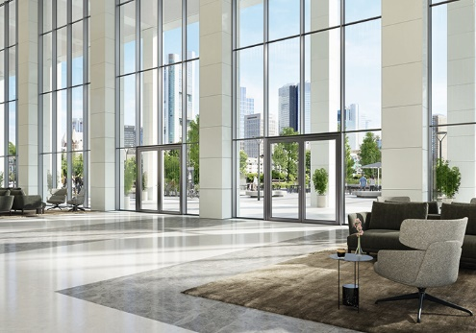
The Schüco AD UP door system platform for all basic depths proves that stability and thermal insulation can be combined using intelligent design principles.

