Press release  November 2024 |  | Further information about publication:  Schüco International KG  Lisa Kottmann  Karolinenstr. 1 – 15  33609 Bielefeld  Tel.: +49 (0)5217837366  E-mail: PR@schueco.com  www.schueco.de/presse  www.schueco.com/press

Resource-efficient fabrication

Schüco AF 500 ECO

Bielefeld. Fast, flexible and sustainable fabrication – Schüco is continuously developing its machinery portfolio to offer every partner the right machine for their fabrication requirements. With the AF 500 ECO five-axis CNC machine, Schüco provides smaller businesses with a machine for cutting and preparation, allowing them to save CO₂ and reduce costs during fabrication. Thanks to the lower power consumption, CO₂ emissions in production can be significantly reduced. And the intelligent energy recovery of the AF 500 ECO also contributes to this.

The AF 500 ECO five-axis machine allows Schüco to also offer smaller metal fabricators a contemporary entry point into CNC fabrication. The machine has been specifically developed for the processing of window, door, façade and special profiles made from aluminium. Its special benefit is that the Schüco AF 500 ECO five-axis CNC machine combines the cutting and preparation production steps with an innovative ecological concept. This can be achieved thanks to the reduced power consumption compared to similar CNC machines. Smaller cylinders for all of the clamps result in a significant reduction in compressed air consumption. And the central drive reduces the power consumption. This not only saves CO₂ but it also saves money, meaning that the acquisition costs can be redeemed as quickly as possible.
In addition, the AF 500 ECO CNC machine has intelligent energy recovery. When using the brakes for the CNC axes, the kinetic energy of the axes is converted into electrical energy, which prevents it from escaping as heat. In doing so, the drive motors function as generators for the conversion to electrical energy. The frequency converter regulates the recovery of this energy, meaning that any unused power can be utilised elsewhere or can be fed back into the network.
Thanks to its low power consumption, the intelligent energy recovery, and cutting and preparation using a CNC machine, Schüco AF 500 ECO minimises the carbon footprint produced during fabrication. Fabrication, however, is just one of the phases in construction. With Schüco Carbon Control, Schüco creates a modular solution for the project-specific decarbonisation of the building envelope throughout all of the lifecycle phases of a building. From planning, through construction and operation to dismantling, Schüco Carbon Control products and services provide a way to significantly reduce the carbon footprint of a building holistically.

Intelligent combination
The reduced energy consumption and time savings through the combination of cutting and preparation in a single machine also deliver economical advantages during fabrication. At the same time, the software-controlled optimisation of cutting allows for the best possible use of materials. Thanks to the new bumper technology, the space required is also reduced and the machine can be loaded and unloaded easily and ergonomically. This openness renders anti-slip mats and safety saws unnecessary and cultivates a high degree of flexibility. With its predictive maintenance function, the Schüco AF 500 ECO machine already meets a key requirement of Industry 4.0. Thanks to the integrated measurement of vibrations as machine protection, comprehensive diagnosis and maintenance of all the important parts of the machine is possible at all times.

Schüco – System solutions for windows, doors and façades
Based in Bielefeld, the Schüco Group develops and sells system solutions made of aluminium, steel and PVC-U for the building envelope. The product portfolio includes window, door, façade, ventilation, security and sun shading systems, as well as intelligent networked solutions for residential and commercial projects. Schüco also provides consultancy and digital solutions for all phases of a building project – from the initial idea through to design, fabrication and installation, as well as after sales with maintenance and servicing. Fabrication machinery and customer-oriented service complement the product portfolio. As one of the leading companies in the construction industry, Schüco is committed to being a pioneer for comprehensive sustainability and to making an active contribution to climate neutrality and the circular economy within the construction sector through its products and services. Founded in 1951, Schüco is now active in more than 80 countries and achieved a turnover of 2.11 billion euros in 2023 with 6750 employees.
For more information, visit www.schueco.com
High-resolution pictures are available to download in the Schüco Newsroom at www.schueco.com/press

Photographer: Frank Peterschröder
Usage rights: Schüco International KG
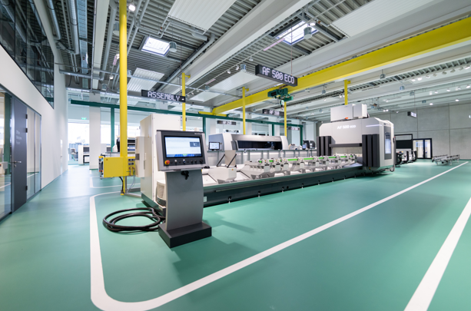
The Schüco AF 500 ECO five-axis CNC machine combines the cutting and preparation production steps with an innovative ecological concept.

Photographer: Frank Peterschröder
Usage rights: Schüco International KG
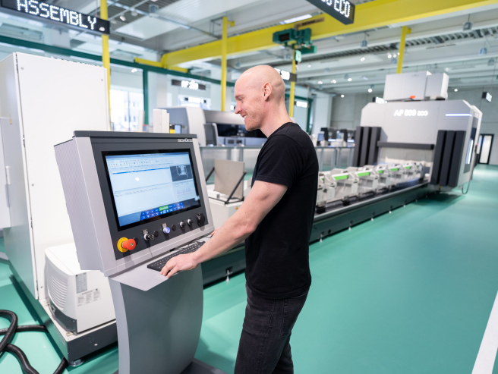
The reduced energy consumption and time savings due to the combination of cutting and preparation in a single CNC machine deliver economical advantages during fabrication.

Photographer: Frank Peterschröder
Usage rights: Schüco International KG
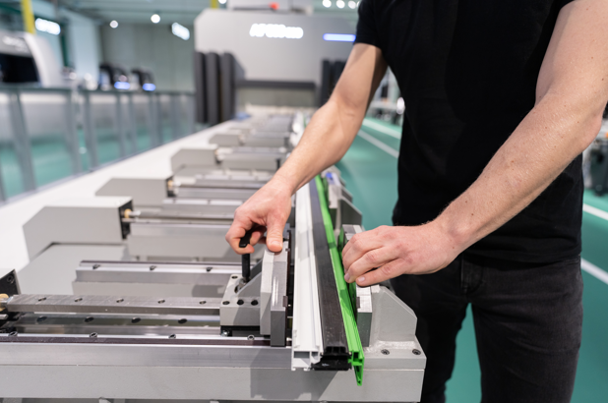
Thanks to its high processing potential, the Schüco AF 500 ECO CNC machine is designed to meet the widest range of requirements for profile processing.

