Press release  November 2024 |  | Further information about publication:  Schüco International KG  Lisa Kottmann  Karolinenstr. 1 – 15  33609 Bielefeld  Tel.: +49 (0)5217837366  E-mail: PR@schueco.com  www.schueco.com/press  www.schueco.com/press

Innovative solutions for the building lifecycle

Schüco at BAU 2025

Bielefeld. As a cross-material systems house with a broad product and service offering, Schüco is exhibiting its latest developments and prototypes for a circular and sustainable construction industry at Stand 301 in Hall B1. The focus is on the entire lifecycle of buildings. Schüco offers products and solutions for a value-enhancing renovation process that tie in seamlessly with its modular range for reducing the carbon footprint of buildings. Schüco Carbon Control was introduced for the first time at BAU 2023 and has been consistently further developed ever since. The range of products being presented is rounded off with solutions for modular construction, fire protection and high security for residential building and for the digitalisation of the construction industry.

The property industry is being hit hard by high material costs, supply bottlenecks, shortages of skilled workers and high interest rates, particularly in parts of Europe. Investors are continuing to hold back when it comes to newbuilds and renovations. Added to this are resource shortages and changing climate conditions. These factors and the targets imposed by the European Union are putting the spotlight on the topic of adaptive reuse in the construction industry.

From an existing building to a successful renovation project
In Munich, Schüco is showcasing reliable and value-enhancing products and services for investors, architects, specialist designers, fabricators and building operators to enable them to work with existing buildings in a responsible way that conserves resources. What this means in concrete terms is that Schüco is pooling its decades of experience to offer solutions for a project-specific, value-enhancing renovation process.
With Schüco Perfect, the company is presenting an all-in-one system made from aluminium and, for the first time, PVC-U too. This modular system is a flexible complete solution for windows, patio doors and lift-and-slide doors, meaning it is also suitable for adaptive reuse projects. In addition, there is a range of integrated add-ons in the system, such as sun shading, flyscreens, window sills, safety barriers and thresholds, which can be selected and combined to suit requirements. Replacing and retrofitting the add-ons is also easy thanks to the modular principle. This simplifies and accelerates numerous processes. Large-scale building projects can therefore be executed quickly and cost-effectively.

Schüco Carbon Control
Schüco Carbon Control is a modular range of consultations, products and services with the aim of reducing the carbon footprint of building envelopes. To do this, the entire lifecycle of the building is taken into account and organised according to four lifecycle stages: planning, construction, operation and dismantling. These stages are interdependent. Decisions made during the design and planning stage affect the three other stages. The carbon footprint of a building can therefore be influenced throughout its entire lifecycle, for example via the shape of the building, the choice of material and surface finish, the unit sizes, the use of smart building technologies and the recyclability of the materials. With a comprehensive range of services and products with a reduced carbon footprint, Schüco is actively supporting those involved in the construction process to comply with the building regulation requirements stipulated by climate policy throughout the entire lifecycle of a building.

Low carbon material grades
A building's embodied carbon can be consciously reduced through the choice of materials. To do this, Schüco offers aluminium and PVC-U material grades with different recycled material content and hybrid constructions. The Low Carbon (LC) and Ultra Low Carbon (ULC) aluminium material grades supplement the standard aluminium and are distributed by Schüco in accordance with the allotment process. For profiles made from Schüco Low Carbon aluminium, a value of 4.47 kg CO₂e/kg is stated in the Environmental Product Declarations, while the value for Schüco Ultra Low Carbon profiles is even lower at 2.27 kg CO₂e/kg. For PVC, three different material grades are available: Balanced, Recycled and Attributed PVC. With the Balanced PVC material standard, profiles are manufactured with recycled material or a formulation that makes optimum use of resources in the inner core. PVC-U profiles in the Recycled PVC material class are guaranteed to contain recycled material in the inner core and, depending on the geometry, are supplied with a recycled material content of between 39% and 57%. With the new, particularly sustainable Bio-Attributed PVC material class, partner companies receive PVC-U profiles based on non-fossil raw materials. In PVC production, crude oil is replaced by tall oil, which is a by-product of paper production. Compared to primary PVC made from crude oil, PVC made from tall oil saves up to 90 percent CO₂e in the manufacturing process for the same manufacturer.

Maintenance and servicing
With Schüco Service, the Bielefeld-based building envelope specialist has founded a company that handles the challenges faced by building operators. Schüco Service is a manufacturer and material-independent provider of comprehensive service solutions for windows, doors and façades: from individual orders for repairs to long-term maintenance contracts and replacement parts management to screening and potential analyses for energy-efficient renovation concepts. Experts provide advice and qualified Schüco service engineers implement all of the required services in a timely, professional and reliable manner. And with the Schüco IoF ID, the installed opening and façade units – including their entire maintenance history – can also be recorded digitally. This helps the building operator to efficiently manage their properties throughout their entire lifecycle and plan necessary investments with foresight.

From fire protection to high security
Schüco fire and smoke protection solutions not only offer comprehensive safety, but also feature sound reduction, ease of access and smart control for added convenience. Thanks to Schüco system compatibility, the transition between fire protection areas and standard areas is visually imperceptible – for safety without compromising on design. Dismantling has also been taken into account for Schüco fire and smoke protection solutions, as many of the products are already Cradle to Cradle certified and are based on the principle of the circular economy. The feature exhibit in the Security exhibition area is the Schüco Deflame fire-rated panel, which can now also be used with Structural Glazing façades as well as the FWS 50/60 mullion/transom construction. In addition to fire protection, the visitors can also see high-security windows, doors and façades from subsidiary Sälzer. Sälzer offers individual consultancy, tailored project-specific concepts and comprehensive high-security solutions worldwide from a single source. The Sälzer Centre of Excellence was recently opened at the company's Marburg site. This showroom has a multifunctional test rig where windows and doors are tested against shock waves and vandalism, as well as for resistance to break-in and break-out attempts.

Residential construction meets interior design
For discerning private clients, residential construction firms and investors in the residential construction sector, Schüco is the first choice for high-quality windows, entrance doors and sliding doors. Be it aluminium or PVC-U, newbuilds or renovations – the combination of timeless design and smart functions creates a modern residential aesthetic characterised by maximum durability. Schüco demonstrates this with minimalist and easy-to-operate sliding and folding sliding systems for maximum opening widths. Window and door systems for all materials with smart door communication complete the residential product range. Visitors will also find stylish systems for interior design with generous glass areas on the Schüco exhibition stand. For example, the subsidiary Schüco Interior Systems is presenting a partition wall system with organic round edges. When combined with the Schüco Smartcube shelving system fitted in the interior, which seamlessly follows the lines of the partition wall system, a uniform look is created.

Schüco – System solutions for windows, doors and façades
Based in Bielefeld, the Schüco Group develops and sells system solutions made of aluminium, steel and PVC-U for the building envelope. The product portfolio includes window, door, façade, ventilation, security and sun shading systems, as well as intelligent networked solutions for residential and commercial projects. Schüco also provides consultancy and digital solutions for all phases of a building project – from the initial idea through to design, fabrication and installation, as well as after sales with maintenance and servicing. Fabrication machinery and customer-oriented service complement the product portfolio. As one of the leading companies in the construction industry, Schüco is committed to being a pioneer for comprehensive sustainability and to making an active contribution to climate neutrality and the circular economy within the construction sector through its products and services. Founded in 1951, Schüco is now active in more than 80 countries and achieved a turnover of 2.11 billion euros in 2023 with 6750 employees.
For more information, visit www.schueco.com

High-resolution pictures are available to download in the Schüco Newsroom at www.schueco.com/press

Picture credits: Schüco International KG
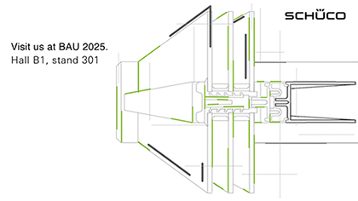
It's all about the lifecycle of buildings at the 1600 m² Schüco exhibition stand for BAU 2025.

Picture credits: Schüco International KG
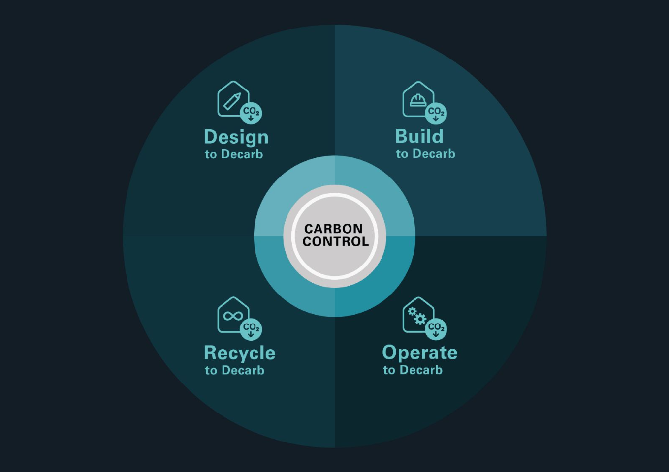
Schüco Carbon Control offers a modular solution concept for architects, fabricators, investors, project developers and construction companies. The product range helps the carbon footprint of the building envelope to be reduced throughout its entire lifecycle – from planning right through to dismantling.

Picture credits: Schüco International KG
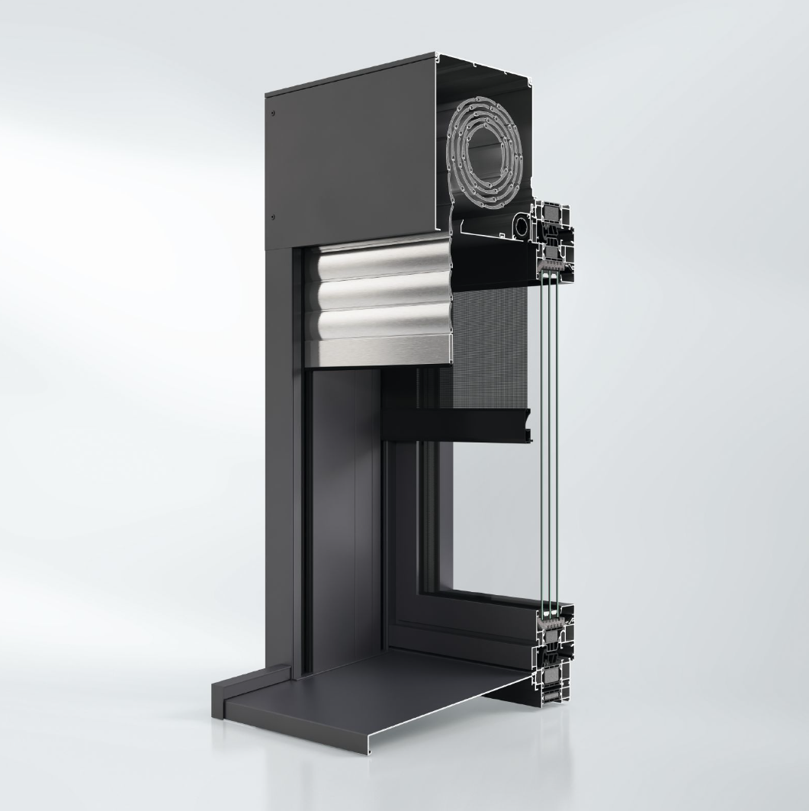
The Schüco Perfect complete solution for windows, patio doors and lift-and-slide doors will be showcased at BAU in aluminium and, for the first time, PVC-U too.

