Press release  March 2024 |  | Further information about publication:  Schüco International KG  Sandra Greiser  Karolinenstr. 1 – 15  33609 Bielefeld, Germany  Tel.: +49 (0)5217831174  E-mail: PR@schueco.com  www.schueco.de/presse  www.schueco.com/press

New system with reduced CO₂ material composition

Schüco FocusIng

Bielefeld/Weißenfels. Optimum performance characteristics, clean lines and a reduced CO₂ material composition with an inner core made from recycled material. The innovative Schüco FocusIng PVC-U system has many advantages and, with its 76 mm vent basic depth, is suitable for use in both newbuilds and renovation projects.

With Schüco FocusIng, the building envelope specialist Schüco is expanding its portfolio to include a PVC-U system that has a manageable basic depth yet excellent structural values. It has been designed to contain as much recycled material as possible and to make efficient use of materials. When they go on sale in the fourth quarter of 2024, the profiles will therefore contain up to 50 percent recycled content, and seven out of the ten profiles will be supplied with a "coloured" inner core made from recycled material as standard. To ensure optimum work processes, a high degree of compatibility with the Schüco LivIng and Schüco CT 70 systems was also ensured during development. Attachment and supplementary profiles as well as steel reinforcements and standard glazing beads can be used in the same way on all systems, which ensures that fabrication and storage are kept as simple as possible. Pre-fitted gaskets ensure that production is efficient. The holes in all of the main profiles for ventilation and drainage are identical, which further reduces the fabrication time. The customary high level of process reliability is ensured by the clever design and improved accessories.

Excellent thermal insulation values and a modern design
Structurally, Schüco FocusIng boasts a 5/6-chamber profile design with an improved chamber geometry, the option to install triple glazing up to 52 millimetres, and a rebate gasket with two weldable drainage levels. It has a basic depth of 70 millimetres, a vent basic depth of 76 millimetres, a glass edge cover of 20 millimetres and a uniform rebate height of 3 millimetres. As a result, it can be used in both newbuilds and renovation projects, and the wide range of unit options including single-field and multi-field windows, parallel-sliding and tilt/slide windows, window doors and side entrance doors means that it can be installed in a wide variety of construction scenarios. The system also boasts excellent thermal insulation properties, with a U_{w} value of below 0.8 W/(m²K) with appropriate triple glazing.

In addition, the modern system looks simply stunning. Its design can be customised with a choice of colours from more than 300 standard and special foils with metallic, single colour and woodgrain finishes. Due to its modern design with clean, straight lines and minimal rebates, colours with a stylish, aluminium appearance are the perfect choice here. The design possibilities are endless, which is why it can also be seamlessly combined with other Schüco systems made of PVC-U and aluminium.

Schüco FocusIng has been developed to make the most efficient use of materials containing a high proportion of recycled material in its inner core and it is suitable for return to the recycling process at the end of its useful life. As a result, Schüco FocusIng can help to reduce the CO₂ emissions of building envelopes.

www.schueco.com

Schüco – System solutions for windows, doors and façades
Based in Bielefeld, the Schüco Group develops and sells system solutions made of aluminium, steel and PVC-U for the building envelope. The product portfolio includes window, door, façade, ventilation, security and sun shading systems, as well as intelligent networked solutions for residential and commercial projects. Schüco also provides consultancy and digital solutions for all phases of a building project – from the initial idea through to design, fabrication and installation, as well as after sales with maintenance and servicing. Fabrication machinery and customer-oriented service complement the product portfolio. As one of the leading companies in the construction industry, Schüco is committed through its products and services to being a pioneer for comprehensive sustainability and actively contributing to climate neutrality and the circular economy within the construction sector. Founded in 1951, Schüco is now active in more than 80 countries and achieved a turnover of 2.28 billion euros in 2022 with 6750 employees.
For more information, visit www.schueco.com

High-resolution pictures are available to download in the Schüco Newsroom at
www.schueco.com/press

Usage rights: Schüco International KG
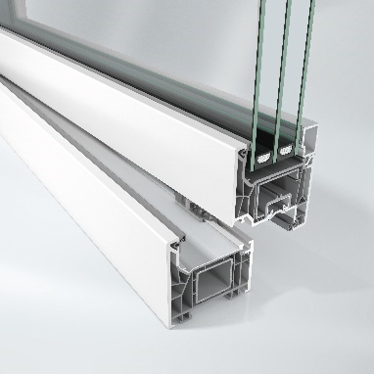
The new Schüco FocusIng PVC-U system boasts a modern appearance, a high proportion of recycled material and excellent thermal insulation values.

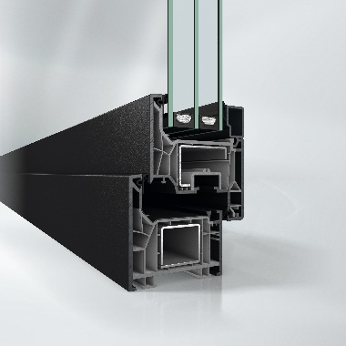
For a harmonious look when combined with dark surface finishes, Schüco FocusIng is also available with grey profiles.

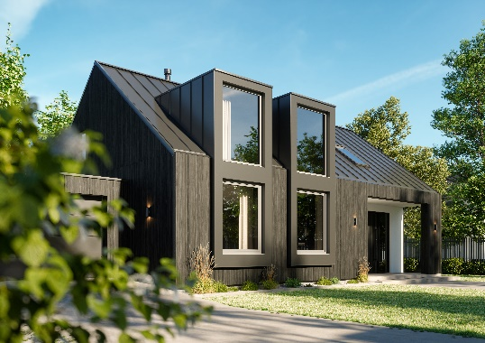
Schüco FocusIng is ideal for private homes with panoramic fixed glazing and turn/tilt units.

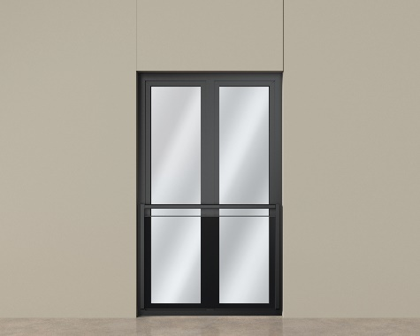
Two-field, floor-to-ceiling window unit from the new Schüco FocusIng series combined with a safety barrier.

