Press release  March 2024 |  | Further information about publication:  Schüco International KG  Sandra Greiser  Karolinenstr. 1 – 15  33609 Bielefeld, Germany  Tel.: +49 (0)5217831174  E-mail: PR@schueco.com  www.schueco.de/presse  www.schueco.com/press

New system with reduced CO₂ material composition

Schüco FocusIng

Bielefeld/Weißenfels. A stylish aluminium appearance, clean lines, optimum performance characteristics and a reduced CO₂ material composition. The innovative Schüco FocusIng PVC-U system has many advantages and, with its 76 mm vent basic depth, is suitable for both newbuilds and renovation projects.

The new Schüco FocusIng PVC-U system boasts a modern design with clean, straight lines and minimal rebates featuring an aluminium appearance. More than 300 standard and special foils with metallic, single colour and woodgrain finishes permit a unique degree of design flexibility, whatever the project. A variety of Schüco PVC-U and aluminium systems can also be combined together without any difference in colour. When it comes to its design, FocusIng has an impressive basic depth of 70 millimetres, a vent basic depth of 76 millimetres, a glass edge cover of 20 millimetres and a uniform rebate height of 3 millimetres. As a result, it can be used in both newbuilds and renovation projects, and the wide range of unit options including single-field and multi-field windows, window doors, side entrance doors as well as parallel-sliding and tilt/slide windows means that it can be installed in a wide variety of construction scenarios.
In addition to its clever design for use in many different areas, the system also has excellent thermal insulation properties, with U_{w} values below 0.8 W/(m²K) with appropriate triple glazing.

Increased use of recycled material
The new profile system has been developed to make the most efficient use of materials containing a high proportion of recycled material in its inner core and it is suitable for return to the recycling process at the end of its useful life. When they go on sale in the fourth quarter of 2024, seven out of the ten profiles will therefore be supplied with a "coloured" inner core made from recycled material as standard, with the profiles containing up to 50 percent recycled content. The system also boasts a 5/6-chamber profile design with an improved chamber geometry, the option to install triple glazing up to 52 millimetres, and also comes with rebate gasket options for two weldable drainage levels. The high proportion of recycled material, optimised use of materials and excellent thermal insulation contribute to reducing the CO₂ emissions of building envelopes.

To ensure optimum work processes, a high degree of compatibility with the Schüco LivIng and Schüco CT 70 systems was also ensured during development. Attachment and supplementary profiles as well as steel reinforcements and glazing beads can be used in the same way on all system platforms, which ensures that fabrication and storage are kept as simple as possible. The use of the standard glazing bead as well as pre-fitted gaskets ensure that production is efficient. The holes in all of the main profiles for ventilation and drainage are identical, which further reduces the fabrication time. The customary high level of process reliability is ensured by the clever design and improved accessories.

www.schueco.com

Schüco – System solutions for windows, doors and façades
Based in Bielefeld, the Schüco Group develops and sells system solutions made of aluminium, steel and PVC-U for the building envelope. The product portfolio includes window, door, façade, ventilation, security and sun shading systems, as well as intelligent networked solutions for residential and commercial projects. Schüco also provides consultancy and digital solutions for all phases of a building project – from the initial idea through to design, fabrication and installation, as well as after sales with maintenance and servicing. Fabrication machinery and customer-oriented service complement the product portfolio. As one of the leading companies in the construction industry, Schüco is committed through its products and services to being a pioneer for comprehensive sustainability and actively contributing to climate neutrality and the circular economy within the construction sector. Founded in 1951, Schüco is now active in more than 80 countries and achieved a turnover of 2.28 billion euros in 2022 with 6750 employees.
For more information, visit www.schueco.com

High-resolution pictures are available to download in the Schüco Newsroom at
www.schueco.com/press

Usage rights: Schüco International KG
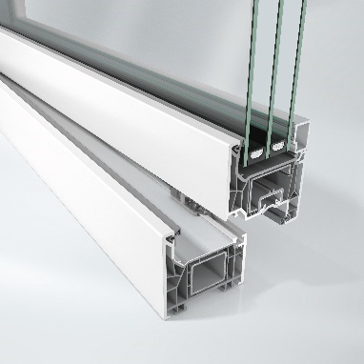
The new Schüco FocusIng PVC-U system boasts a modern appearance, a high proportion of recycled material and excellent thermal insulation values.

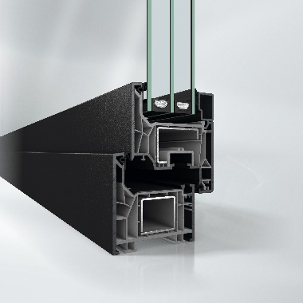
For a harmonious look when combined with dark surface finishes, Schüco FocusIng is also available with grey profiles.

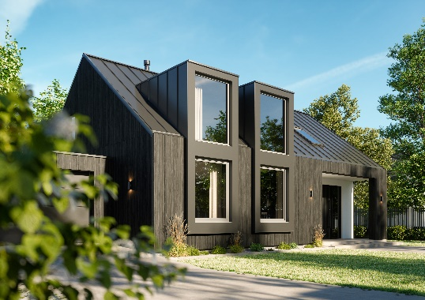
Schüco FocusIng is ideal for private homes with panoramic fixed glazing and turn/tilt units.

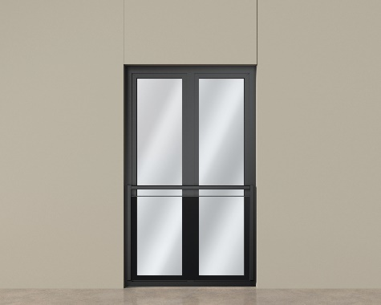
Two-field, floor-to-ceiling window unit from the new Schüco FocusIng series combined with a safety barrier.

