Press release  November 2023 |  | Further information about publication:  Schüco International KG  Sandra Greiser  Karolinenstr. 1–15  33609 Bielefeld, Germany  Tel.: +49 (0)5217831174  E-mail: PR@schueco.com  www.schueco.com/press  www.schueco.com/press

New sliding window and sliding door system

Maximum wathertightness: Schüco LivIng move

Bielefeld/Weißenfels. The new LivIng move PVC-U sliding system from Schüco Polymer Technologies KG features optimum watertightness (up to Class 9A) to meet the most exacting requirements for thermal insulation and comfort. Schüco LivIng move is therefore perfectly suited to use in multistorey buildings and offers an alternative to lift-and-slide systems for commercial and private projects.

The Schüco LivIng move series is designed for economical, partially automated fabrication, as well as easy and cost-efficient assembly. The vent frame is suitable for series production and the vent profile is based on the Schüco LivIng system. Window fabricators benefit from this, as they can use the same parts in the glazing. Triple glazing can be used for glass thicknesses up to 54 mm. The construction of Schüco LivIng move features impressive weathertightness, as the gasket design was optimised for the new series. It comprises two weldable levels as standard, with the option to add a centre gasket. With high sound reduction and weathertightness values, as well as a U_{f} value as low as 1.1 W/(m²K), the design meets all individual requirements. The sophisticated sliding fitting with its low number of parts and proven fittings principle makes for fast installation on site. An additional benefit of the sliding window design is the option to place the handle in any position.

Multistorey residential buildings with optimum weathertightness
Its clever design means that Schüco LivIng move can be used in a variety of different projects, particularly multistorey buildings, and meets the needs of architects, housing development associations, investors and private clients. The sliding system offers individual solutions of the highest standard in terms of ease of use, energy efficiency, security (resistance class RC2) and design. Maximum design freedom is ensured thanks to the numerous single and metallic colours, woodgrain finishes and cover caps from the Schüco TopAlu series. Schüco LivIng move is therefore the perfect alternative to parallel sliding, tilt/slide and lift-and-slide doors. Schüco LivIng move is also a great replacement for turn/tilt window units, as the sliding function means that the vent does not project into the room. This means that completely new configuration concepts can be implemented.

www.schueco.de/living-move-en

Schüco – System solutions for windows, doors and façades
Based in Bielefeld, the Schüco Group develops and sells system solutions made of aluminium, steel and PVC-U for the building envelope. The product portfolio includes window, door, façade, ventilation, security and sun shading systems, as well as intelligent networked solutions for residential and commercial projects. Schüco also provides consultancy and digital solutions for all phases of a building project – from the initial idea through to design, fabrication and installation, as well as after sales with maintenance and servicing. Fabrication machinery and customer-oriented service complement the product portfolio. As one of the leading companies in the construction industry, Schüco is committed through its products and services to being a pioneer for comprehensive sustainability and actively contributing to climate neutrality and the circular economy within the construction sector. Founded in 1951, Schüco is now active in more than 80 countries and achieved a turnover of 2.28 billion euros in 2022 with 6750 employees.
For more information, visit www.schueco.com

High-resolution pictures are available to download in the Schüco Newsroom at www.schueco.com/press

Picture credits: Schüco International KG

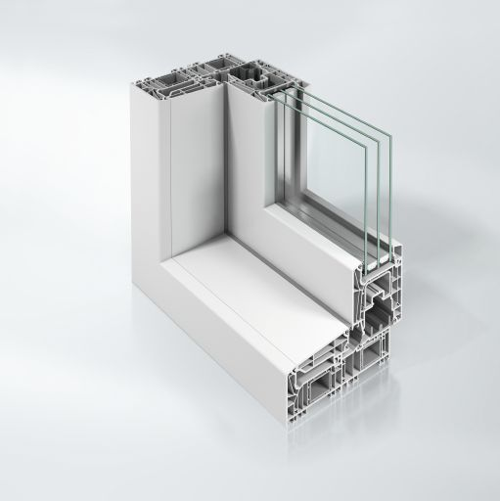
Innovative sliding system for windows and doors with a frame trim basic depth of 159 mm.

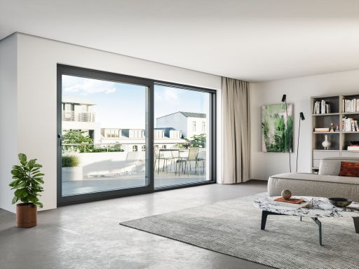
Design freedom is ensured thanks to a range of different unit types, two gasket concepts and numerous surface finish options.

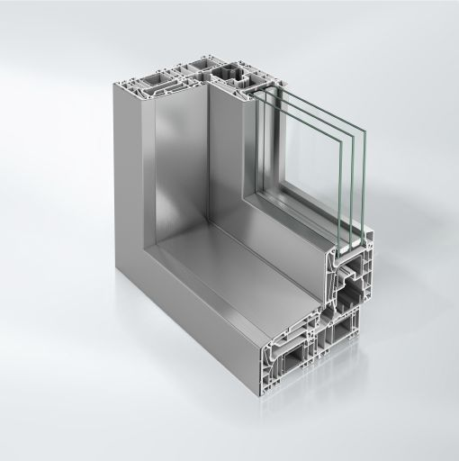
Schüco LivIng move can be designed with cover caps from the Schüco TopAlu series for integration in aluminium façades or even greater design freedom.

