Press release  November 2023 |  | Further information about publication:  Schüco International KG  Sandra Greiser  Karolinenstr. 1–15  33609 Bielefeld, Germany  Tel.: +49 (0)5217831174  E-mail: PR@schueco.com  www.schueco.com/press  www.schueco.com/press

New sliding door and sliding window system

Maximum watertightness: Schüco LivIng move

Bielefeld/Weißenfels. The new LivIng move PVC-U sliding system from Schüco Polymer Technologies KG features optimum watertightness (up to Class 9A) to meet the most exacting requirements for thermal insulation and comfort. Schüco LivIng move is therefore perfectly suited to use in multistorey buildings and offers an alternative to lift-and-slide systems for commercial and private projects.

Light, bright or dark, in single or metallic colours or a woodgrain finish, LivIng move can match any design request. The system can also be configured as a TopAlu series, providing additional design options as well as facilitating integration in aluminium façades. The handles can be individually selected from an extensive range and positioned anywhere. This, combined with the fact that the sliding units are easy to operate, makes the system extremely user friendly.

Multi-storey residential buildings with optimum weathertightness
The innovative construction of LivIng move with weldable, durable gaskets, ensures maximum weathertightness, even in multistorey residential buildings. High thermal insulation with a Uf value as low as 1.1 W/(m²K) plus high sound reduction and weather resistance round off the construction. A centre gasket can be used to ensure optimum sound reduction and thermal insulation values. With its glazing option of up to 54 mm, LivIng move is suitable for use in newbuilds and renovations.

These special design features and the high level of design freedom mean that LivIng move meets a range of different requirements, be it for architects, housing development associations, investors or private clients. The sliding system for windows and doors offers individual solutions to the highest standards – in terms of ease of use, energy efficiency, security (resistance class RC2) and design. With its sliding windows and doors, Schüco LivIng move is therefore the perfect alternative to parallel sliding, tilt/slide and lift-and-slide doors. Schüco LivIng move is also a great replacement for turn/tilt window units, as the sliding function means that the vent does not project into the room. This means that completely new configuration concepts can be implemented.

www.schueco.de/living-move-en

Schüco – System solutions for windows, doors and façades
Based in Bielefeld, the Schüco Group develops and sells system solutions made of aluminium, steel and PVC-U for the building envelope. The product portfolio includes window, door, façade, ventilation, security and sun shading systems, as well as intelligent networked solutions for residential and commercial projects. Schüco also provides consultancy and digital solutions for all phases of a building project – from the initial idea through to design, fabrication and installation, as well as after sales with maintenance and servicing. Fabrication machinery and customer-oriented service complement the product portfolio. As one of the leading companies in the construction industry, Schüco is committed through its products and services to being a pioneer for comprehensive sustainability and actively contributing to climate neutrality and the circular economy within the construction sector. Founded in 1951, Schüco is now active in more than 80 countries and achieved a turnover of 2.28 billion euros in 2022 with 6750 employees.
For more information, visit www.schueco.com

High-resolution pictures are available to download in the Schüco Newsroom at www.schueco.com/press

Picture credits: Schüco International KG

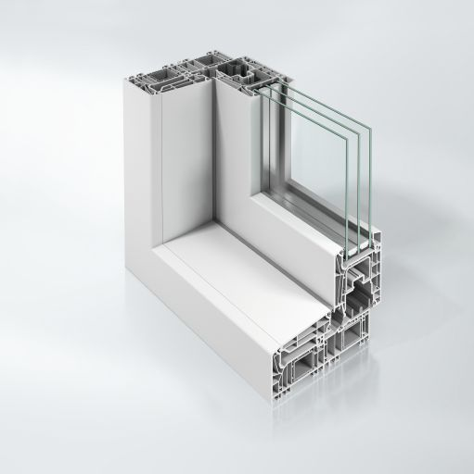
Innovative sliding system for windows and doors with a frame trim basic depth of 159 mm.

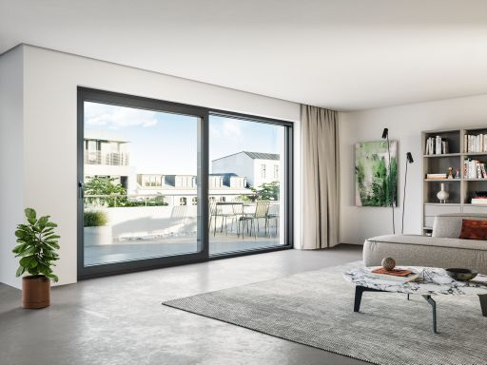
Design freedom is ensured thanks to a range of different unit types, two gasket concepts and numerous surface finish options.

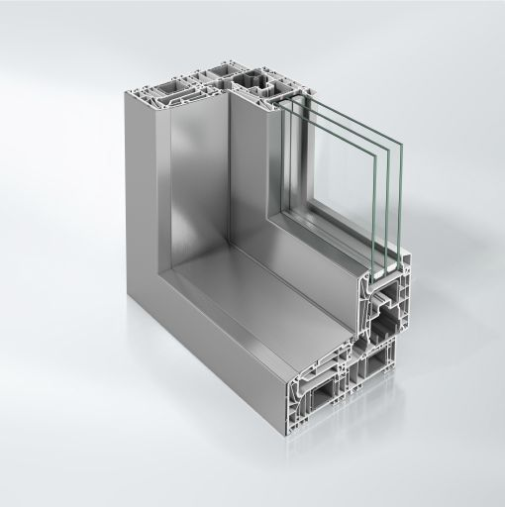
Schüco LivIng move can be designed with cover caps from the Schüco TopAlu series for integration in aluminium façades or even greater design freedom.

