Press release  27 July 2023 |  | Further information about publication:  Schüco International KG  Thomas Lauritzen  Karolinenstr. 1–15  33609 Bielefeld, Germany  Tel.: +49 (0)521 783-233  E-mail: tlauritzen@schueco.com  www.schueco.com/press  www.schueco.com/press

2022 annual report

Schüco positions itself as a pioneer of sustainable construction

Bielefeld. In the midst of a persistently difficult macro-economic environment, the Schüco Group has recorded positive growth, concluding the 2022 fiscal year with a total turnover of €2.28 billion (an increase of 14.3 percent compared to the previous year).

The Schüco Group employed a total of 6750 employees on average in 2022, split as follows: 2650 people worked for Schüco outside Germany. Within Germany, there were 4100 employees, with 2100 of those working at the headquarters in Bielefeld. The company employs a total of 2455 people in the East Westphalia-Lippe region.

The economic equity continues to be stable, with a balanced capital structure even during this challenging time. €89.5 million was invested in 2022, which was slightly more than the previous year. Likewise in this year, a large portion of this money went into the extensive construction work to expand the site, which began in 2016. In 2022, two new buildings were completed. The Welcome Forum, measuring 4500 m² and designed by the One Fine Day architectural practice (Düsseldorf), was opened in May 2022. By the end of 2022, it had welcomed over 7800 visitors, who were able to gain an insight into the world of Schüco. Completed in autumn 2022 and designed by 3XN Architects (Copenhagen), the new main building, Schüco One, is a striking addition to the Schüco campus. The exterior design and the interior architecture, which features open communication spaces for a modern, employee-focused work environment, perfectly reflect the company culture and set standards in terms of sustainability too. Schüco One was the first building in the world to be awarded all three sustainability certifications: German Sustainable Building Council (DGNB) Platinum, LEED Platinum and BREEAM Excellent. Andreas Engelhardt, Managing Partner of Schüco International KG, is especially delighted that the DGNB has also given the Schüco One building the "Diamond" award for high-quality design and architecture in addition to the Platinum certification for sustainability.

- Acquisitions, joint ventures and new companies

  - SÄLZER GmbH – high security for the building envelope
In January 2022, Schüco acquired the remaining shares in SÄLZER GmbH in Marburg. SÄLZER GmbH provides tailored high-security solutions. It covers the areas of burglar, explosion and bullet resistance and also offers the option to individually combine the safety classes of each of these security functions.

1.2 Schüco Interior Systems KG – interior and furniture systems
In April 2022, Schüco Alu Competence (based in Borgholzhausen) was established as an independent company through the foundation of Schüco Interior Systems KG, with the aim of opening up further areas of growth and driving the development of new products under the umbrella of the Schüco Group. Specifically, this means developing innovations for living and work spaces, particularly for interiors, such as multifunctional partition wall, shelving and furniture systems.

1.3 Schüco Global Services KG – maintenance and servicing
On 30 May 2022, Schüco Global Services KG, Bielefeld, was entered into the commercial register. The new company aims to combine the after-sales area of the business with maintenance and servicing, to develop the business internationally and thereby support our partners in meeting the increasing demand.

On 3 June 2022, Schüco Global Services KG acquired the Dutch company Service Kunststof Kozijnen B.V., based in Assen, with backdated effect from 1 January 2022. The experienced provider of maintenance and repair work for windows and doors has made a name for itself in the area of residential construction in particular, with its fast, professional service. Schüco and SKK B.V. jointly aim to offer an extensive after-sales service for residential and commercial buildings for the entire Dutch market.

As part of the expansion of the after-sales area, Schüco Global Services KG acquired the business operations of MM Metall- und Glastechnik (based in Schriesheim) on 1 September 2022. This company focuses on the maintenance, repair, installation and servicing of solutions by Schüco and other well-known competitors.

1.4 AWB Aluminiumwerk Berlin GmbH – metal supply and carbon footprint
On 1 July 2022, Schüco acquired a share of 26 percent in AWB Aluminiumwerk Berlin GmbH, Berlin. This is intended to deepen the close partnership of many years between Schüco and AWB and ensure the physical supply of metal while reducing the carbon footprint at market conditions.

1.5 RE:CORE GmbH – closed loop recycling system
In August 2022, as part of a joint venture under the name RE:CORE GmbH, based in Lünen, Schüco Polymer Technologies KG from Weißenfels and REMONDIS Recycling GmbH & Co. KG entered into a strategic partnership. The aim is to ensure a closed loop recycling process for PVC-U window profiles as part of the circular economy in construction. RE:CORE offers Schüco partner companies an exclusive recycling service for old windows and profile offcuts from the window industry, in order to close the Schüco PVC recycling loop.

1.6 Kestrel – expansion of range for commercial and residential construction
On 5 September 2022, the British subsidiary Schüco UK acquired both Kestrel Aluminium Systems Ltd and Kestrel Powder Coating Ltd, based in Birmingham, UK. Kestrel is a window systems provider operating in the UK that develops products for commercial and residential projects. The Kestrel systems complement the Schüco range. Both companies will benefit from each other's expertise, as well as the expanded product range, which will enable them to secure additional market share in the UK.

- Development of the metal business

2.1 Development worldwide
The Metal division (aluminium and steel) achieved global turnover of €1.820 billion, 14.8 percent more than the previous year (€1.585 billion) – despite huge uncertainty in the respective procurement markets.

  - Sales regions outside Europe
Outside Europe, turnover increased by 32.8 percent to €425 million compared to the previous year (€320 million). The majority of the markets developed in different ways. Although China was still heavily affected by the country's zero-Covid policy in the first half of the year, it managed to make significant recoveries by year end. Indian subsidiary Schüco India also benefited from the recovery effects of the coronavirus pandemic and managed to exceed expectations by increasing turnover. The same was true for the Southeast Asia sales region, which continued its positive growth trend. The subsidiaries in Dubai and Turkey also closed the year successfully for their business segment.

2.3 Sales regions in Europe
The 2022 fiscal year – which continued to be marked by supply-chain issues worldwide, sharply increasing raw material prices, the ongoing war in Ukraine and the huge rise in energy costs and rates of inflation – presented huge challenges to the Europe sales region and heavily impacted business activity in the second half of the year. Nevertheless, the markets in France, Italy, Iberia, the Netherlands and Belgium still managed to see positive growth. The Metal division of the Europe sales region was therefore able to increase turnover to €1.310 billion, which is 10.5 percent higher than the previous year (€1.185 billion).

2.3.1 Germany sales region
In 2022, the construction sector helped to stabilise economic output in Germany, but still came under pressure. While order backlogs and pull-forward effects in the first half of the year helped to make good use of customer capacity, from the third quarter of 2022 there was a significant decline in incoming orders, particularly with newbuild projects. Triggers for this included the extreme pricing pressure across all products in the industry, as well as the increasing uncertainty due to the geopolitical situation. Nevertheless, at €600 million, turnover in the Metal business division's home market was above the previous year's level (€558 million).

- Development of the PVC-U business

The PVC-U business saw positive growth in 2022, with an increase in turnover to €420 million, which is 8 percent higher than the previous year (€389 million). In the core market of Germany, turnover was slightly above the previous year (€143 million) at €145 million. The other European sales markets also saw a positive development, particularly in Italy, Belgium and the Netherlands.

- Digital roadmap

The strategy of almost complete digitalisation of the processes in construction – with the aim of networking the design and planning stages of a building project, as well as fabrication, installation, use, maintenance and recycling – continued to be pursued in 2022. To this end, new products and services were developed and marketed. One example of this is SchüCal MES (Manufacturing Execution System), which Schüco metal fabrication customers can use to control all fabrication processes. The system is thereby taking a key step towards digital, paperless fabrication, providing the information required for processing in a clear, understandable way.

5. Motivation Green

Above and beyond climate and environmental protection, sustainability at Schüco is seen as a concrete objective. In the PVC-U business unit, the focus in 2022 was on the "Go Circular" project, based on the idea that building envelopes are future raw material reserves. To this end, a closed PVC-U recycling process is to be achieved through the joint venture RE:CORE GmbH, making a further active contribution to a more sustainable construction industry.

One of the major challenges of our time is achieving climate neutrality in the building sector across all materials. The construction industry has the task of achieving the ambitious targets set by politicians and reducing the CO₂ emissions generated during the construction, operation and dismantling of buildings to zero. The CO₂ value of a building will become a main criterion in all future investments and tenders. This is why, in 2022, Schüco started to establish a modular range of products and services that cater for the entire lifecycle of a building, enabling the decarbonisation of windows, doors and façades to be monitored on a project-specific basis.

6. Industry campaign to tackle the shortage of skilled workers

The metal fabrication industry has around 52,000 vacancies. This fact has consequences. After all, windows, doors, façades, sliding systems and sun shading systems are essential parts of construction. This is why, in 2021, Schüco and agency YeaHR developed a comprehensive, long-term industry and recruitment campaign "Metallbau(t) Zukunft" ("Metal is building the future"), in order to showcase the positive aspects of the industry, address potential employees and specialists, and show young people the path towards the metal fabrication industry.

At the heart of the campaign is the website www.metallbaut-zukunft.com, where people can find out key facts about the industry, learn about relevant jobs and career opportunities, and look for vacancies at participating companies. In 2022, the information and job portal raised its profile and promoted job opportunities within the industry through targeted advertising and communication measures. This also included a report by German TV channel WDR broadcast in October 2022. Currently, over 300 metal fabrication companies are taking part in this campaign.

7. Product developments

2022 also saw an emphasis on the development of overall solutions for the building envelope in the Metal division. The focus was on the architecturally seamless integration of solutions for windows, doors and façades, as well as easy, convenient and safe use thereof. To this end, solutions were developed for the seamless integration of sliding doors and windows in façades, as well as sun shading solutions in windows, façades and doors. Alongside this architectural fusion, there was also a spotlight on the smart networking of all the components in the building envelope using control technology.

Furthermore, Schüco WoodDesign was successfully launched on the market. The solution combines the high weathering resistance and durability of an aluminium window with the natural appearance of a timber surface. The room side of the window is clad with real wood decorative strips, lending the interior a cosy atmosphere. In addition, a new Schüco AOC add-on construction combines aluminium with a timber or steel substructure to create a striking appearance. Thanks to optimised thermal insulation and sound reduction values, the Cradle to Cradle-certified system achieves passive house standard, uniting energy-efficient construction with streamlined fabrication and installation. The Schüco AOC.TI (Timber) options also use the renewable resource timber in the substructure. In the area of sliding systems, there were two market launches in the form of a new folding/sliding platform and a new panorama design sliding platform. The façade-integrated VentoTherm Twist ventilation solution with heat recovery was also enhanced to include a retrofit solution suitable for schools and an automatic night-time cooling function. For acoustic solutions, 2022 saw tests being carried out to determine sound reduction levels with partially opened windows in different configurations.

At Schüco Polymer Technologies KG in Weißenfels, the focus continued to be on expanding the product and service portfolio for use in residential construction, with the aim of being seen as an even more efficient supplier in this area in future.

One of the key products here is Schüco Symbiotic. The hybrid design window system meets individual design and colour requirements. A high-quality, puristic aluminium surface provides protection on the outside, while the inside is made from highly thermally insulated PVC-U. The flush-fitted appearance of Schüco Symbiotic means that windows and window doors in this series are especially well suited to modern living and architecture concepts.

8. Outlook in 2023

Climate change and energy costs are posing huge challenges but also opportunities for the property and construction industries. The political impasse caused by months of debate just on whether it makes sense to invest in heat pumps has led to uncertainty, particularly among private clients in Germany. The industry is also under pressure due to the lack of skilled workers, high metal prices and wage agreements, as well as worsening financial conditions, which is resulting in significant declines in construction investments.

The rate of renovations has to be increased significantly in order to achieve a climate-neutral, energy-efficient building stock. The government needs to set clear, sustainable framework conditions now, as otherwise the climate objectives in the building sector will not be met. A smooth collaboration of the trades and interplay of the products in the building envelope, building services and energy infrastructure based on a tailored renovation schedule are essential in order to drastically reduce the carbon footprint of buildings.
With Carbon Control, Schüco is offering true circularity through an extensive, modular range of various products and services over the entire lifecycle of a building, which enables the decarbonisation of windows, doors and façades to be monitored on a project-specific basis. The use of recycled material is a key factor here, but is not the only option.

Schüco – System solutions for windows, doors and façades
Based in Bielefeld, the Schüco Group develops and sells system solutions made of aluminium, steel and PVC-U for the building envelope. The product portfolio includes window, door, façade, ventilation, security and sun shading systems, as well as intelligent networked solutions for residential and commercial projects. Schüco also provides consultancy and digital solutions for all phases of a building project – from the initial idea through to design, fabrication and installation, as well as after sales with maintenance and servicing. Fabrication machinery and customer-oriented service complement the product portfolio. As one of the leading companies in the construction industry, Schüco is committed through its products and services to being a pioneer for comprehensive sustainability and actively contributing to climate neutrality and the circular economy within the construction sector. Founded in 1951, Schüco is now active in more than 80 countries and achieved a turnover of 2.28 billion euros in 2022 with 6750 employees.

High-resolution pictures are available to download in the Schüco Newsroom at
www.schueco.com/press

Photographer: Frank Peterschröder
Usage rights: Schüco International KG
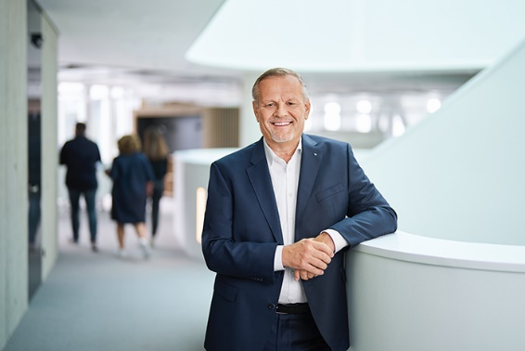
Andreas Engelhardt, Managing Partner of Schüco International KG.

Photographer: Stefan Brückner
Usage rights: Schüco International KG
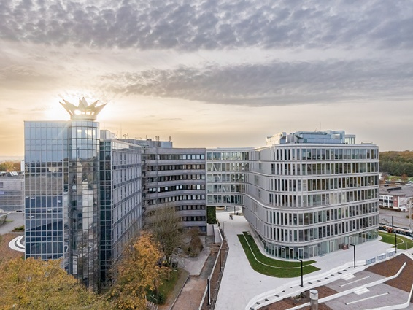
The new Schüco One building (right) along with the existing buildings forms the Bielefeld headquarters.

