Press release  July 2023 |  | Further information about publication:  Schüco International KG  Sandra Greiser  Karolinenstr. 1–15  33609 Bielefeld, Germany  Tel.: +49 (0)521 783-1174  Fax: +49 (0)521 783-950803  E-mail: PR@schueco.com  www.schueco.com/press  www.schueco.com/press

For sustainable aluminium profiles:

Schüco acquires strategic interest in AWB Aluminiumwerk Berlin GmbH

Bielefeld. For many years AWB Aluminiumwerk Berlin GmbH has been a main supplier of aluminium profiles for Schüco International KG. Schüco has now deepened this long-standing partnership through strategic investment in the aluminium plant. Together, both companies intend to address strategic topics more intensively in the future, particularly in the area of sustainability.

"AWB Aluminiumwerk Berlin GmbH has dedicated itself to sustainability in its own factory. We want to join this effort with activities of our own to contribute to optimisation along the entire value chain," said Dr. Walter Stadlbauer, COO/CTO of Schüco, explaining the investment. Sustainability and innovation are the focus of the companies' joint cooperation. Looking to the future, alongside using standard aluminium, AWB is expected to produce billets with the two new aluminium grades Low Carbon (LC) and Ultra Low Carbon (ULC) aluminium which have a significantly lower carbon footprint. "On the basis of the long-standing, cooperative collaboration of the two companies, this is the logical step to better meet the growing challenges of the market and customer requirements," added Reiner Bachnick, Managing Director of AWB. Both companies also profit from one another in regards to speed and flexibility when it comes to jointly creating new tools or quality management, for example. The goal is to further optimise the processes between the two companies so that the overall process of future collaboration can be even more efficient. "All of this comes down to benefitting our customers first and foremost," stresses Dr Stadlbauer.

Schüco – System solutions for windows, doors and façades
Based in Bielefeld, the Schüco Group develops and sells system solutions made of aluminium, steel and PVC-U for building envelopes. Its product portfolio comprises window, door, façade, ventilation, security and sun shading systems. Intelligent and networked products complete the range available for residential and commercial projects. Schüco also provides consultancy and digital solutions for all phases of a building project – from the initial idea through to design, fabrication and installation, as well as after sales with maintenance and servicing. Fabrication machinery and customer-oriented service complement the product portfolio. Sustainability is a significant part of the business model. For example, the circular construction industry with closed material cycles is one of six defined focus areas for sustainability. Founded in 1951, the company is now active in more than 80 countries and achieved a turnover of 1.995 billion euros in 2021 with 6330 employees. For more information, visit www.schueco.com

AWB Aluminiumwerk Berlin GmbH
The family-owned company AWB Aluminiumwerk Berlin GmbH (AWB) that was founded in 2005 with its headquarters in Berlin Spandau is an innovative and technologically modern extrusion plant for precision aluminium profiles. With years of experience in extrusion technology, the company produces profiles to the highest customer requirements. AWB provides a range of services from profile fabrication according to specified customer drawings to technical services for new product development, consultation for product-specific packaging and complete logistics handling. This offer is rounded off by expert advice on securing the starting material. Sustainability is not only strongly anchored in the company aims, but is also lived by AWB on a daily basis. The company is certified to comply with the rules for quality, environment, energy and occupational safety. Around 130 people work at the Berlin Spandau location. Additional information is available at www.awb-alu.com

High-resolution pictures are available to download in the Schüco Newsroom at www.schueco.com/press.

Photographer: Frank Peterschröder
Usage rights: Schüco International KG
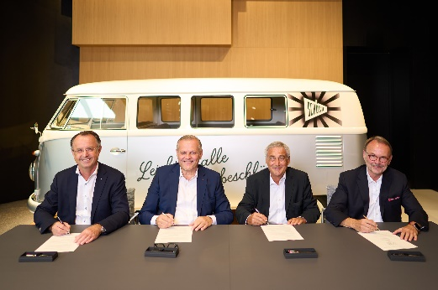
(From left) Dr Walter Stadlbauer and Andreas Engelhardt, COO/CTO and Managing Partner of Schüco, sign the contract documents in the Schüco Welcome Forum in Bielefeld together with Lázló Kálmán, Managing Director of Metallinvest Holding GmbH, and Reiner Bachnick, Managing Director of RSFB Technologie GesmbH & AWB Aluminiumwerk Berlin GmbH.

