Press release  May 2023 |  | Further information about publication:  Schüco International KG  Sandra Greiser Vorndamme  Karolinenstr. 1–15  33609 Bielefeld, Germany  Tel.: +49 (0)521 783-1174  E-mail: PR@schueco.com  www.schueco.com/press  www.schueco.com/press

Award-winning product design:

Schüco receives Red Dot and iF Design 2023 awards

Bielefeld. An aesthetic shape is as much an important aspect of product design as high functionality. Four Schüco systems have impressed in international design competitions due to the high quality of their product design. The Red Dot Award 2023: Product Design was awarded to the Schüco AS PD 75.HI Panorama Design sliding system, the Schüco AS FD 75/90.HI folding sliding system, the Schüco WoodDesign window system and the Schüco AD AL 75 door system. The folding sliding system and the Panorama Design sliding system also received the coveted iF Design Award 2023 for pioneering design.

Schüco AS PD 75.HI Panorama Design sliding system
Everything is concealed: the frameless appearance, slimline face widths in the interlock section and a barrier-free threshold which sinks into the ground when closed (Performance Line) encapsulate the concept of elevated minimalism. The Schüco AS PD 75.HI sliding system enables the largest possible views to the outside, seamlessly connecting the indoor and outdoor areas. Individual customisation options are also possible for the Access Line and Design Line, including a dynamic cover profile for a flush-fitted appearance, an integrated flush pull grip and numerous customisable features such as integrated sun shading, a timber appearance and integration in building automation systems. This ensures a perfect interplay of design, convenience, security and smart technology.

Schüco AS FD 75/90.HI folding sliding system platform
A folding design to meet high architectural demands: available in heights of up to 3.5 metres and widths of up to 1.5 metres, the folding sliding system platform has the appearance of a glass façade. The individual units can be folded easily and flexibly to the inside or outside, in just one direction or to the left and right like curtains, opening up the entire width of up to 9 metres without any fixed sliding vents. A side-hung door can also be integrated for quick access to the outside. Accessibility does not get any better than this. The system allows daylight to flood inside and provides undisturbed views to the outside and the feeling of being close to nature.

Schüco WoodDesign for aluminium windows
The natural material timber is timeless, cosy and versatile, making it absolutely on trend in terms of interior design. To meet this requirement for high-quality design, Schüco has combined the two materials timber and aluminium in a single window system: the timber surface finish, available in numerous options, covers the interior window profile and blends harmoniously into the interior design. On the outside, aluminium offers impressive stability, durability and resistance. The Schüco WoodDesign window system offers the perfect combination of design, materials and functionality.

Schüco AD AL 75 pivot door system
The perfect combination of movement and design: Schüco AD AL 75 is a pivot door which consists of thermally-insulated aluminium profiles and innovative air-lux gasket technology. The gaskets inflate with air, completely closing the gap between the door leaf and frame. This ensures excellent structural properties in all weather conditions and creates a pleasant living environment. The large-scale door leaves can be individually designed with opaque or transparent infills in various materials.

www.schueco.com

Schüco – System solutions for windows, doors and façades
Based in Bielefeld, the Schüco Group develops and sells system solutions made of aluminium, steel and PVC-U for building envelopes. Its product portfolio comprises window, door, façade, ventilation, security and sun shading systems. Intelligent and networked products complete the range available for residential and commercial projects. Schüco also provides consultancy and digital solutions for all phases of a building project – from the initial idea through to design, fabrication and installation, as well as after sales with maintenance and servicing. Fabrication machinery and customer-oriented service complement the product portfolio. Sustainability is a significant part of the business model. For example, the circular construction industry with closed material cycles is one of six defined focus areas for sustainability. Founded in 1951, the company is now active in more than 80 countries and achieved a turnover of 1.995 billion euros in 2021 with 6330 employees. For more information, visit www.schueco.com

High-resolution pictures are available to download in the Schüco Newsroom at www.schueco.com/press.

Picture credits: Schüco International KG

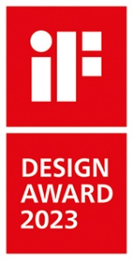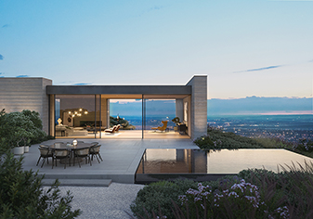
The Schüco AS PD 75.HI Panorama Design sliding system platform received the Red Dot Award 2023: Product Design and the iF Design Award 2023.

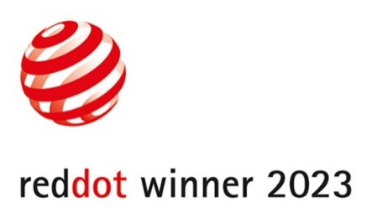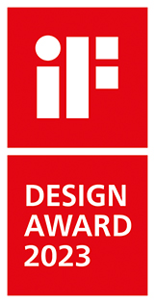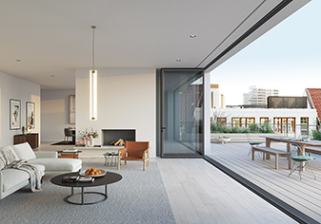
The Schüco AS FD 75/90.HI folding sliding system platform received the Red Dot Award 2023: Product Design and the iF Design Award 2023.

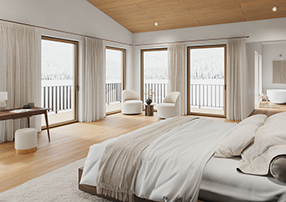
Schüco WoodDesign for aluminium windows received the Red Dot Award 2023: Product Design.

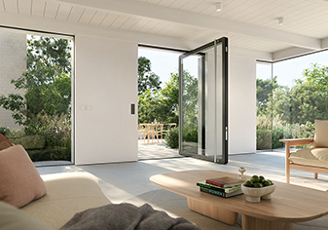
The Schüco AD AL 75 pivot door system received the Red Dot Award 2023: Product Design.

