Press release  January 2023 |  | Further information about publication:  Schüco International KG  Lisa Kottmann  Karolinenstr. 1–15  33609 Bielefeld, Germany  Tel.: +49 (0)521 783-7366  Fax: +49 (0)521 783-950803  E-mail: PR@schueco.com  www.schueco.de/presse  www.schueco.com/press

The digital identity of Schüco units

Schüco IoF ID

Bielefeld. Digitalisation is changing how we build. But much of building management is still analogue. With the IoF (Internet of Façades) ID, Schüco has developed a solution offering smart added value for the entire lifecycle of a building envelope for fabricators, building operators and occupants. The small tag is easily attached to the installed windows and doors. Information on the installed parts, guarantees, the maintenance history and the recycling options for the materials and components used can be called up by via a smartphone. Schüco IoF ID can also be used to quickly submit digital service requests. This increases the lifespan of the unit and allows for sustainable operation.

The IoF ID involves every Schüco unit in a building – whether it is aluminium, PVC-U or steel – being equipped with its own digital identity. A component can therefore be clearly identified, located and automatically linked to all the information and documentation related to the product. Schüco IoF ID therefore makes a significant contribution towards the circularity of the products used in a building. Using the information recorded, the tag helps to ensure that units are reused in the best possible way at the end of their lifecycle. This saves time and money and allows for complete control and transparency, meaning the units can be operated sustainably.

Small but mighty
The Schüco IoF ID is a UV and weather-resistant PVC-U tag that is placed directly on the unit and assigned to the unit via the software. The hardware includes an integrated NFC chip and a QR code which carries all of the data, information and documents about the unit stored in the cloud. When was the unit installed? Which handle was installed? What maintenance work was carried out? How can old components and materials be recycled? Fabricators and building operators can find all of this out quickly and efficiently on site using the app or in the office using the browser-based IoF Manager application. In the IoF Manager, buildings and the Schüco units installed inside them can be managed in a clear and easy way. Creating projects, assigning units, storing documents and certificates, creating inspection documentation and processing service requests – all of this is carried out in the IoF Manager and stored in the cloud in a completely paperless process. In this way, a digital service history is compiled which, just like the service book of a car, provides a transparent overview of the maintenance and service history of all the façade units. If, for example, the handle on one unit needs to be replaced, the engineer can scan the IoF ID and immediately access all the relevant product information, such as serial and article numbers.

For more information, visit schueco.com/iofid.

Schüco – System solutions for windows, doors and façades
Based in Bielefeld, the Schüco Group develops and sells system solutions made of aluminium, steel and PVC-U for building envelopes. Its product portfolio comprises window, door, façade, ventilation, security and sun shading systems. Intelligent and networked products complete the range available for residential and commercial projects. Schüco also provides consultancy and digital solutions for all phases of a building project – from the initial idea through to design, fabrication and installation, as well as after sales with maintenance and servicing. Fabrication machinery and customer-oriented service complement the product portfolio. Sustainability is a significant part of the business model. For example, the circular construction industry with closed material cycles is one of six defined focus areas for sustainability. Founded in 1951, the company is now active in more than 80 countries and achieved a turnover of 1.995 billion euros in 2021 with 6330 employees. For more information, visit www.schueco.com

High-resolution pictures are available to download in the Schüco Newsroom at www.schueco.com/press

Picture credits: Schüco International KG

In the Schüco vision of the Internet of Façades, the building envelope has particular significance as the smart interface between the physical and digital world.


Whether it is the maintenance history, the materials used or recycling options, the Schüco IoF ID allows all the relevant information about the installed unit to be accessed.

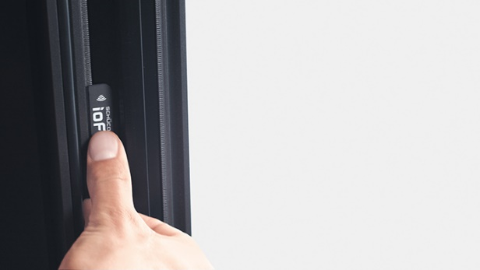
The Schüco IoF ID can be stuck to the inside of the unit easily without the need for drill holes or screws.

