Press release  January 2023 |  | Further information about publication:  Schüco International KG  Lisa Kottmann  Karolinenstr. 1–15  33609 Bielefeld, Germany  Tel.: +49 (0)521 783-7366  Fax: +49 (0)521 783-950803  E-mail: PR@schueco.com  www.schueco.de/presse  www.schueco.com/press

One façade – maximum design freedom

Schüco Grid2Shell

Bielefeld. The new Schüco Grid2Shell freeform façade is a self-supporting aluminium/glass solution for three-dimensional roof and façade constructions. The building envelope specialist based in Bielefeld has developed a façade solution that offers maximum design freedom and a wide range of possible applications – all without steel substructures or welded joints. Grid2Shell features a self-supporting bolted connection system for simple and rapid fabrication and installation. Schüco offers additional support from the design through to the implementation of the freeform façade for architectural firms and metal fabricators.

Schüco Grid2Shell allows maximum design freedom for three-dimensional façade and skylight constructions. Square, polygonal or triangular module units can be used to create individual shapes on the building envelope, as well as skylight constructions with large spans. The option to have the vertical façade plane transition into the roof gives rise to particularly unique façades. Furthermore, Grid2Shell is also a fully-fledged curtain wall and skylight construction with an all-glass look and outstanding structural, weathertightness and insulation properties.

Stability without any substructure
Unlike most skylight constructions featuring large spans, Grid2Shell does not require any complex and costly substructures. This is because the system is scalable, self-supporting and able to directly accommodate the three-stage sealing system thanks to the profile and node system. The 3D nodes lie at the heart of the system. With the help of the self-supporting bolted connection system, these nodes can be fixed to the mullion profiles, which are cut at a 90-degree angle, using screws at the marked point. Additional welded joints are not required.

Efficient planning and implementation
Schüco provides comprehensive advice from the design through to the implementation of the freeform façade. This includes improving the digital designs by calculating and optimising the load-bearing structures and node intersection points. The feasibility of the design is also checked using the latest design and structural analysis software. Schüco offers metal fabricators on-site support by providing training and advice at the construction site.

Simple fabrication and installation
The Grid2Shell profiles are first cut at an angle of 90 degrees. The screw holes are then drilled and the pockets machined. The nodes for the global market are fabricated in a centralised production facility owned by Schüco in the United Arab Emirates. The metal fabricator installs the freeform façade on site by means of the snowflake principle. As a result, no large crane devices are required. The numbering of the nodes makes it clear which connecting bar is assigned to which node intersection point and enables straightforward "building by numbers".

For more information, visit schueco.com/grid2shell.

Schüco – System solutions for windows, doors and façades
Based in Bielefeld, the Schüco Group develops and sells system solutions made of aluminium, steel and PVC-U for building envelopes. Its product portfolio comprises window, door, façade, ventilation, security and sun shading systems. Intelligent and networked products complete the range available for residential and commercial projects. Schüco also provides consultancy and digital solutions for all phases of a building project – from the initial idea through to design, fabrication and installation, as well as after sales with maintenance and servicing. Fabrication machinery and customer-oriented service complement the product portfolio. Sustainability is a significant part of the business model. For example, the circular construction industry with closed material cycles is one of six defined focus areas for sustainability. Founded in 1951, the company is now active in more than 80 countries and achieved a turnover of 1.995 billion euros in 2021 with 6330 employees. For more information, visit www.schueco.com

High-resolution pictures are available to download in the Schüco Newsroom at www.schueco.com/press

Picture credits: Schüco International KG
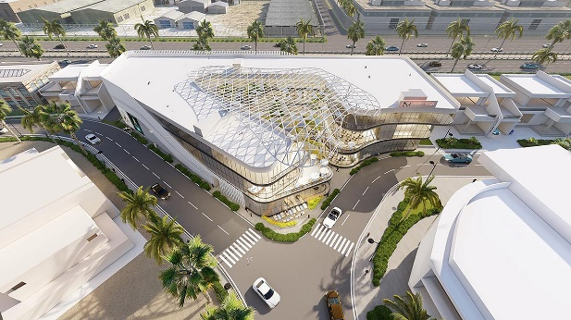
Smart building for the future: Schüco Grid2Shell makes it possible to efficiently plan and easily execute three-dimensional, free-form roof and façade constructions.

Picture credits: Schüco International KG
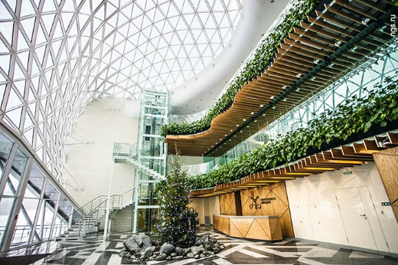
Grid2Shell is scalable, self-supporting and able to directly accommodate the three-stage sealing system thanks to the profile and node system.

Picture credits: Schüco International KG
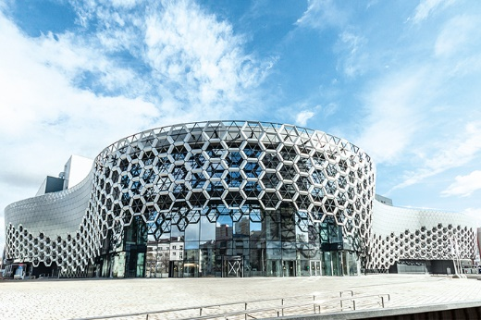
Square, polygonal or triangular module units can be used to create individual shapes on the building envelope, as well as skylight constructions with large spans.
Picture credits: Schüco International KG
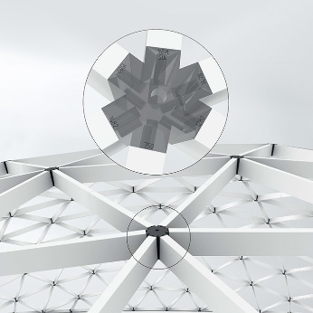
The self-supporting bolted connection system means that steel substructures and welded joints are not required, enabling the construction project to be implemented quickly and efficiently.

