Press release  March 2023 |  | Further information about publication:  Schüco International KG  Ulrike Krüger  Karolinenstr. 1–15  33609 Bielefeld, Germany  Tel.: +49 (0)521 783-803  Fax: +49 (0)521 783-950803  E-mail: PR@schueco.com  www.schueco.de/presse  www.schueco.com/press

New Schüco AS PD 75.HI Panorama Design sliding system:

Minimalism par excellence

Bielefeld. With minimalism representing the epitome of supreme functionality, Schüco presents its new generation of the sliding system range: Schüco AS PD 75.HI (Aluminium Sliding, Panorama Design, 75 millimetre basic depth, High Insulation). New lift-and-slide technology makes it possible to combine a concealed frame with a barrier-free level threshold for the very first time. The individually scalable range is able to meet a variety of usage requirements. What's more, significant reductions in the complexity of the system design ensure that it is easy to fabricate and install.

New lift-and-slide technology makes it possible: the mechatronically-operated, barrier-free threshold extends out of the outer frame integrated in the floor when the Schüco AS PD 75.HI sliding system is opened. As a result, a barrier-free threshold can be combined with the frameless appearance of concealed frame profiles for the very first time (Performance Line). Other highlights of the sliding system include a dynamic cover profile in the side outer frame that conceals the installed TipTronic fittings components when open, making it appear completely flush with the wall. Sensor-free finger-trap protection up to security class SK 3 is guaranteed.

In addition to the Performance Line, which combines almost every design option, the Schüco AS PD 75.HI system range is individually scalable. While the barrier-free threshold of the Access Line ensures that the floor is completely level on both sides – and therefore guarantees ease of access – the Design Line makes a visual impact. Frameless due to the concealed profiles in the wall, floor and ceiling, this product line makes large expanses of glass possible, ensuring unobstructed views and maximum transparency. Thanks to Schüco AluWood Design, it can be coordinated with the interior design.

System features and add-ons
The Schüco AS PD 75.HI sliding system is characterised by narrow profile face widths of just 35 millimetres and a basic depth of 75 millimetres. When it comes to thermal insulation, the system boasts excellent Uw values to 0.82 W/(m2K) (Performance Line). With the Schüco TipTronic fitting, a mechatronic drive can be selected, which is compulsory for the Performance Line. The Access Line and Design Line achieve burglar resistance up to Resistance Class 2 (RC 2), while the Performance Line achieves up to RC 3. Other add-ons that can be selected include integration of the Schüco AB ZDS (Aluminium Blind, Zip Design Screen) sun shading system, locking device in opening position, monitoring of closing as well as integration in the Schüco Building Skin Control platform for controlling and monitoring all mechatronic Schüco units.

Fabrication benefits
The new premium Schüco AS PD 75.HI sliding system is characterised by its significant reduction in complexity: there is a high number of identical parts, the fabrication steps are shorter and simpler, fewer varieties of tools are required and the system is easier to adjust once installed, ensuring that it is easier to fabricate, install and maintain.

In addition, Schüco actively provides its partners with fabrication support if they have no or only limited options to fabricate the systems in their own workshops: pre-assembled kits for Panorama Design sliding systems can be purchased directly from PreFab Solutions in Paderborn.

www.schueco.com
www.schueco.de/as-pd-75-performance-en
www.schueco.de/as-pd-75-design-en
www.schueco.de/as-pd-75-access-en

Schüco – System solutions for windows, doors and façades
Based in Bielefeld, the Schüco Group develops and sells system solutions made of aluminium, steel and PVC-U for building envelopes. Its product portfolio comprises window, door, façade, ventilation, security and sun shading systems. Intelligent and networked products complete the range available for residential and commercial projects. Schüco also provides consultancy and digital solutions for all phases of a building project – from the initial idea through to design, fabrication and installation, as well as after sales with maintenance and servicing. Fabrication machinery and customer-oriented service complement the product portfolio. Sustainability is a significant part of the business model. For example, the circular construction industry with closed material cycles is one of six defined focus areas for sustainability. Founded in 1951, the company is now active in more than 80 countries and achieved a turnover of 1.995 billion euros in 2021 with 6330 employees. For more information, visit www.schueco.com

High-resolution pictures are available to download in the Schüco Newsroom at www.schueco.com/press

Usage rights: Schüco International KG

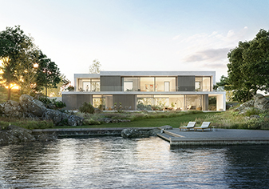
Minimalism represents the epitome of supreme functionality: the new Schüco AS PD 75.HI sliding system range (Aluminium Sliding, Panorama Design, 75-millimetre basic depth, High Insulation).

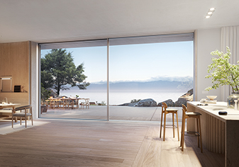
The new Schüco AS PD 75.HI (Performance Line) lift-and-slide technology combines concealed frame profiles with a barrier-free threshold for the very first time.

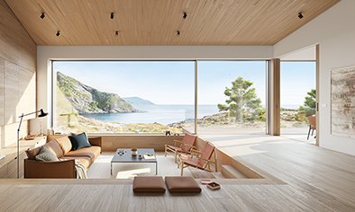
Harmonious interior design with Schüco Wood Design: individual profiles with a woodgrain finish make a real design statement in the interlock section of the Schüco AS PD 75.HI sliding system.

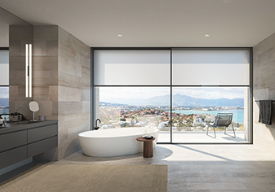
To provide sufficient sun shading and glare protection, the AS PD 75.HI Panorama Design sliding system can be combined with the Schüco AB ZDS sun shading system.

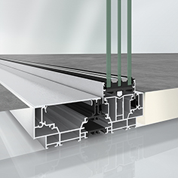
Schüco AS PD 75.HI Access Line sliding system with barrier-free threshold.

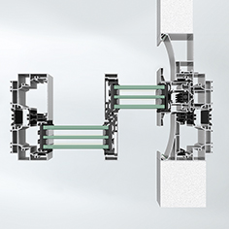
Schüco AS PD 75.HI (Design Line) sliding system with integrated flush pull grip.

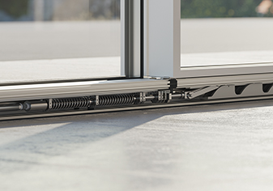
Schüco AS PD 75.HI (Performance Line) sliding system with new lift-and-slide technology.

