Press release  March 2023 |  | Further information about publication:  Schüco International KG  Lisa Kottmann  Karolinenstr. 1–15  33609 Bielefeld, Germany  Tel.: +49 (0)521 783-7366  Fax: +49 (0)521 783-950803  E-mail: PR@schueco.com  www.schueco.de/presse  www.schueco.com/press

Fire protection for external areas
Schüco FireStop ADS 90 FR 30-CE

Bielefeld. With the new Schüco FireStop ADS 90 FR 30-CE aluminium door, the Bielefeld-based company is expanding its tried-and-tested FireStop platform with a fire door for external use. While the former FireStop platform range was exclusively comprised of fire doors for use in internal areas, Schüco now also offers an external door. The new fire door provides 30 minutes of fire resistance, features impressively high weathertightness values, and is CE-classified for use throughout Europe. As part of the FireStop system platform, Schüco FireStop ADS 90 FR 30-CE also boasts an open-rebate profile geometry, which combines modern design with a high level of flexibility and efficiency in planning, fabrication and installation.

The thermally broken aluminium fire construction with a basic depth of 90 mm offers a high degree of design freedom for external use. Narrow profile face widths alongside concealed fittings and door closers ensure an elegant, minimalist door design. Large sidelights and toplights as well as narrow profile face widths allow a high level of transparency. Extending the system sizes for single and double-leaf door constructions with and without side units offers additional possibilities for implementing project-specific, architectural solutions for the building envelope, while also ensuring maximum user comfort.

The perfect solution for every requirement
Whatever the requirements in terms of barrier-free access, sound reduction, watertightness or thermal insulation, Schüco
FireStop ADS 90 FR 30-CE offers a variety of threshold solutions and substructure profiles to flexibly meet the requirements of any project. In addition to 30 minutes of fire resistance, the new fire door also features excellent weathertightness values. A total of four different threshold solutions are available: thresholds with an automatic threshold gasket (0 mm and 12 mm), and thresholds with an insert profile, brush seal or balloon gasket (3 mm and 15 mm). These enable air permeability up to class 4 and watertightness up to class 5 A to be achieved. By using glass or, alternatively, thermally insulated panel infills, the new platform can be customised to meet different requirements.

One system – maximum individuality
The core feature of the system platform is the open-rebate profile geometry, which allows retrospective changes in use to be carried out on existing doors even during operation. A system with a compatible construction can therefore be fitted quickly and economically with additional electric components such as electric strikes, to enhance its function in a variety of ways. Fittings and locks can also be integrated without the need for time-consuming machining and concealed with a simple functional make-up piece. Using fittings components from tried-and-tested Schüco system platforms also ensures efficient fabrication and installation.

For more information, visit schueco.de/ads-90-fr30-ce-en.

Schüco – System solutions for windows, doors and façades
Based in Bielefeld, the Schüco Group develops and sells system solutions made of aluminium, steel and PVC-U for building envelopes. Its product portfolio comprises window, door, façade, ventilation, security and sun shading systems. Intelligent and networked products complete the range available for residential and commercial projects. Schüco also provides consultancy and digital solutions for all phases of a building project – from the initial idea through to design, fabrication and installation, as well as after sales with maintenance and servicing. Fabrication machinery and customer-oriented service complement the product portfolio. Sustainability is a significant part of the business model. For example, the circular construction industry with closed material cycles is one of six defined focus areas for sustainability. Founded in 1951, the company is now active in more than 80 countries and achieved a turnover of 1.995 billion euros in 2021. For more information, visit www.schueco.com

High-resolution pictures are available to download in the Schüco Newsroom at www.schueco.com/press.

Picture credits: Schüco International KG
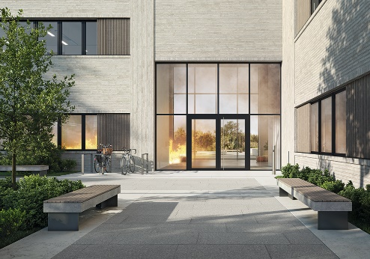
With Schüco FireStop ADS 90 FR 30-CE, Schüco is expanding the FireStop system platform to include aluminium fire doors for external use. The doors are CE-classified in accordance with EN 16034 for 30 minutes of fire resistance and EN 14351-1 for excellent weathertightness values.

Picture credits: Schüco International KG
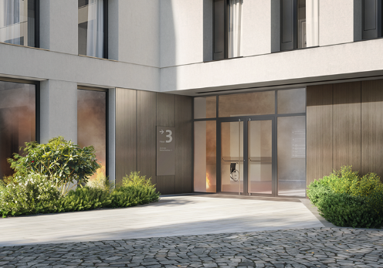
The CE-classified fire door system for use in the building envelope offers planners, architects and fabricators a new level of flexibility when it comes to implementing building regulations throughout Europe.

Picture credits: Schüco International KG
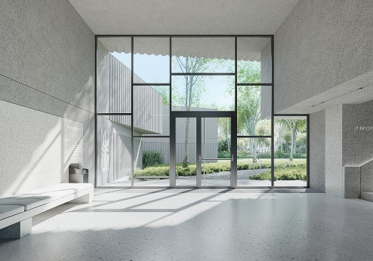
Narrow profile face widths alongside concealed fittings and door closers ensure an elegant, minimalist door design with a high level of transparency.

Picture credits: Schüco International KG
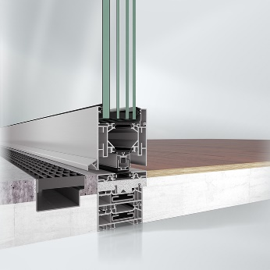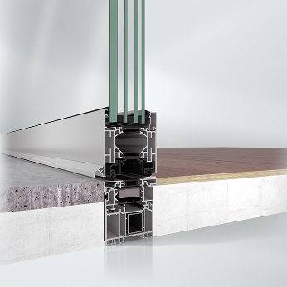
Be it thresholds with an automatic threshold gasket or with an insert profile, brush seal or balloon gasket, Schüco FireStop ADS 90 FR 30-CE offers the perfect solution to meet every requirement.

Picture credits: Schüco International KG
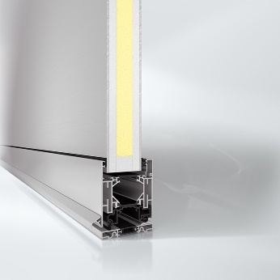
In addition to glass infills, thermally insulated fire-resistant panels are also available for external use.

