Press release  December 2022 |  | Further information about publication:  Schüco International KG  Ulrike Krüger  Karolinenstr. 1–15  33609 Bielefeld, Germany  Tel.: +49 (0)521 783-803  Fax: +49 (0)521 783-950803  E-mail: PR@schueco.com  www.schueco.de/presse  www.schueco.com/press

Schüco AOC add-on construction with Schüco AW RO 50 roof window

Sustainably functional

Bielefeld. The new Schüco AOC add-on construction combines aluminium with a timber or steel substructure to create a striking appearance. Thanks to optimised thermal insulation and sound reduction values, the Cradle to Cradle-certified system achieves passive house standard, uniting energy-efficient construction with streamlined fabrication and installation. The add-on construction also impresses with its high load-bearing capacity and narrow face widths. The Schüco AOC.TI (Timber) options also use the renewable resource timber in the substructure. The façade construction is supplemented by the new Schüco AW RO 50 (Aluminium Window Roof) roof window for different skylight constructions. Schüco AW RO 50 allows for large vent sizes and weights, and offers high energy efficiency alongside simple fabrication.

Whether it is used in a residential or commercial building, the AOC add-on construction and the AW RO 50 roof window combine functionality with modern design. The add-on construction from Schüco offers high load-bearing capacity alongside narrow face widths. Numerous outer frame options fully cover substructures with face widths of 50, 60 or 75 mm and create a harmonious appearance for vertical façades and skylights. Thanks to the continuous gasket, Schüco AOC can span façade areas and skylights up to 25 m long. Glazed roofs with pitches up to 2° and the Schüco AW RO 50 roof window create maximum openness and transparency.

Economical and efficient
The uniform gasket for mullions and transoms reduces the work needed for planning, logistics and purchasing. This minimises sources of error while saving time and money. The innovative GI (Gasket Injection) technology guarantees clean and controlled application of the sealant for optimal, repeatable sealing. A special add-on profile with a positioning aid and the isolator system with integrated screw guide ensure reliable installation. The modular platform of RICON® single connectors for timber substructures makes fabrication easier and can support large glass weights of up to 1100 kg when combined with a graduated range of glazing supports. For steel substructures, powder-actuated fastening technology and self-drilling screws offer a secure and efficient alternative to conventional welding for maximum glass weights of 1500 kg.

Schüco AW RO 50 roof window
Schüco AW RO 50 allows for large vent sizes and weights without compromising on energy efficiency and streamlined fabrication. The Cradle to Cradle-certified system offers many optimum technical values such as large vent sizes up to 4.5 m², vent weights up to 250 kg and a low thermal transmittance value of 1.2 W/(m²K). The window system is also highly flexible and offers numerous application possibilities. Various outer frame and glazing bead options provide design freedom and allow for flexible installation in different skylight constructions – whether it is Schüco FWS 50/60 as a skylight construction, the Schüco AOC add-on construction or the Schüco CMC 50 conservatory system.

Reliable and easy to install
Improved corner cleat contours allow for simple, high-quality fabrication of the Schüco roof window. The tried-and-tested SimplySmart locking fitting also aids the installation of vent sizes over 2.73 m². The two outer frame options can be used for all substructure types (Schüco FWS 50/60, Schüco AOC and Schüco CMC 50). The glazing beads can be installed as single bars or as part of the frame fabrication via a concealed screw-fixing with a simple clip-on profile. The fabrication and installation is made particularly simple thanks to the high use of identical parts with components from the Schüco AWS platform, Schüco AW RO 50 and the tried-and-tested Schüco SimplySmart locking fitting.

For more information, visit schueco.de/aoc.

Schüco – System solutions for windows, doors and façades
Based in Bielefeld, the Schüco Group develops and sells system solutions for windows, doors and façades. With 6330 employees worldwide, the company strives to be the industry leader in terms of technology and service both now and in the future. In addition to innovative products for residential and commercial buildings, the building envelope specialist offers consultation and digital solutions for all phases of a building project – from the initial idea through to design, fabrication and installation. Schüco works with 10,000 fabricators and 30,000 architectural practices, as well as construction professionals, who commission buildings around the world. Founded in 1951, the company is now active in more than 80 countries and achieved a turnover of 1.995 billion euros in 2021. For more information, visit www.schueco.com

High-resolution pictures are available to download in the Schüco Newsroom at www.schueco.com/press.

Photographer: Måns Berg Photography
Usage rights: Schüco International KG

The combination of aluminium and either timber or a slimline load-bearing structure made of steel allows for design-oriented solutions with a striking look.

Photographer: Måns Berg Photography
Usage rights: Schüco International KG

The Schüco AOC Cradle to Cradle-certified system achieves passive house standard thanks to optimised thermal insulation values and sound reduction values. Schüco AOC.TI (Add-On Construction, Timber) also uses the renewable resource timber in the substructure.

Picture credits: Schüco International KG
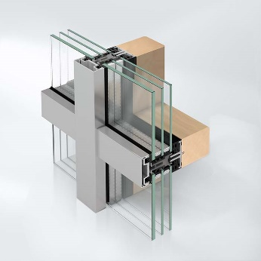
High-performance system: Schüco AOC offers a scalable range of glazing supports to achieve a high load-bearing capacity.

Picture credits: Schüco International KG
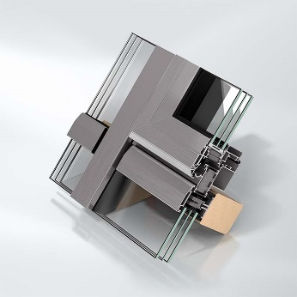
With maximum vent sizes and weights as well as optimum energy efficiency and streamlined fabrication, the Schüco AW RO 50 roof window is designed for use in AOC skylight constructions.

